Spring Term Recommended Reads for Elm Class

Our class reader this term is The Firework Maker’s Daughter by Phillip Pullman

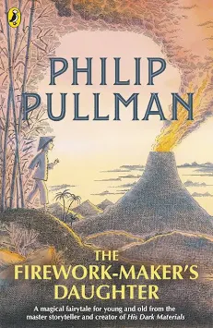

Other narratives by Phillip Pullman:
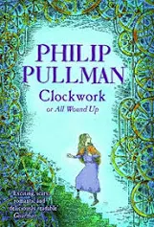 | In Phillip Pullman's Clockwork, an apprentice clockmaker and his acquaintances wind up some characters and fit them into a story on a cold winter's evening. With the snow swirling down, suddenly life and the story begin to merge in a peculiarly macabre - and unstoppable - way.  Almost like clockwork ... Tick, tock, tick, tock! Some stories are like that. Once you've wound them up, nothing will stop them ...
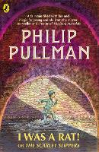 | Who is Roger? He says he was a rat - and some of the time he behaves like a rat. But, he is also a small boy. Or, he could be the Monster of the sewers…Everyone has a view – including The Daily Scourge – who tells their own version in screaming newspaper headlines. There is just one person who really knows who Roger is. And she’s the princess…  Cleverly, Pullman weaves together strands of story from different sources creating a fast-paced and multi-layered adventure.

We will also be reading Jim- A Cautionary Tale, which is a short, rhyming tale written by Hillaire Belloc.
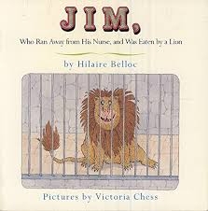

If you enjoyed this, you may wish to read some other humorous tales:
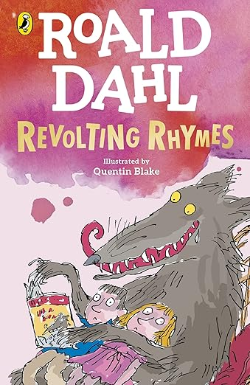 | This is a witty collection of six twisted retellings of classic fairy tales, including stories like Cinderella, Snow White, and Little Red Riding Hood. Dahl replaces the traditional happy endings with darkly humorous twists, unexpected outcomes, and clever rhymes that subvert readers’ expectations. Illustrated by Quentin Blake, the book combines satire and playful language to entertain while poking fun at conventional moral lessons, making it a mischievous and memorable take on beloved tales.
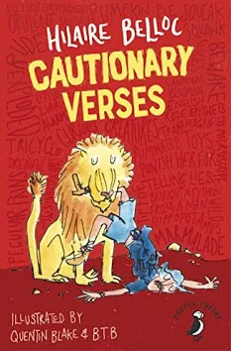 | This is an hilarious classic anthology of moral instruction introduced by Quentin Blake. If you are you prone to telling tales or running away then ignore these poems at your peril or you might suffer the same fate as Matilda, who told lies and was Burned to Death or Jim, Who ran away from his nurse and was eaten by a Lion!
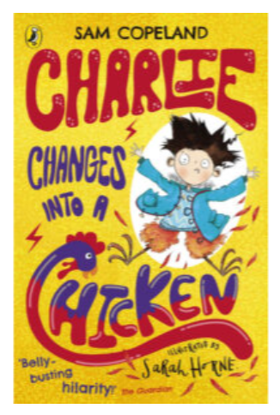 | Children will love this laugh-out-loud series with a tongue-in-cheek humour and plenty of funny asides, but also a poignant side about bullying, overcoming adversity and dealing with big emotions.  Charlie magically changes into animals when he is worried or stressed (not necessarily chickens, though). Charlie’s worries pile up, with a brother in hospital, parents bickering and a school bully to deal with. Riproaring and hilarious antics follow suit as Charlie navigates temporarily changing into a spider, a rhino, a pigeon, snake and more.  Children with a wacky sense of humour will find this story really funny, and it provides plenty of opportunity to think and discuss the deeper topics too.

You might like to explore some books based on our Science focus, Ecology:

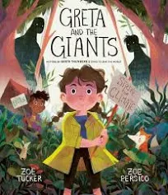 | Greta and the Giants” by Zoë Tucker is an inspiring picture book based on the real-life environmental activist Greta Thunberg. It tells the story of a young girl named Greta who lives in a beautiful forest threatened by greedy giants cutting down trees and destroying nature. Determined to protect her home, Greta speaks up and rallies other animals and children to join her peaceful protest, showing that even small voices can make a big difference. With vibrant illustrations by Zoë Persico, the book delivers a powerful message about courage, activism, and caring for the planet.
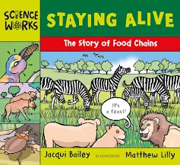 | The Science Works series use cartoon style illustrations and lively narrative text to make key topics in science both accessible and engaging.  Two legs, four legs, 100 legs or none – every animal needs food to keep it alive, and all of our food comes from other living things.  In this text, we follow the story of a food chain on the grasslands of Africa. We find out how plants create their food from sunlight, the way insects feed on plants and birds feed on insects. We learn how zebras feed on grass, and lions feed on zebras and that each creature has its own source of food and forms part of the food chain. This book also contains an experiment, more great facts to know, useful websites and an index.
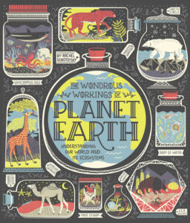 | An illustrated tour of our planet’s ecosystems both large and small, from reefs, deserts and rainforests to a single drop of water – from the bestselling author of Women in Science .  Through exquisite illustrations, maps and infographics, bestselling author Rachel Ignotofsky explains how our planet works, from its incredible ecosystems and the plants and animals that live there to the importance of biodiversity , weather cycles and more. Including information on the dangers of climate change and ideas for how to protect Planet Earth, this utterly charming guide is the perfect gift for all nature-loving readers on the planet we call home.

In our history lessons, we will begin to learn about the Ancient Romans:
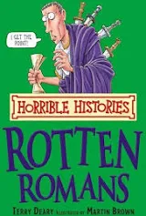 | Rotten Romans is a book in the Horrible Histories series that teaches children about Ancient Rome by focusing on its more gruesome, unpleasant, and humorous aspects. It uncovers the beastly battles, deadly doctors and marvellous myths. Discover what Roman soldiers wore under their kilts, how ancient Britons got their hair nice and spikey and why rich Romans needed a vomitorium. The book's goal is to make history fun and accessible, presenting shocking facts and stories in a "nasty bits left in" style to engage young readers.
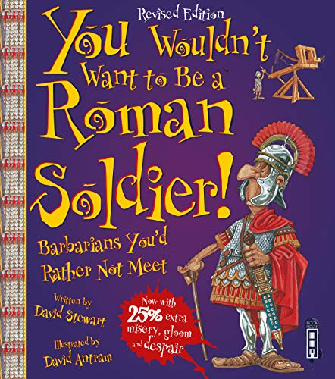 | Get ready... as a young man living in the Roman Empire, you’ve heard many stories about far-away lands and people. It sounds exciting but you’re about to discover how tough life really is for a Roman soldier! The humorous cartoon-style illustrations and narrative approach encourage readers to get emotionally involved with the characters, aiding their understanding of what life would have been like. Informative captions, a complete glossary and an index make this title an ideal introduction to the conventions of non-fiction texts for young readers. This text is an ideal accompaniment to KS2 History learning.
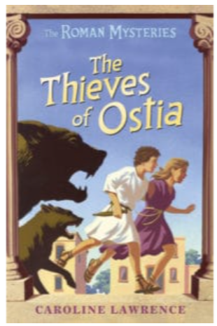 | The Thieves of Ostia is a gripping novel and is part of a historical fiction series that provides plenty of background information about life in Ancient Roman times.  The plot of The Thieves of Ostia centres around a young girl called Flavia who investigates the mystery of who is killing the dogs in the Roman port of Ostia.
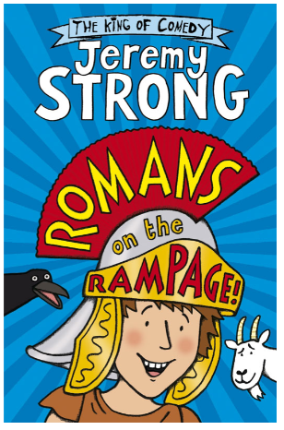 | Romans on the Rampage is a laugh-out-loud and easy-to-read story offering a bit of light relief and is perfect to read aloud to lower KS2 pupils.  This is a super-fun novel by Jeremy Strong that tells of the crazy adventures of Perilus, a Roman boy who dreams of riding chariots in the Circus Maximus.

Books linked to our art and DT learning:
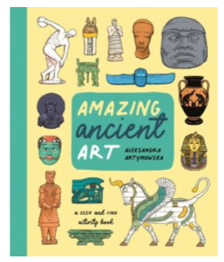 | Dive into this treasure trove of beautifully illustrated artefacts and learn more about the amazing ancient civilisations that created them as you complete puzzles and search for clues.  Can you find all the Egyptian gods hidden in the scene? Or can you match these Roman busts to the description of famous emperors? Explore precious jewels, mosaics, statues and ceramics from across history and throughout the world and find out more about the incredible ancient civilisations who made them. This busy activity book on ancient art is jam-packed with stimulating search-and-finds and perplexing puzzles that can be enjoyed time and time again.
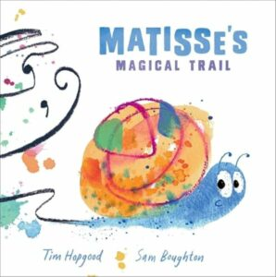 | A beautiful, colourful and bold picture book that encourages children to notice the small things, think big, and express themselves! Matisse is a young snail who loves to create beautiful drawings with his trail. The trouble is most of the time people are far too busy to even notice them. It's only when a child notices Matisse's beautiful trails that his art is finally celebrated - and they inspire a whole class of children to get creative too!

Miss Beaumont’s favourite books:
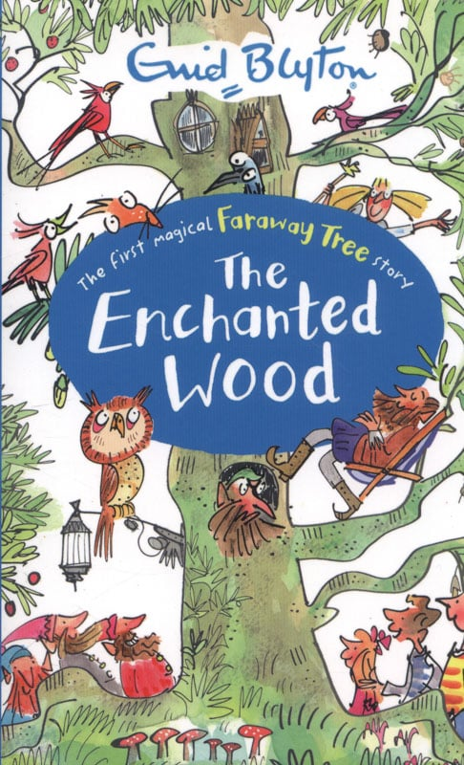 | The first magical story in the Faraway Tree series by one of the world’s most popular children’s authors, Enid Blyton.  Joe, Beth and Frannie find the Enchanted Wood on the doorstep of their new home, and when they discover the Faraway Tree they fall into all sorts of adventures!  Join them and their friends Moonface, Saucepan Man and Silky the fairy as they discover which new land is at the top of the Faraway Tree. Will it be the Land of Spells, the Land of Treats, or the Land of Do-As-You-Please? Discover the magic!
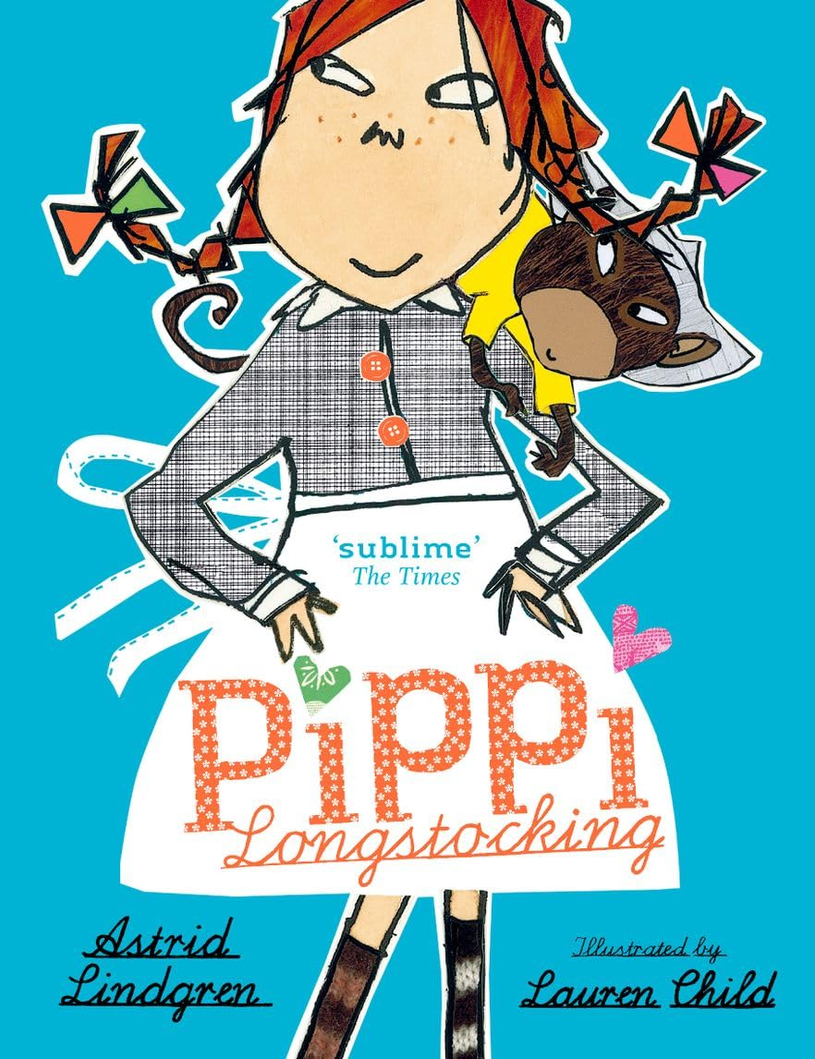 | Pippi Longstocking is nine years old. She has just moved into Villa Villekulla where she lives all by herself with a horse, a monkey, and a big suitcase full of gold coins. The grown-ups in the village try to make Pippi behave in ways that they think a little girl should, but Pippi has other ideas. She would much rather spend her days arranging wild, exciting adventures to enjoy with her neighbours, Tommy and Annika, or entertaining everyone she meets with her outrageous stories. Pippi thinks nothing of wrestling a circus strongman, dancing a polka with burglars, or tugging a bull’s tail.  Generations of children have fallen in love with Pippi Longstocking. Just like Tommy and Annika, readers are instantly charmed by her warmth, strength and sense of fun

