Recommended Reads

Our class reader this term is still Stig of the Dump by Clive King.

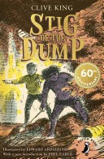

If you enjoy this book, you might also enjoy:

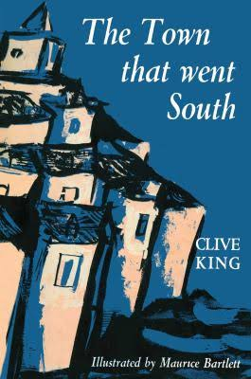

In Clive King's The Town That Went South, the English town of Ramsly floats away from England during a storm and embarks on a whimsical journey across the world. The story unfolds through the experiences of the town's cat, Gargoyle, as Ramsly travels from the Mediterranean and Africa to Australia and eventually reaches the South Pole, providing a humorous and ironic perspective on cultural encounters, particularly with British attitudes.

Other books which feature themes of unexpected friendships, often in a historical or fantastical setting are:
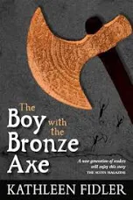

The Boy with the Bronze Axe is a historical fiction novel by Kathleen Fidler, set in the Stone Age village of Skara Brae, where two children, Kali and Brockan, are rescued from the tides by Tenko, a mysterious boy with a strange, sharp bronze axe. Tenko brings new skills and ideas that both benefit and create conflict within the community. As a deadly storm threatens, the village must decide how to use Tenko's knowledge to survive.
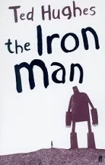
This story begins when a mysterious metal giant arrives and begins eating farm machinery, causing panic. After a young boy named Hogarth befriends him, they must work together to save the Earth from a monstrous "Space-Bat-Angel-Dragon" that threatens all life. The story explores themes of prejudice, fear of the unknown, and the power of understanding and acceptance over violence, ultimately advocating for peace.

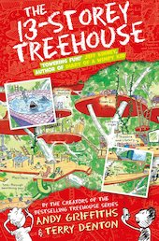
This is a funny book! It is about two boys called Andy and Terry who live in a 13-storey treehouse. They invent things and write stories. Andy does the writing and Terry does the drawings. Their treehouse is filled with bizarre features like a marshmallow machine and a tank of man-eating sharks, but struggle to write a new book due to numerous distractions, including 13 flying cats, a giant gorilla, and a mischievous mermaid. The story centres on their chaotic attempts to meet a looming book deadline amidst their absurd surroundings, ultimately leading them to write a story about their own adventures.

We will also be reading The Jabberwocky by Lewis Carroll, which is a non-sense poem.

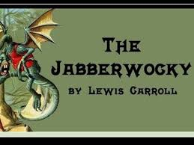

If you enjoyed this, you may wish to read some other humorous poems:

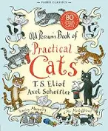
This is a collection of whimsical poems by T.S. Eliot, first published in 1939, that describe the unique personalities and "secret lives" of various cats. Intended for Eliot's godchildren, the book's light verses celebrate feline eccentricities and independence. The poems feature distinct characters like the magical Mr. Mistoffelees and the mysterious Macavity, and the book inspired Andrew Lloyd Webber's famous musical Cats.

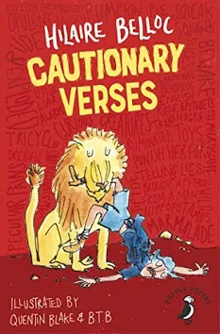
This is an hilarious classic anthology of moral instruction introduced by Quentin Blake. If you are you prone to telling tales or running away then ignore these poems at your peril or you might suffer the same fate as Matilda, who told lies and was Burned to Death or Jim, Who ran away from his nurse and was eaten by a Lion!

You might like to explore some non-fiction books, based on our Science focus:

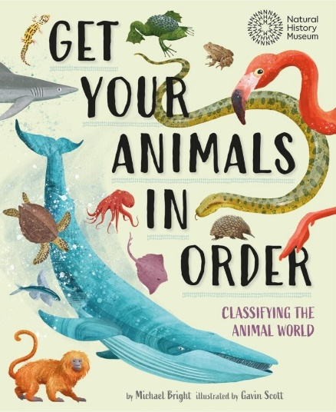
This clever and clear explanation of animal classification puts your animals in order and explains why classifying animals is important.

From whales to worms and snakes to stinkbugs, every creature ever discovered has been identified and added to a group within the animal kingdom. Scientists use this classification system to help them research, discover and save species. This children’s book showcases the amazingly diverse range of animals found around the world and the different features that help determine their place in the animal kingdom. We see the similarities, differences and connections between animal groups, and discover how classification helps scientists conserve animals and their habitats.
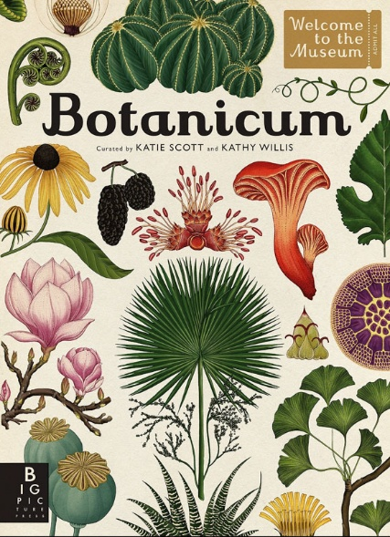
From perennials to bulbs to tropical exotica, Botanicum is a wonderful feast of botanical knowledge complete with superb cross sections of how plants work.
This impressive hardback is the closest thing you can get to a museum in book form. Exhibited in the pages are all sorts of plants from different habitats around the globe, displayed with beautiful botanical illustrations and informative text explaining the science behind how each plant looks and behaves. This is a beautiful non-fiction text to treasure and to amaze readers with the incredible diversity of the plant world.

After the half-term, we will begin our learning about Ancient Greece. Here are some books that you may enjoy:
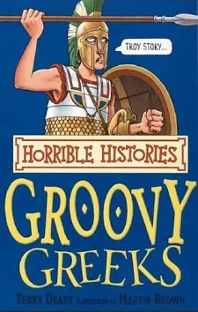
Groovy Greeks is a book in the Horrible Histories series that teaches children about Ancient Greece by focusing on its more gruesome, unpleasant, and humorous aspects. It covers topics such as the brutality of Spartan soldiers, the peculiarities of Greek doctors, the origin of the Olympics, and the invention of various items. The book's goal is to make history fun and accessible, presenting shocking facts and stories in a "nasty bits left in" style to engage young readers.
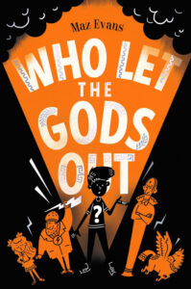
This fast-moving narrative with plenty of laugh-out-loud moments is a huge hit, especially with more confident readers. The story is based on the exploits of a boy called Elliot, who falls into an adventurous mission and calls on the help of the Olympian gods. Full of comedy scenes and sad parts too, this is an excellent story to read aloud for a light-hearted take on how Greek gods would fare in the modern world.

