“A cord of three strands is not easily broken”

Ecclesiastes 4:12


Weeting Primary School
Procedures For a Child Not Collected From School

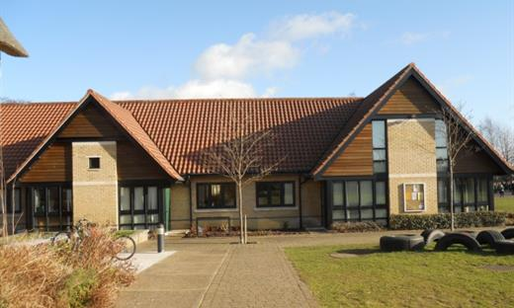

Agreed: September 2025
Reviewed: September 2026




Under Section 175 of the Education Act 2002, Local Authorities and Schools have a duty to safeguard and promote the welfare of children. A similar duty is placed on Independent Schools and Academies (Section 157). This duty should include making arrangements for dealing with children who are not collected at the end of the school day, or at the end of a school activity which is authorised by the school, and where the Model B Governance retains responsibility for the use of school premises.

Weeting Primary School recognises that it has a statutory duty to safeguard and promote the welfare of children, and that this duty extends to having arrangements in place for dealing with children who are not collected at the end of a school day, or at the end of an authorised activity.

The procedures will be brought to the attention of parents when their child starts school or at such time as there are any amendments.

On admission of their child to the school, parents should supply:
- Names and full addresses of parents/carers (and confirmation of parental responsibility)

- Home and work telephone numbers (where appropriate)

- Mobile phone numbers

- Two emergency contacts who may be called in the event of parents/carers being unobtainable or in the case of an emergency. This information should be updated annually or whenever circumstances change.

It is the parents’/carers’ responsibility to ensure that their child is collected by a responsible person. The school must be notified immediately if it becomes apparent that the person collecting the child may be late. Weeting Primary School agrees to care for a child who has not been collected from school until such a time that he/she has been collected by a parent/carer, or until appropriate, alternative care arrangements have been made with Children’s Services and/or the Police, in order to maintain the child’s safety.

The school’s Designated Safeguarding Lead (DSL) will keep a record of incidents on CPOMS where parents/carers do not collect a child from school or are late for no explained or good reason, or where there are repeated incidents. If there any concerns about the child’s safety and welfare, these will be dealt with in accordance with the school’s Safeguarding Policy and Procedures.

Child Not Collected From School Procedures

End of school Day
 | If parent/carer is not present at school to collect the child, the children should remain with the class teacher. The class teacher will check with the school office as to whether the parent/carer has contacted school to advise they will be late.
+15 minutes
 | If no contact has been received from parents/carers, the school office/headteacher/DSL should attempt to phone parent/carer to ask them to collect their child. School should also try the emergency contacts for the child.  If school has the consent of the parent/carer, the child could be taken home dependent on having two suitable members of staff available and the school’s health and safety/transportation regulations being met.
+30 minutes
 | Continue to try and contact parent/carer and emergency contacts. Where age appropriate, check with the child if they have any additional contacts who could be telephoned by the school. School should try to identify alternative arrangements for a child in line with the parent/carer’s recorded wishes. Older brothers and sisters could be considered suitable carers dependent on their age/competence. An older child who expects to be collected on that particular day, but often does go home independently could, after reasonable enquiries, be permitted to make their own way home (Do they have a key? Will there by anyone at home? Phone calls to alternative adults).
+60-90 minutes
 | Head/DSL consider contacting Children’s Services and the Police. Advise that you have an abandoned child at school. Have names, addresses and contacts ready. Explain what steps have already been taken to locate a responsible adult for the child. Children’s Services and the Police may pass useful information back to enable school to assist in locating the parent/carer. Notice of actions should be left at the home address. Child should remain in school where he/she feels safe and with staff he/she knows and trusts so there is no additional stress to the young person. In liaison with school staff, Children’s Services should try to identify a placement with a person known to the child. If no placement can be identified, then the child may be placed in a foster placement as they have been technically abandoned. Notice of actions should be left at the home address.
+24 hours
 | Record of actions should be kept by all agencies. School recording should be completed and kept by the Senior Designated Safeguarding Lead.

Regular late collection of a child could be an indicator of other safeguarding concerns. As a result, formal records should be kept by school of parents who arrive late to collect their child (date, times, explanations etc) to avoid potential future contact with Children’s Services.

