Here are some suggested reads to share with your children. These books are closely linked to our theme ‘All About Me’ and our class text ‘Owl Babies’.

**Shine By Sarah Asuquo**

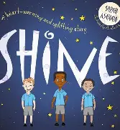

This book is all about celebrating the differences about yourself and what makes you special. Come and have a read to see what makes you special and shine!

**Think Big! By Kes Gray**

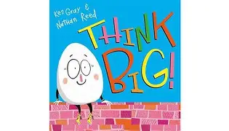

Humpty Dumpty wants to explore the world around him and think of all of the possibilities of the different jobs he could do! There is so many jobs that Humpty would like to do. Come and explore the endless possibilities and find out which jobs you might like to do!

**Owl’s lesson By Nick Butterworth**

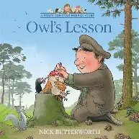

Percy the park keeper has a very important job to do! He has to make sure all of the animals that live in the park are happy and safe. One day Percy finds an owl and discovers that he cannot fly. I wonder what Percy could do to help the little owl fly?

**Little Owl**

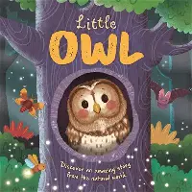

Little Owl is a story book that tells us about the life cycle of an owl. In this book you will meet a little tawny owl. This rhyming story will help you learn about how the owl grows from a chick into a fully grown owl!

**Colour Monster goes to School By Anna Llenas**

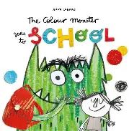

The colour monster is off to school but what exactly is school? Is it a castle? Does it have rainbows? The colour monster is not too sure how to feel. Come and explore what the colour monster gets up to on the first day of school!

**The Colour Monster By Anna Llenas**

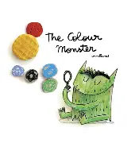

The Colour Monster is a story book that helps us to recognise the different emotions that we feel. However the Colour Monsters emotions have all been mixed up. Could you come and help the Colour Monster organise his emotions.