If you have enjoyed the story “Supertato” Why not explore these other great stories about heroes and adventures. We will be exploring these books throughout this half term in Acorn class.
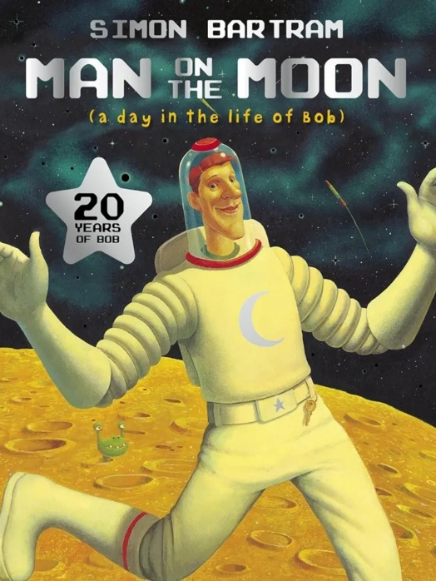

A Day in the life of Bob by Simon Bartram
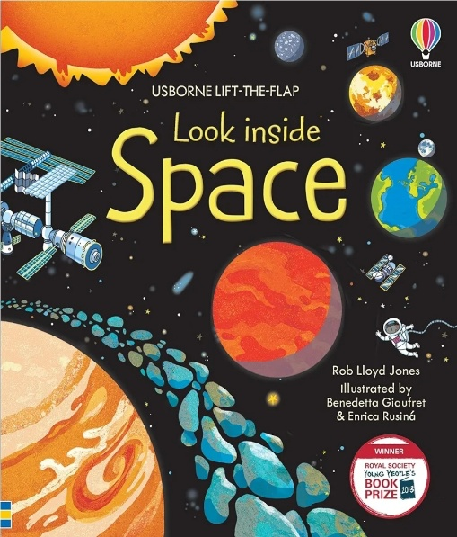
Bob has a special job-looking after the moon! Follow him on his daily adventures- keeping the moon clean, entertaining space tourists and giving guided tours.

Look inside Space
A great fun flap book, packed with interesting information about space. Learn what is floating through space as well as what goes on inside the international space station!

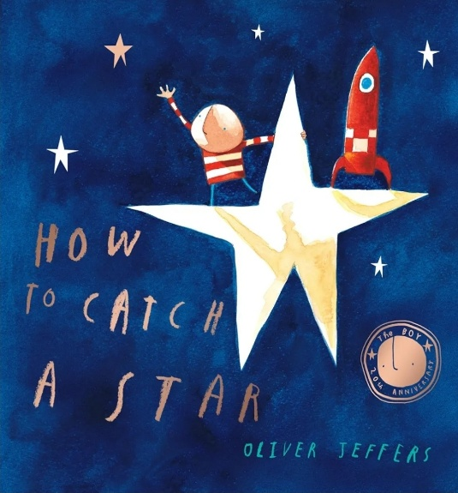

How to Catch a star by Oliver Jeffers
There once was a boy who loved stars so much that he wished he had one of his very own. Each night he watched the stars in the sky from his bedroom window and dreamed of how he could be their friend- one day, he decided to set about catching a star of his very own!

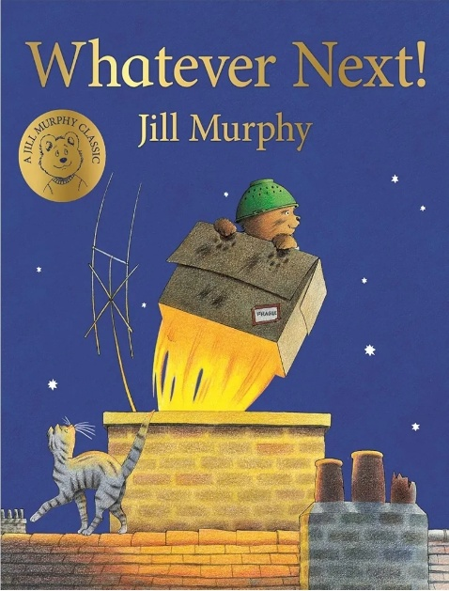
Whatever Next! By Jill Murphy
Baby Bear wants to go on one more adventure before bed- a quick trip to the moon! Mrs Bear isn’t pleased, and anyway, she says, Baby Bear doesn’t have a rocket. Luckily there’s one- under the stairs!
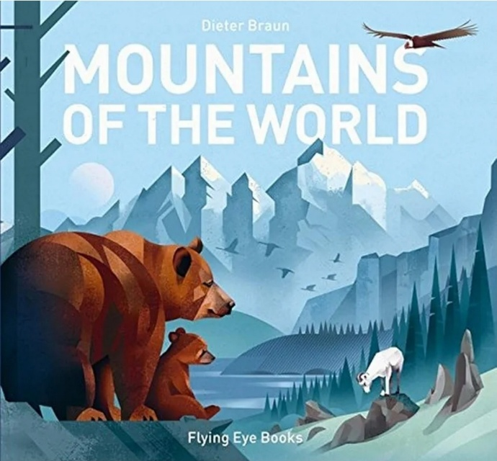
Mountains of the World by Dieter Braun
Take a closer look at the mountains of the world, from Alps to the Andes, to the peaks of the Himalayas. Meet the animals and people who make their homes on these rocky peaks, as well as the adventurers and athletes who challenge these great heights.
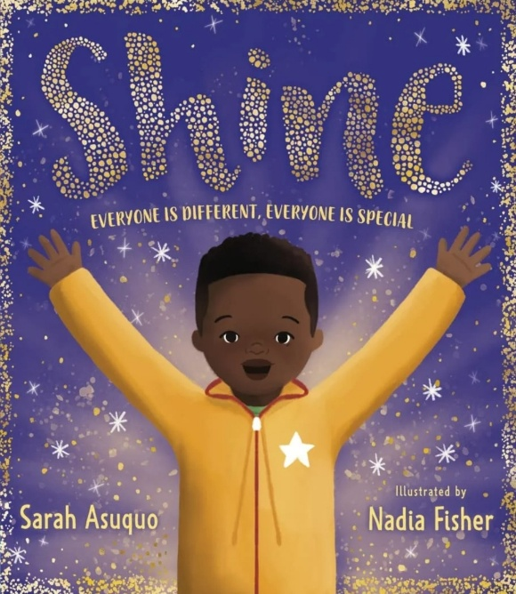
Shine by Sarah Asuquo
Kai begins to wish he was the same as everybody else after being bullied for being different. With the help of his parents, can Kai learn that the things that make him different are the things that make him special and let his own light shine through?

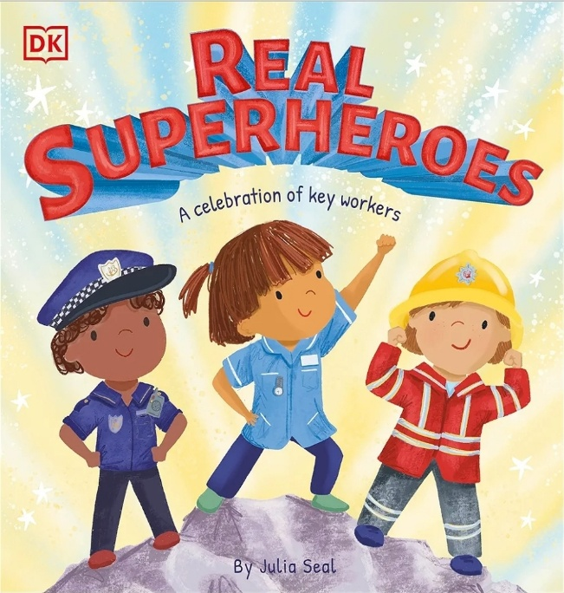
Real Superheroes by Julia Seal
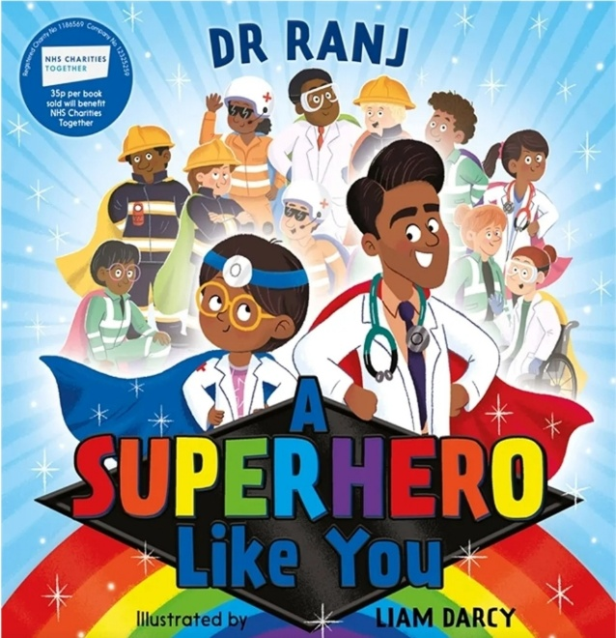
From supermarket staff and firefighters to doctors and nurses, this book celebrates the brave, everyday heroes who keep our world turning through difficult times.

A Superhero like you by Dr Ranj Singh
Join Lily as she meets the extraordinary Superheroes all around us, from doctors, teachers and air ambulance paramedics to scientists, recycling truck drivers and carers. Discover the amazing work these real-life heroes do using their incredible superpowers of kindness, care and love.

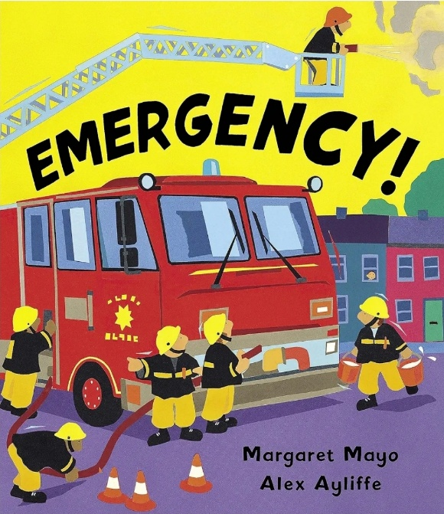
Emergency! By Margaret Mayo
It’s all going on in this action-packed picture book! Discover a different emergency vehicle on each page, from fire engines and police cars to lifeboats, breakdown trucks, rescue helicopters and more.

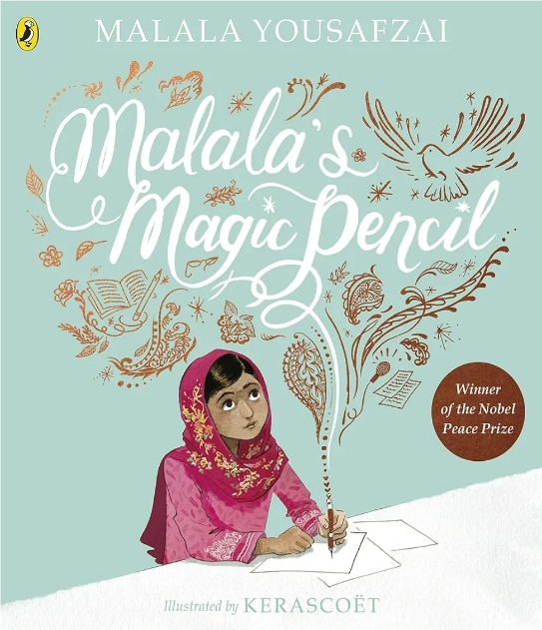
Malala’s Magic Pencil by Malala Yousafzai
As a child in Pakistan, Malala made a wish for a magic pencil that she could use to redraw reality. She would use it for good- to give gifts to her family, to ease the smell from the rubbish dump near her house. As she got older she realised that she could still fix things in the world, even without a magic pencil!

