Summer Term Recommended Reads
Stories about The Gingerbread Man
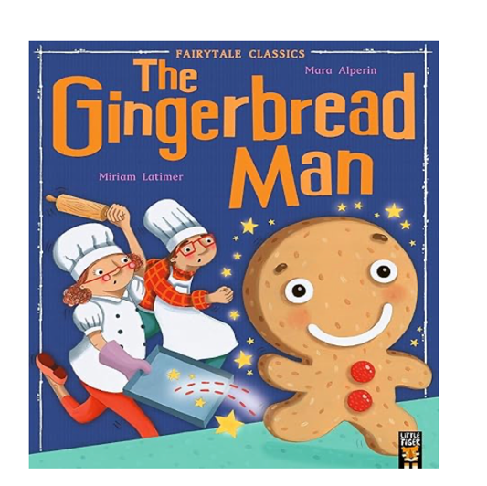 | The cheeky little gingerbread man is having so much fun! He scurries away from Mr and Mrs Baker and all the hungry animals, but then he meets a crafty fox . . .  Will the gingerbread man meet a sticky end?
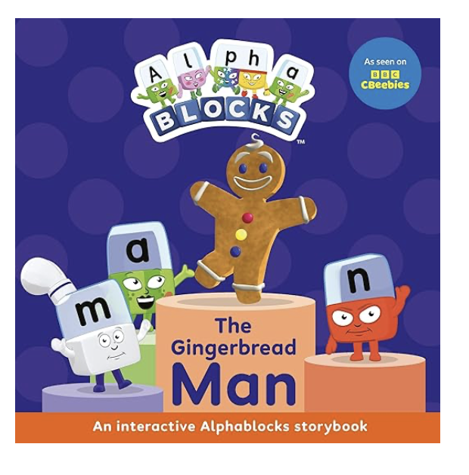 | Let’s go, Alphablocks! Run, run, as fast as you can… we need to catch the gingerbread man!  Based on the popular stories and characters from the hit CBeebies show, this Alphablocks picture book features colourful illustrations, fun-to-say sentences and interactive activities.  When Alphablock M feels hungry, his friends help him create a tasty gingerbread man – who causes chaos in Alphaland! Help the Alphablocks by copying sounds, following actions and reading simple words to finish the story... and catch the gingerbread man!
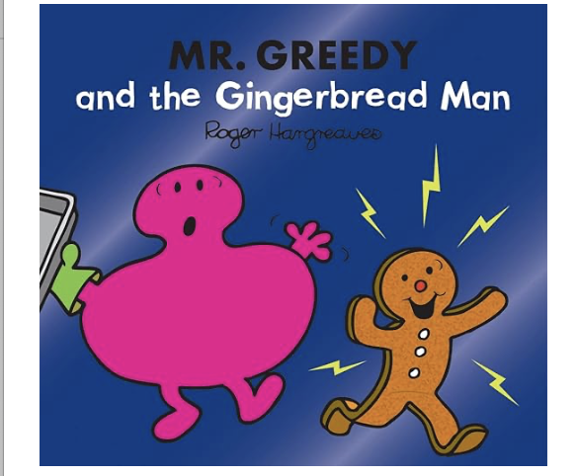 | It's perhaps not so surprising to hear that one day Mr. Greedy was feeling hungry. And also not particularly surprising to hear that he made himself a giant gingerbread man. But before he has the chance to enjoy his snack the gingerbread man is on the run!  Run, run, as fast as you can. You can’t catch me, I’m the gingerbread man!
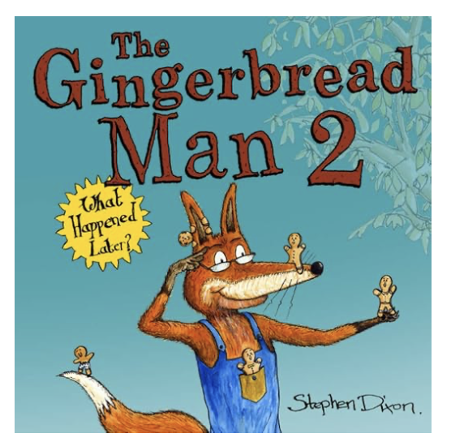 | The Gingerbread Man 2 is a fun, rhyming sequel to the traditional folk tale, in a wonderfully illustrated and kind-hearted follow-up to the dramatic ending of the original story.  This story follows the fox on his journey back to the bakery with his newfound desire to bake. Find out what happens when he makes an oven full of little Gingerbread Men, and whether a happier ending is in store!

Stories about Little Red Riding Hood
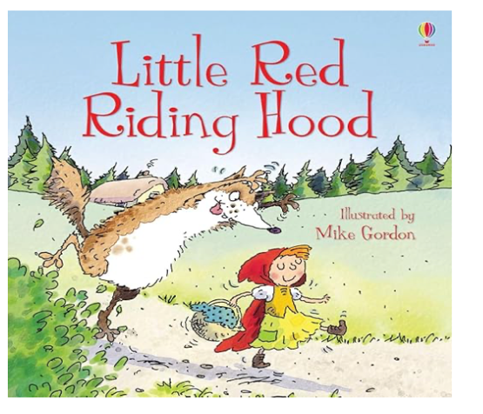 | Oh Granny, what big ears you have! says Little Red Riding Hood. "All the better to hear you with." snaps back the wolf. Enjoy finding out how Little Red Riding Hood outwits the wolf, in this quirky retelling of the classic fairy tale.
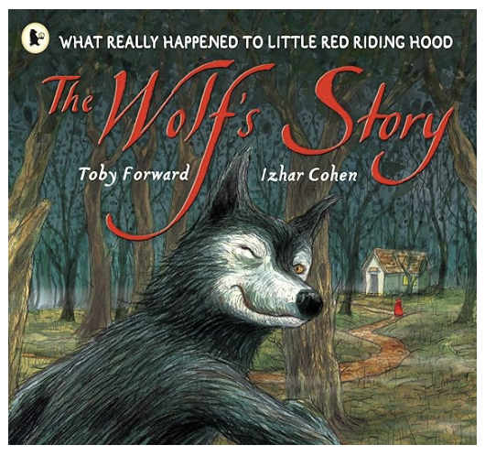 | Recounted in the confidential, conversational voice of a New York wheeler-dealer, this funny version of the Grimm Brothers' Little Red Riding Hood is retold from a fresh perspective – the Wolf's! Full of humorous revelations and surprises, the story shows, as it unfolds, how a series of misunderstandings and accidents leads to his vilification.
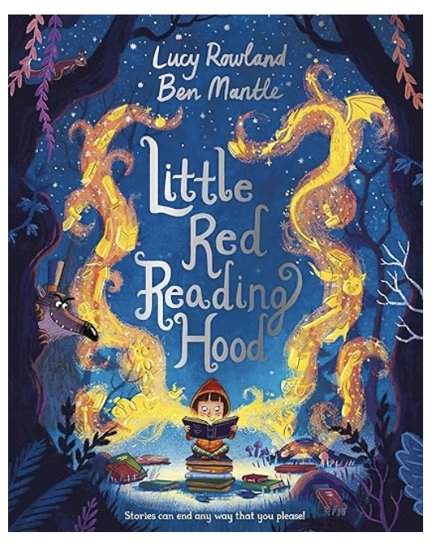 | Little Red Reading Hood loves reading books and making up stories of her own. When she meets a cunning wolf while on her way to the library, he convinces her to stray from the path and read for a little while. But hasn’t she read this in a story before? Perhaps it’s time she came up with a new ending . . .
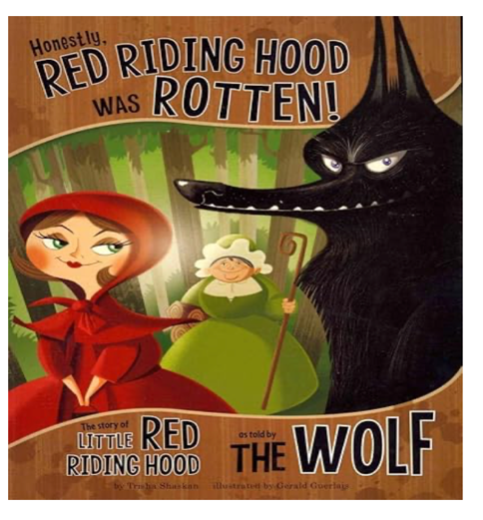 | OF COURSE you think I did a horrible thing by eating Little Red Riding Hood and her granny. You don't know the other side of the story. Well, let me tell you...

Stories From Around The World
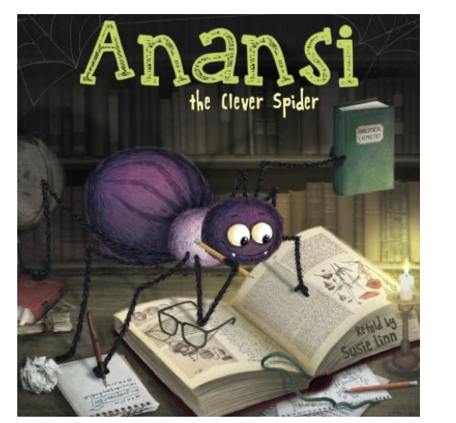 | Anansi the spider was very clever and very wise, but he wanted to be cleverer and wiser still! Discover his cunning plan in this new story based on West African and Caribbean folklore.  In this re-telling of one of the legendary Anansi tales, our clever spider hero is determined to become even cleverer and even wiser . . . with consequences for everyone in the world!
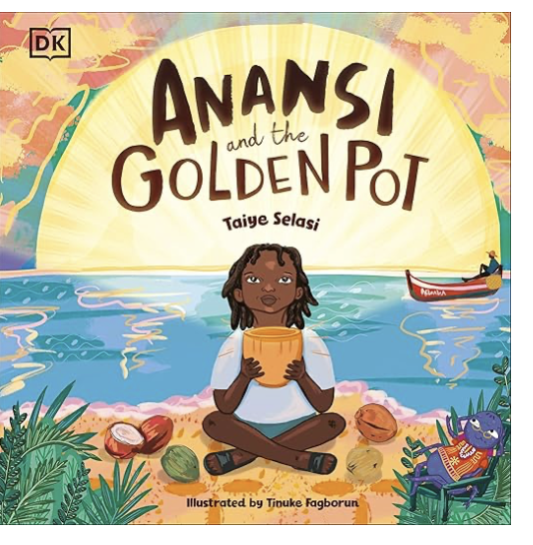 | Kweku has grown up hearing stories about the mischievous spider Anansi. He is given the nickname Anansi by his father because of his similarly cheeky ways. On a holiday to visit his beloved Grandma in Ghana, Anansi the spider and Anansi the boy meet, and discover a magical pot that can be filled with whatever they want. Anansi fills it again and again with his favourite red-red stew, and eats so much that he feels sick. Will he learn to share this wonderful gift?
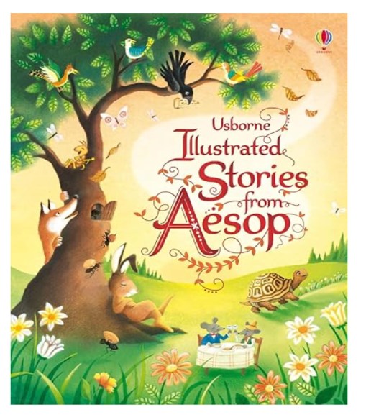 | Each of these timeless stories conveys a message about how to behave towards others. Stories include The Fox and the Crow, The Hare and the Tortoise, The Boy who cried Wolf and The Goose that Laid the Golden Eggs.
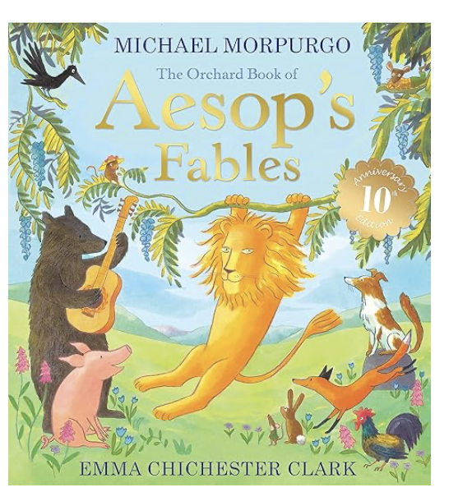 | A timeless collection of over twenty of Aesop's best-loved fables, including favourites such as The Hare and the Tortoise, Town Mouse and Country Mouse, Dog in the Manger and The Lion and the Mouse. The tales are retold with warmth and humour by former Children's Laureate Michael Morpurgo.

