Summer Term Recommended Reads
Stories about Kings and Queens
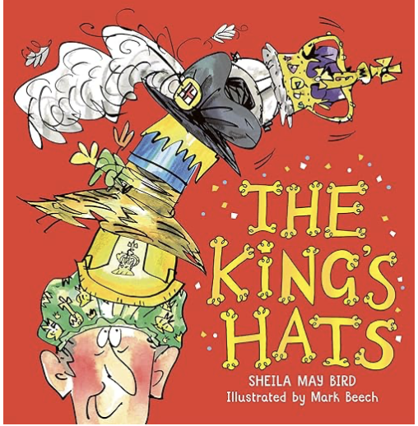 | King Charles the III is now King of the United Kingdom and the Commonwealth and he is finding his new crown just a little heavy to manage. But his good friend Tom the gardener is on hand to show him that kings must wear all sorts of hats and that he must be brave and allow himself to be the king he was born to be.
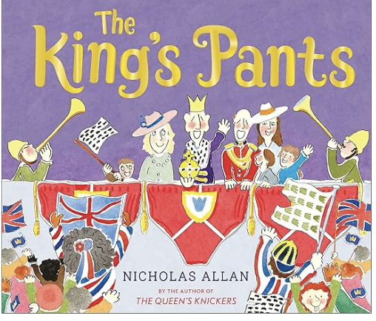 | The King cannot rule without his Royal Pants. He has a pair for every occasion: coronation pants (he can't be crowned without them), organic pants (edible in royal emergencies) and even inflatable space-pants (because one never knows when they might come in handy). But in a boxer-shorts blunder at the Royal Mail, the King's undies have been posted to his subjects nationwide! With his Y-fronts gone wandering, how will the King possibly cope?
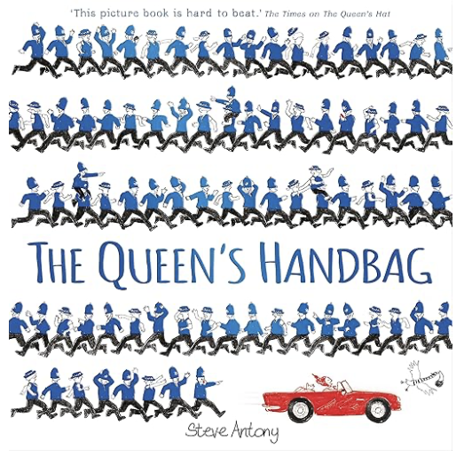 | What does the Queen do when a sneaky swan snatches her handbag? Gives chase, of course. By car, motorbike, plane and more! Hold on to your hats (and handbags) for a whirlwind trip around the British Isles.
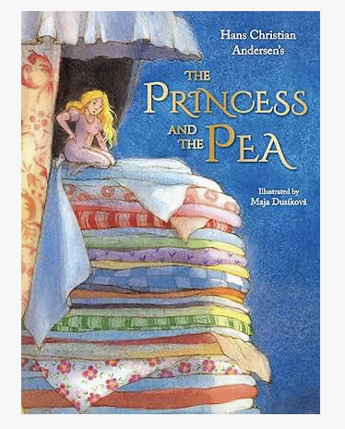 | Once upon a time a prince was looking for a princess to marry, but she would have to be a real princess. One stormy night a young woman knocks on the palace door claiming to be a princess. Putting her to the test, the queen places a single pea underneath a huge pile of mattresses. Is the young woman a real princess after all?

Stories about Cinderella
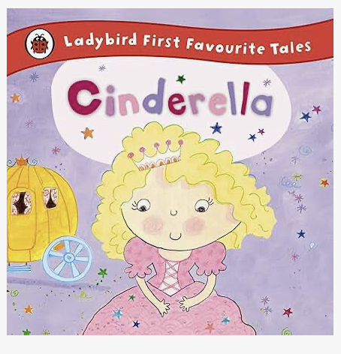 | Find out what happens when Cinderella meets a handsome prince at the ball. This version has lots of funny rhythm and rhyme to help children with their re-reading skills.
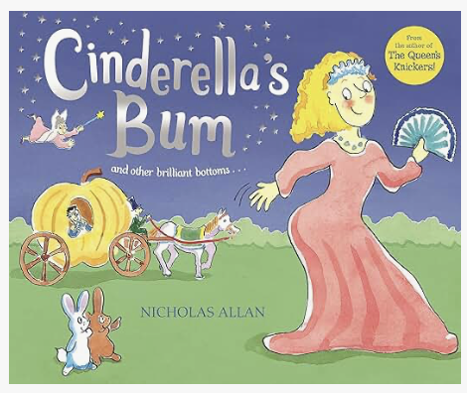 | A big sister is horrified when she can't fit into her swimming costume. Her BOTTOM IS SOO BIG! But her little sister has some good advice. She explains exactly why a big bottom can be useful. Father Christmas needs one for crash landings and, if you are a queen, a big bum is vital to keep you comfy while sitting on your throne . . .
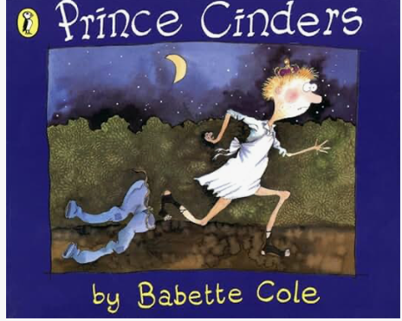 | Prince Cinders leads a very hard life. Bullied by his three hairy brothers about his less-than-perfect looks, he spends all his time cleaning and tidying up after them. One Saturday night Prince Cinders' luck changes as a small, dirty fairy falls down the chimney and promises that his wishes shall come true. Not all the fairy's spells turn out as planned in this twist of a traditional story.
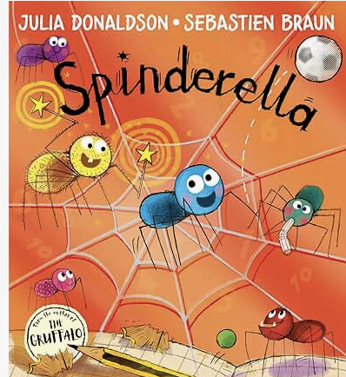 | Spinderella the spider has a passion for football! She tries to play a match with her brothers and sisters but she doesn’t know how many spiders should be on each team. Even worse, she can’t count the goals! Luckily for Spinderella, her Hairy Godmother has a plan…

Non-fiction
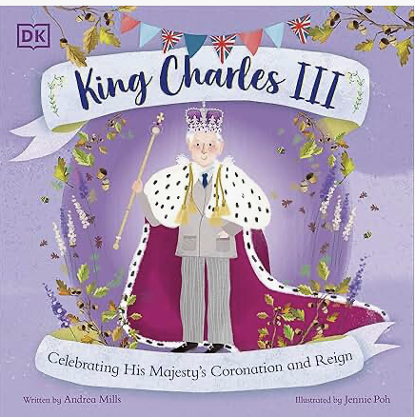 | In honour of King Charles III's coronation, this history book tells the story of a young prince who has been heir to the throne since he was just three years old. But what do we know about our new king? This book traces Charles' life, from his investiture as Prince of Wales and his time in the navy, to his extensive charity work and now his accession to the throne. The book also includes lesser-known information, like before becoming King, Charles was a magician, plus information like what being king actually involves.
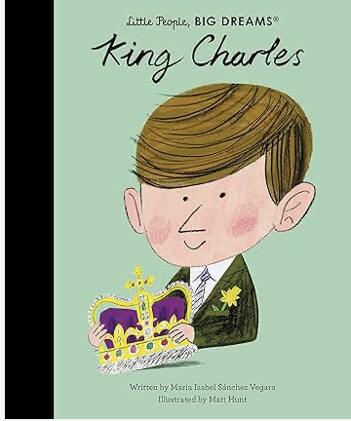 | Little Charles always knew that, one day, he would have a big job to do. As the son of Queen Elizabeth II, he was a prince, and in the future, he was to inherit the throne of the United Kingdom.  As a young man, he developed a passion for one cause: the environment. Charles recognised that plastics and pollutants were causing harm to Earth, and as the Prince of Wales, he spent all his efforts championing climate justice and sustainability.
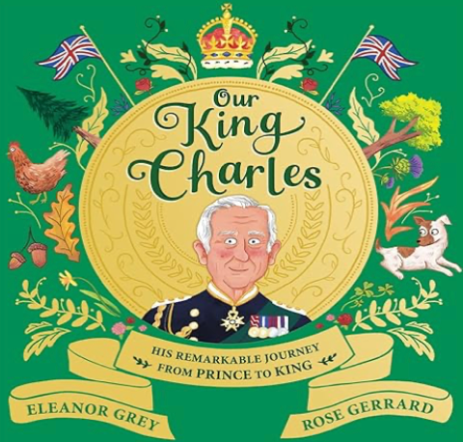 | Did you know the king powers his car with cheese? Or that he was the first royal to have rescue dogs in Buckingham palace? And that he likes to shake hands with trees?  Discover everything there is to know about King Charles III. Readers will learn about Charles' childhood as the first British royal to attend school, his efforts to protect and campaign for the environment and his incredible charity work.  You will also get to meet his beloved chickens, Jack Russells and of course, his very famous family. And discover how everything from money to post boxes get a makeover when a new monarch ascends the throne.

