Summer Term Recommended Reads for Oak Class
Stories by Eva Ibbotson
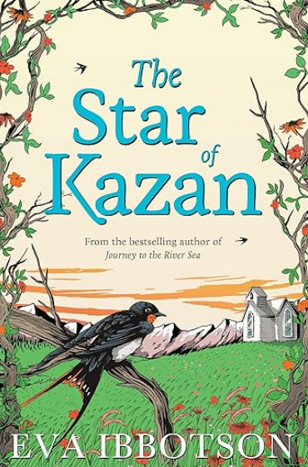 | In 1896, in a pilgrim church in the Alps, an abandoned baby girl is found by a cook and a housemaid. They take her home, and Annika grows up in the servants' quarters of a house belonging to three eccentric Viennese professors. She is happy there, but dreams of the day when her real mother will come to find her.  And sure enough, one day a glamorous stranger arrives at the door. After years of guilt and searching, Annika's mother has come to claim her daughter, who is in fact a Prussian aristocrat whose true home is a great castle. But at crumbling, spooky Spittal, Annika discovers that all is not as it seems in the lives of her new-found family…
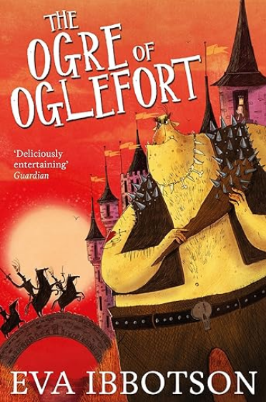 | When a Hag, an orphan boy called Ivo, Ulf the troll and wizard Brian Brainsweller are sent to rescue a princess from an ogre, they briefly consider running away and hiding. Can they be any match for the gruesome, terrifying, ghastly, flesh-eating Ogre of Oglefort? But not all is as it first appears – the Ogre is depressed and the princess doesn't want to be rescued. The Norns, who rule their fates, decide to take things in hand and send a gang of the vilest, most petrifying ghouls to get the job done properly . . .
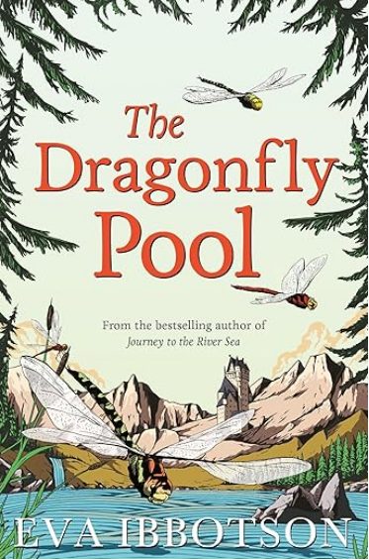 | Tally Hamilton is furious to hear she is being sent from London to a horrid, stuffy boarding school in the countryside. And all because of the stupid war. But Delderton Hall is a far more interesting place than Tally ever imagined, and an exciting school trip to the beautiful and luscious kingdom of Bergania whisks Tally into an unexpected adventure . . . will she be able to save her new friend, Prince Karil, before it's too late?
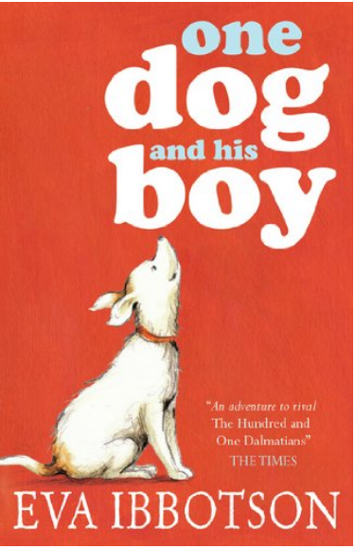 | All Hal has ever wanted is a pet dog, but a dog would damage the expensive carpets in Hal's glamorous home, and his wealthy parents refuse to consider one. Then they discover Easy Pets, a convenient dog-rental agency. Terrier Fleck arrives on Hal's birthday, but when Hal discovers that his dog must be returned, he runs away. Hal and Fleck are joined by a group of pedigree breeds joyfully escaping from Easy Pets. A large reward is offered for the missing boy, and soon Hal and his dogs are being chased across the country by ruthless pursuers. Helped by a travelling circus, and the sympathetic children from an orphanage, they race for their freedom.

Stories about journeys or adventures
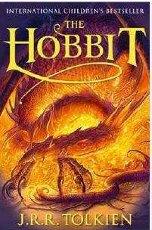 | This is the classic story of Bilbo Baggins - a home-loving hobbit who enjoys a quiet and contented life in his cosy hobbit hole and has no desire to travel afar. But then the wizard Gandalf and a band of dwarves arrive unexpectedly and enlist his services, and soon Bilbo finds himself part of an extraordinary expedition to raid the treasure-hoard of Smaug the Dragon - and on the way becomes the possessor of a very unusual ring.
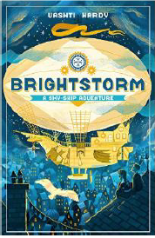 | Twins Arthur and Maudie Brightstorm receive word in Lontown that their famous explorer father has died in a failed attempt to reach the southernmost point in the world. Not only that, but he has been accused of stealing fuel before he died! The twins don't believe the news, and they answer an ad to join a new attempt to reach South Polaris. It's their only hope of learning the truth ... and salvaging their family's reputation.
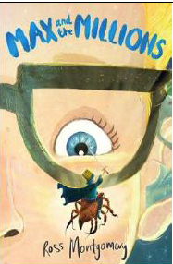 | Max is used to spending time alone - it's difficult to make friends in a big, chaotic school when you're deaf. He prefers to give his attention to the little things in life... like making awesome, detailed replica models. Then Mr Darrow, the school caretaker and fellow modeller, goes missing. Max must follow his parting instruction: 'Go to my room. You'll know what to do.'  There on the floor he finds a pile of sand ... and in the sand is Mr Darrow's latest creation... a tiny boy, no bigger than a raisin, Luke, Prince of the Blues. And behind the tiny boy... millions of others - a thriving, bustling, sprawling civilization!
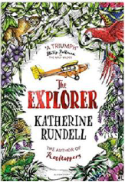 | From his seat in the tiny aeroplane, Fred watches as the mysteries of the Amazon jungle pass by below him. He has always dreamed of becoming an explorer, of making history and of reading his name amongst the lists of great discoveries. If only he could land and look about him. As the plane crashes into the canopy, Fred is suddenly left without a choice. He and the three other children may be alive, but the jungle is a vast, untamed place. With no hope of rescue, the chance of getting home feels impossibly small.
Non-fiction
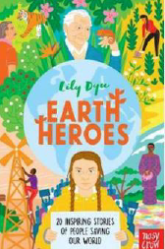 | When faced with climate change, the biggest threat that our planet has ever confronted, it's easy to feel as if there is nothing you can do. Luckily, Lily Dyu's Earth Heroes is here to tell us different. From the introduction to the conclusion, and the profiles of 20 "earth heroes" in between, this book fizzes with energy and a call to arms that every child (and adult) truly can fight to make a difference, no matter how small the act. The 20 inspirational people profiled range from the obvious (Sir David Attenborough) and well known (Stella McCartney) to people like young William Kamkwamba, who built windmills in Malawi to give energy to his village and more.
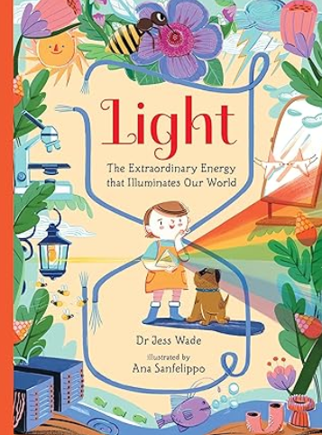 | This exciting non-fiction picture book introduces young readers to the spectacular science of light.  Light is the extraordinary energy that illuminates our world. It is essential for life on Earth – it powers plants, keeps us warm and helps us to see. From the award-winning author of Nano, comes a fascinating narrative introduction to science of light – and the cutting-edge ways we use its energy to build a better world.  With words by Dr Jess Wade – a highly skilled physicist and trailblazing campaigner for diversity in STEM fields – and beautiful, dynamic pictures by award-winning artist Ana Sanfelippo, this is the perfect book for budding young scientists and engineers.
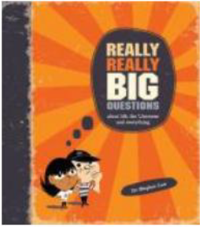 | 100 Really Really Big Questions is an unusual and fun introduction to philosophy that explores life's important but often unanswered questions. Readers will be able to explore the history of thought and the great thinkers and learn how to think rationally for themselves. Mind-teasers, optical illusions and thought experiments make this philosophic journey unforgettably fun.

