Summer Term Recommended Reads for Oak Class
Stories by Eva Ibbotson
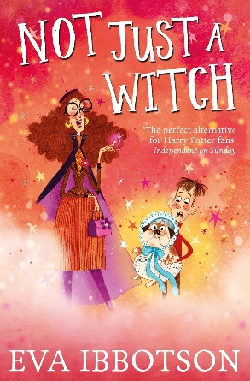 | I want you to change the next wicked person you see into a tiger,' demanded Lionel. 'A very large tiger.'  Heckie is not just a witch – she's an animal witch, who wants to make the world a better place by transforming evil people into harmless animals, using her incredible Toe of Transformation and her awesome Knuckle of Power. But when slimy Lionel Knapsack charms Heckie, her magic begins to take a darker direction. Her friends, including a cheese wizard and a boy called Daniel, must come to the rescue . . .
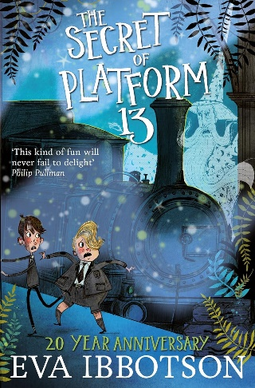 | Under Platform 13 at King's Cross Station there is a secret door that leads to a magical island . . .  It appears only once every nine years. And when it opens, four mysterious figures step into the streets of London. A wizard, an ogre, a fey and a young hag have come to find the prince of their kingdom, stolen as a baby nine years before.  But the prince has become a horrible rich boy called Raymond Trottle, who doesn't understand magic and is determined not to be rescued.
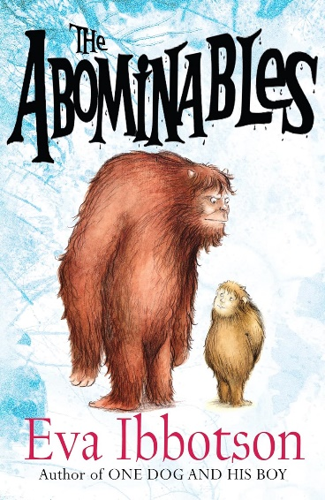 | A hundred years ago, in the Himalayan peaks of Nanvi Dar, the daughter of an English earl is kidnapped by a huge hairy monster. In a secret valley Agatha Farlingham is introduced to a family of motherless yetis and devotes her life to their upbringing. She teaches them to speak, tells them stories and insists on polite manners. When a boy and his sister stumble upon her hidden valley, she knows she has found the courageous people who will carry out her plan. The excited yetis are smuggled into the bridal suite at the hotel. A freezer lorry is waiting to put them into semi-hibernation on the long trip home. But the baby yak that has fallen in love with the youngest yeti foils the refrigeration plan and they set off on a hugely entertaining road trip half way across the world.
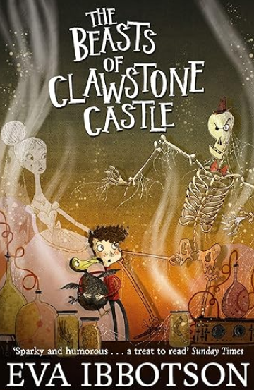 | 'We need proper ghosts,' said Ned, 'really scary ones with heads that come off and daggers in their chests!'  When Madlyn and her younger brother Rollo arrive at crumbling Clawstone Castle, they can see that emergency action is needed before Clawstone falls down completely. With the help of a team of homeless, scary ghosts –including a one-eyed skeleton and Brenda the Bloodstained Bride – they hatch a spooky plan to get the money rolling in. But with a sinister scientist on the loose, money might not be enough to save the mysterious beasts of Clawstone Castle …

Stories about journeys or adventures
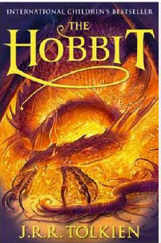 | This is the classic story of Bilbo Baggins - a home-loving hobbit who enjoys a quiet and contented life in his cosy hobbit hole and has no desire to travel afar. But then the wizard Gandalf and a band of dwarves arrive unexpectedly and enlist his services, and soon Bilbo finds himself part of an extraordinary expedition to raid the treasure-hoard of Smaug the Dragon - and on the way becomes the possessor of a very unusual ring.
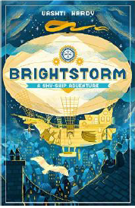 | Twins Arthur and Maudie Brightstorm receive word in Lontown that their famous explorer father has died in a failed attempt to reach the southernmost point in the world. Not only that, but he has been accused of stealing fuel before he died! The twins don't believe the news, and they answer an ad to join a new attempt to reach South Polaris. It's their only hope of learning the truth ... and salvaging their family's reputation.
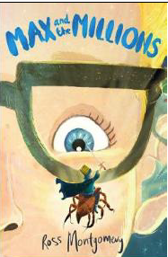 | Max is used to spending time alone - it's difficult to make friends in a big, chaotic school when you're deaf. He prefers to give his attention to the little things in life... like making awesome, detailed replica models. Then Mr Darrow, the school caretaker and fellow modeller, goes missing. Max must follow his parting instruction: 'Go to my room. You'll know what to do.'  There on the floor he finds a pile of sand ... and in the sand is Mr Darrow's latest creation... a tiny boy, no bigger than a raisin, Luke, Prince of the Blues. And behind the tiny boy... millions of others - a thriving, bustling, sprawling civilization!
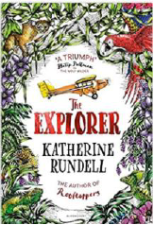 | From his seat in the tiny aeroplane, Fred watches as the mysteries of the Amazon jungle pass by below him. He has always dreamed of becoming an explorer, of making history and of reading his name amongst the lists of great discoveries. If only he could land and look about him. As the plane crashes into the canopy, Fred is suddenly left without a choice. He and the three other children may be alive, but the jungle is a vast, untamed place. With no hope of rescue, the chance of getting home feels impossibly small.
Non-fiction
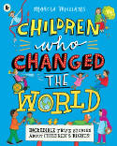 | Celebrate the 30th anniversary of the Rights of the Child and the amazing children who have stood up for them all over the world.  From the heroes familiar to everyone, such as Malala Yousafzai, to the amazing activists you might not have heard of, like Baruani Ndume, the teenager who gave a voice to fellow refugee children in Tanzania, discover the incredible true stories of child activists.  An inspirational and moving book from beloved author-illustrator Marcia Williams, providing the perfect introduction to an important subject and marking 30 years since the Convention on the Rights of the Child was signed by the United Nations General Assembly.
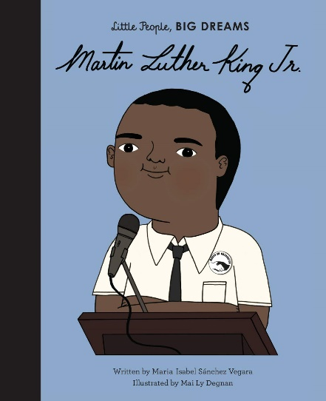 | In this book from the critically acclaimed, multimillion-copy bestselling Little People, BIG DREAMS series, discover the life of Martin Luther King Jr., the inspiring minister and civil rights activist.  Little Martin grew up in a family of preachers: his dad was a preacher, his uncle was a preacher, his grandfather was a preacher… so maybe he’d become a great preacher too. One day, a friend invited him to play at his house. Martin was shocked when his mother wouldn’t let him in because he was black. That day he realized there was something terribly unfair going on. Martin believed that no one should remain silent and accept something if it's wrong. And he promised himself that – when he grew up – he’d fight injustice with the most powerful weapon of all: words. This moving book features stylish and quirky illustrations and extra facts at the back, including a biographical timeline with historical photos and a detailed profile of the inspiring activist’s life.
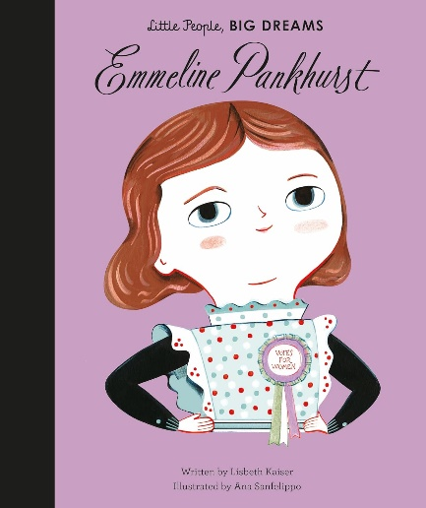 | In this international bestseller from the critically acclaimed Little People, BIG DREAMS series, meet Emmeline Pankhurst, an inspiring women's rights activist who changed the world for future generations of women.  As a child, Emmeline Pankhurst was inspired by books about heroes who fought for others. She dedicated her life to fighting for women's voting rights and, with hard work and great bravery, led a remarkable movement that changed the world. This moving book features stylish and quirky illustrations and extra facts at the back, including a biographical timeline with historical photos and a detailed profile of the activist's life.

