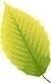

Beech Class
Summer Term 2 Homework
Science    Draw the solar system and label the planets. Can you discover 10 interesting facts that you would like to share about space? | History    Do you think we should only go to school for 3 days a week? Try and convince people to listen to your point of view by giving them reasons that you are right.  Let’s see how convincing you can be! | Art  Draw your own name in the style of a graffiti artist. How can you use colours and shading to make it look effective?
English  Write a letter to Mowgli and tell him what it is like living in a town or village compared to the jungle. | English  Write a story in which a baby grows up in an unusual setting. Maybe it grows up on a different planet, or lives with penguins in the South Pole, or is looked after by meerkats in the Kalahari Desert. What is the problem that needs to be resolved? Don’t forget to describe the setting! | English  What could Mowgli say to the wolves to convince them to let him stay in the pack?  Write about him talking to the wolves using speech.
Maths  Think about everyone in our class. How many children are there? What would be a half of that number? What would be a quarter of that number? What would be a third?  Show your working out | Maths  Create a poster showing your 2 times tables, 5 times tables, 10 times tables and 3 times tables.  Which numbers can you spot more than once? | Maths  Can you find any spare change in your house?  Draw around the coins and label them.  Add up how much you have altogether.

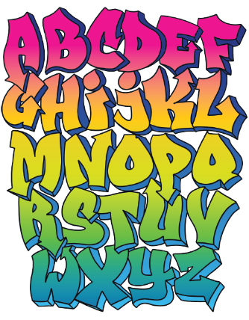
Compulsory Weekly Homework
All children should be reading at least 3 times a week.  This can be your school reading book, library books or books from home.  Please record this in the reading record.  To ensure fluency, the school reading book will be changed after it has been read twice over 2 days at home. | Children have spellings linked to their Phonics learning.  They should practise these at home and our spelling test day will be Thursday.

