Reading Rockets  Read at least 3 times a week for 10 minutes each time. Parents should sign to record that this has been completed in the reading diary.  Your reading book and diary should be in school every day. | Times tables  Practice two times tables weekly. It can be any of your tables from 2 to 12!  Start by saying your times tables in full.  Then write your times table out in full.  Ask an adult to give you written questions out of sequence, one at a time, from your chosen times table. Can you write the answer in 10 seconds? | Spellings  Practice the spellings in your spelling book.  Bring your spelling book back to school on Friday when you will have your spelling test.  New spellings will be added into your book on Friday. You will either get a new list if you get all your spellings correct or more time to practice the original list. You will need to get 8/10 to move on to your new spelling.
Science  We will be learning about the water cycle. Make a poster to show your knowledge.  Can you use the words: Evaporation, condensation, precipitation  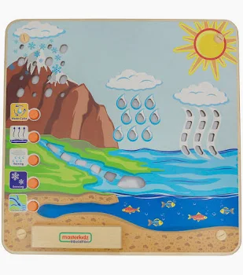 | Science  Which states of matter can you find at home?  Draw pictures of some solids, liquids and gases you can spot at home. Can you make any of the objects change state by warming or cooling? (Make sure you have a parent’s permission!)  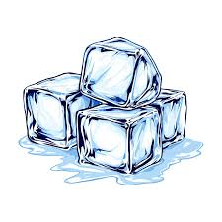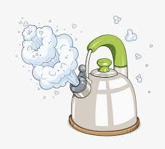 | History  We will be learning about the Stuarts, including the Gunpowder Plot. Write a letter as if you were Guy Fawkes planning the Gunpowder Plot with your friends.  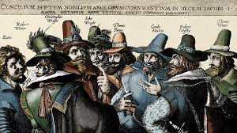
Art  We will be learning about Byzantine monuments, specifically mosaics. Can you create your own mosaic picture?  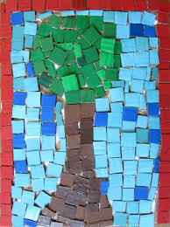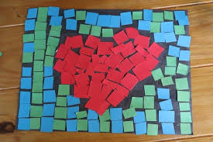 | Geography  Create a fact file about either London, Canterbury, Dover or Brighton. Which landmarks are located there? Which rivers run through them?  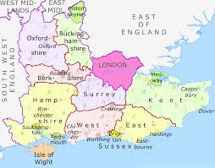 | Maths  Weigh some different objects in your house. Can you find something to weigh in grams? Can you find some things that weigh more than 1Kg? More than 10Kg?  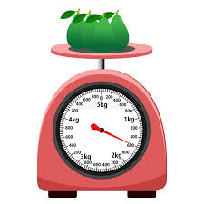
R.E.  Draw a story map or a comic strip to show the creation story.  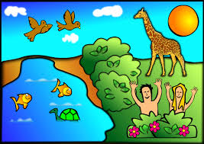 | English  Research Michael Morpurgo. Then make a fact file to show his achievements and any important information you have found out.   | Reading  Complete a book review. It could be your favourite book, the book you are currently reading or a book you know your friends will love. Can you write a summary without giving away the plot? Why should your friends read this book?

Activities marked with a star must be completed at least 3 times a week. Children are expected to complete 6 tasks from all other challenges (Art, Geography, History and Science) during this half term. Children should return their completed homework task, in their homework books, every Thursday. Books will be marked and returned on Friday.

