
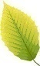
Beech Class
Summer Term 1 Homework
Science  Design a new home for Mowgli in the jungle. What will it look like? What materials would you use to make it? Remember, the jungle is hot and wet, which materials would be best in those conditions?  Which materials would help make sure Mowgli is safe from the predators in the jungle?  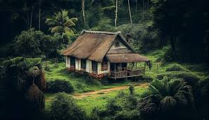 | Geography  Create a fact file about one of the countries in Northern Europe. What does their flag look like? What languages are spoken there? What are the most popular foods? Do they have any interesting buildings or natural features?  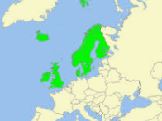 | Art  Choose your favourite story. Can you create a picture that tells the story in one freeze frame?  Try using different materials other than pens or pencils.  Can you create a picture using objects from nature? Can you create a picture using different types of paper from magazines, leaflets or junk mail?  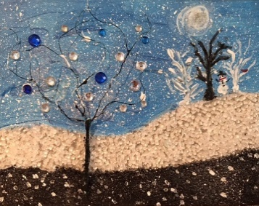
English  Choose an animal. Write a description without saying what it is. Let’s see if your description is detailed enough for a reader to guess your chosen animal. | English  Think of your favourite place. It might be somewhere you went on holiday, a place in your local area, or your back garden!  Describe your setting using adjectives and lots of detail so that a reader is able to picture it clearly. | English  Imagine you wake up in the morning and discover you are in the jungle.  Write a story about what might happen and how you would find a way home.
Maths  Make a list of objects around your house that you would need to measure in metres.  Make a list of objects you would need to weigh in grams. | Maths  https://mathszone.co.uk/category/measuring/  Practise your measuring skills by playing maths games that test your ability to read scales, solve problems and add amounts. | 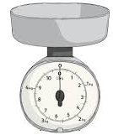  Maths  Help your adults in the kitchen by weighing ingredients for a recipe. Use scales to accurately measure out amounts in either grams or kilograms.

Compulsory Weekly Homework
All children should be reading at least 3 times a week.  This can be your school reading book, library books or books from home.  Please record this in the reading record.  To ensure fluency, the school reading book will be changed after it has been read twice over 2 days at home. | Children have spellings linked to their Phonics learning.  They should practise these at home and our spelling test day will be Thursday.

