Reading Rockets  Read at least 3 times a week for 10 minutes each time. Parents should sign to record that this has been completed in the reading diary.  Your reading book and diary should be in school every day. | Times tables  Practice two times tables weekly. It can be any of your tables from 2 to 12!  Start by saying your times tables in full.  Then write your times table out in full.  Ask an adult to give you written questions, one at a time, from your chosen times table. Make sure they ask you questions out of sequence! Can you write the answer in 10 seconds? | Spellings  Practice the spellings in your spelling book.  Bring your spelling book back to school on Thursday when you will have your spelling test.  New spellings will be added into your book on Friday. You will either get a new list if you get all your spellings correct or more time to practice the original list. You will need to get 8/10 to move on to your new spelling.
Science  We will be learning about food chains. Draw a food chain with at least 4 animals in it. Make sure you label it correctly with the energy transfer. | Science  We have been learning about how to protect our local area. Make a poster to show some of the ways we can help to protect the local habitats and reduce pollution. | Science  Draw an animal and it’s habitat. Write a paragraph to describe what you have drawn and how the animal is adapted to it’s habitat.
Art  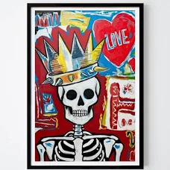  Make a picture in the style of Basquiat.  Draw a cartoon-like picture about something which is important to you. The picture should use a variety of symbols to illustrate the subject which the drawing is about. It could also include some writing. | Art  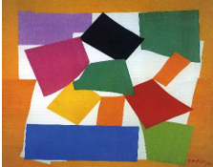  Matisse created art by cutting out different types of paper. Can you create a picture by cutting shapes from magazines, newspapers and old packaging? | Maths  How many factor pairs can you find for:  36  48  54  Can you explain what a factor pair is?  Practice counting in 4s, 6s and 8s as you walk up and down the stairs at home.
R.E.  Find out about Humanism. What are their beliefs? What influences their world view? Make a poster or fact file to show your research. | English  Lila wants to be a firework maker like her dad. Write a job description for the skills she will need to do this job. | PSHE  Citizenship  Create a top trumps card about yourself. What are your strengths? What do you find more difficult? What skills would you like to develop? Remember to include a self-portrait.

Activities marked with a star must be completed at least 3 times a week. Children are expected to complete 6 tasks from all other challenges (Art, Geography, History and Science) during this half term. Children should return their completed homework task, in their homework books, every Thursday. Books will be marked and returned on Friday.

