Spring Term Recommended Reads for Oak Class
Fantasy stories similar to The Lion, The Witch and The Wardrobe
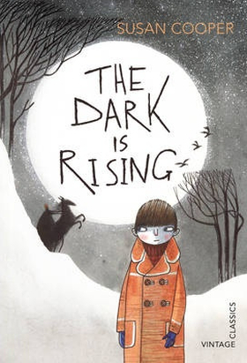 | It is Midwinter's Eve, the night before Will's eleventh birthday. But there is an atmosphere of fear in the familiar countryside around him. Will is about to make a shocking discovery - that he is the last person to be born with the power of the Old Ones, and as a guardian of the Light he must begin a dangerous journey to vanquish the terrifyingly evil magic of the Dark.  This is probably one of the greatest fantasy sequences ever written. Darkly magical and intense Cooper weaves her storytelling wonder over fully realised characters and worlds, drawing in the reader and leading them on a journey that will leave them clambering for the rest of the series.
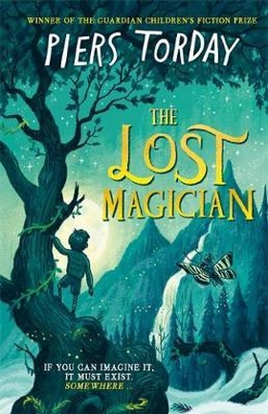 | It’s the end of the Second World War and Simon, Patricia, Evelyn and Larry have been sent away from London while their mum and dad cope with the aftermath of their house being bombed. In Salisbury, Dr Diana Kelly picks them up in her big car and whisks the children off to her huge house where they’re pretty much left alone to explore its many rooms – even the ones that are out of bounds.  When Larry wanders into the strange, fairytale character-populated world of Folio and the Land of the Reads, he rushes to tell the others, who don’t believe him. But when Evie finds her way in too, it seems as though there might be something to Larry’s claims. Yet Evie has found the City of the Unreads, a world of facts and not stories, and the two sides are at war.  This beautiful homage to Narnia sees renowned children’s writer Torday explore what it is to be a reader and the power of books and libraries, as well as the imagination. Fantastical but with real heart, this immersive story is sure to become a firm favourite.
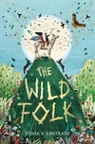 | Tin and Comfrey both live on the mystical island of Farallone but have very different lives: Tin’s from the City, a walled-in industrial zone that prizes machinery and the precious stone stargold above all else, while Comfrey’s from the Country, living in harmony with nature.  But the City’s stargold is running out. Desperate to find more, its leaders start searching beyond the City walls, and they’ll destroy everything in their way, including the countryside and the reclusive Wild Folk, to get what they want.  Magic and mythology and fantastic world-building combine in this breathtaking adventure story. Brought together by two talking hares, Comfrey and Tin embark on an epic quest to find the mythical Elk of Milk and Gold, the only being who can save Farallone from the City.
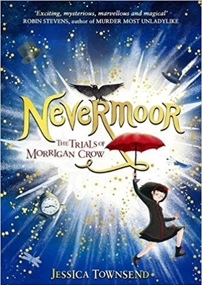 | Born on Eventide, Morrigan Crow is a 'cursed child', blamed for every misfortune and destined to die on her eleventh birthday. But just before midnight strikes, the mysterious Jupiter North appears, offering Morrigan another choice: journey with him to Nevermore. In this magical world, she moves into Jupiter's awesome, ever-changing hotel and enters the trials for membership of the Wundrous Society, which promises friendship, family and an escape from her fate. But the four trials are anything but simple – especially the last one, which requires a special ability Morrigan is sure she doesn't have...  This fabulous new fantasy introduces a vivid and varied magical world, a heroine to truly champion, and a host of characters to become best friends with. Essences of Harry Potter and Lemony Snicket infuse the writing, but this is a story that stands on its own two feet, perfectly balancing the light and dark. Across a year, Morrigan rides a rollercoaster adventure discovering 'wundrous' new things, but underlying it lies the shadowy mystery of the feared and revered Wundersmith. Who exactly is he?

Stories about journeys or adventures
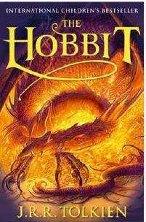 | This is the classic story of Bilbo Baggins - a home-loving hobbit who enjoys a quiet and contented life in his cosy hobbit hole and has no desire to travel afar. But then the wizard Gandalf and a band of dwarves arrive unexpectedly and enlist his services, and soon Bilbo finds himself part of an extraordinary expedition to raid the treasure-hoard of Smaug the Dragon - and on the way becomes the possessor of a very unusual ring.
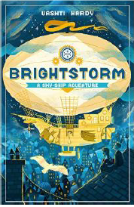 | Twins Arthur and Maudie Brightstorm receive word in Lontown that their famous explorer father has died in a failed attempt to reach the southernmost point in the world. Not only that, but he has been accused of stealing fuel before he died! The twins don't believe the news, and they answer an ad to join a new attempt to reach South Polaris. It's their only hope of learning the truth ... and salvaging their family's reputation.
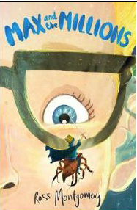 | Max is used to spending time alone - it's difficult to make friends in a big, chaotic school when you're deaf. He prefers to give his attention to the little things in life... like making awesome, detailed replica models. Then Mr Darrow, the school caretaker and fellow modeller, goes missing. Max must follow his parting instruction: 'Go to my room. You'll know what to do.'  There on the floor he finds a pile of sand ... and in the sand is Mr Darrow's latest creation... a tiny boy, no bigger than a raisin, Luke, Prince of the Blues. And behind the tiny boy... millions of others - a thriving, bustling, sprawling civilization!
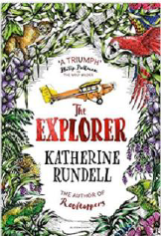 | From his seat in the tiny aeroplane, Fred watches as the mysteries of the Amazon jungle pass by below him. He has always dreamed of becoming an explorer, of making history and of reading his name amongst the lists of great discoveries. If only he could land and look about him. As the plane crashes into the canopy, Fred is suddenly left without a choice. He and the three other children may be alive, but the jungle is a vast, untamed place. With no hope of rescue, the chance of getting home feels impossibly small.

Non-fiction
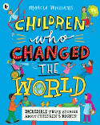 | Celebrate the 30th anniversary of the Rights of the Child and the amazing children who have stood up for them all over the world.  From the heroes familiar to everyone, such as Malala Yousafzai, to the amazing activists you might not have heard of, like Baruani Ndume, the teenager who gave a voice to fellow refugee children in Tanzania, discover the incredible true stories of child activists.  An inspirational and moving book from beloved author-illustrator Marcia Williams, providing the perfect introduction to an important subject and marking 30 years since the Convention on the Rights of the Child was signed by the United Nations General Assembly.
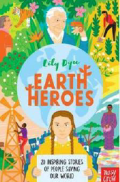 | When faced with climate change, the biggest threat that our planet has ever confronted, it's easy to feel as if there is nothing you can do. Luckily, Lily Dyu's Earth Heroes is here to tell us different. From the introduction to the conclusion, and the profiles of 20 "earth heroes" in between, this book fizzes with energy and a call to arms that every child (and adult) truly can fight to make a difference, no matter how small the act. The 20 inspirational people profiled range from the obvious (Sir David Attenborough) and well known (Stella McCartney) to people like young William Kamkwamba, who built windmills in Malawi to give energy to his village and more.
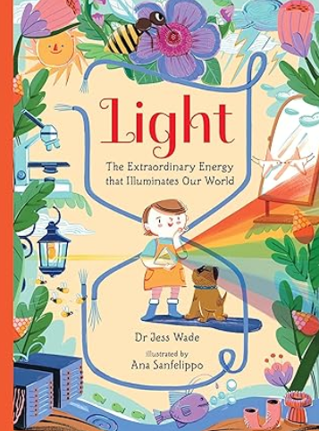 | This exciting non-fiction picture book introduces young readers to the spectacular science of light.  Light is the extraordinary energy that illuminates our world. It is essential for life on Earth – it powers plants, keeps us warm and helps us to see. From the award-winning author of Nano, comes a fascinating narrative introduction to science of light – and the cutting-edge ways we use its energy to build a better world.  With words by Dr Jess Wade – a highly skilled physicist and trailblazing campaigner for diversity in STEM fields – and beautiful, dynamic pictures by award-winning artist Ana Sanfelippo, this is the perfect book for budding young scientists and engineers.
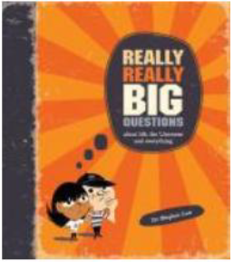 | 100 Really Really Big Questions is an unusual and fun introduction to philosophy that explores life's important but often unanswered questions. Readers will be able to explore the history of thought and the great thinkers and learn how to think rationally for themselves. Mind-teasers, optical illusions and thought experiments make this philosophic journey unforgettably fun.

