Spring Term Recommended Reads for Oak Class
Fantasy stories similar to The Lion, The Witch and The Wardrobe
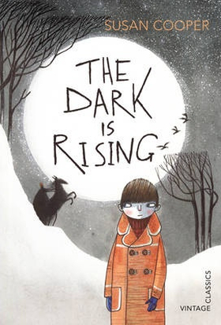 | It is Midwinter's Eve, the night before Will's eleventh birthday. But there is an atmosphere of fear in the familiar countryside around him. Will is about to make a shocking discovery - that he is the last person to be born with the power of the Old Ones, and as a guardian of the Light he must begin a dangerous journey to vanquish the terrifyingly evil magic of the Dark.  This is probably one of the greatest fantasy sequences ever written. Darkly magical and intense Cooper weaves her storytelling wonder over fully realised characters and worlds, drawing in the reader and leading them on a journey that will leave them clambering for the rest of the series.
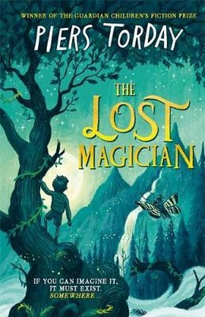 | It’s the end of the Second World War and Simon, Patricia, Evelyn and Larry have been sent away from London while their mum and dad cope with the aftermath of their house being bombed. In Salisbury, Dr Diana Kelly picks them up in her big car and whisks the children off to her huge house where they’re pretty much left alone to explore its many rooms – even the ones that are out of bounds.  When Larry wanders into the strange, fairytale character-populated world of Folio and the Land of the Reads, he rushes to tell the others, who don’t believe him. But when Evie finds her way in too, it seems as though there might be something to Larry’s claims. Yet Evie has found the City of the Unreads, a world of facts and not stories, and the two sides are at war.  This beautiful homage to Narnia sees renowned children’s writer Torday explore what it is to be a reader and the power of books and libraries, as well as the imagination. Fantastical but with real heart, this immersive story is sure to become a firm favourite.
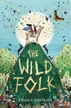 | Tin and Comfrey both live on the mystical island of Farallone but have very different lives: Tin’s from the City, a walled-in industrial zone that prizes machinery and the precious stone stargold above all else, while Comfrey’s from the Country, living in harmony with nature.  But the City’s stargold is running out. Desperate to find more, its leaders start searching beyond the City walls, and they’ll destroy everything in their way, including the countryside and the reclusive Wild Folk, to get what they want.  Magic and mythology and fantastic world-building combine in this breathtaking adventure story. Brought together by two talking hares, Comfrey and Tin embark on an epic quest to find the mythical Elk of Milk and Gold, the only being who can save Farallone from the City.
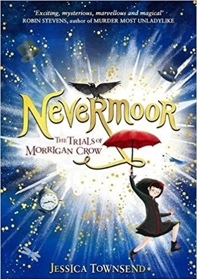 | Born on Eventide, Morrigan Crow is a 'cursed child', blamed for every misfortune and destined to die on her eleventh birthday. But just before midnight strikes, the mysterious Jupiter North appears, offering Morrigan another choice: journey with him to Nevermore. In this magical world, she moves into Jupiter's awesome, ever-changing hotel and enters the trials for membership of the Wundrous Society, which promises friendship, family and an escape from her fate. But the four trials are anything but simple – especially the last one, which requires a special ability Morrigan is sure she doesn't have...  This fabulous new fantasy introduces a vivid and varied magical world, a heroine to truly champion, and a host of characters to become best friends with. Essences of Harry Potter and Lemony Snicket infuse the writing, but this is a story that stands on its own two feet, perfectly balancing the light and dark. Across a year, Morrigan rides a rollercoaster adventure discovering 'wundrous' new things, but underlying it lies the shadowy mystery of the feared and revered Wundersmith. Who exactly is he?

Adventure Stories
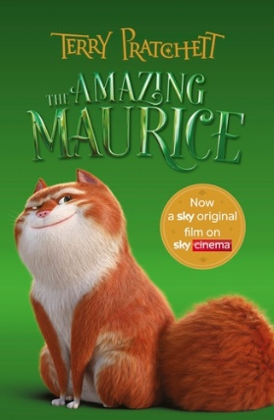 | Terry Pratchett has created a wonderful tail (pardon the pun) about a con artist cat called Maurice and his pack of magical rats. When the rats forage on a wizard’s leftovers they acquire powers never seen before in rodents. They can speak and read and start to make big plans for a comfortable retirement. Maurice is always on the lookout for a get-rich-quick scheme and together with the rats, and young Keith, the ‘piper’, they develop a plan to make big bucks with their very own plague of rats. But things go wrong when they reach the run-down town of Bad Blintz and the educated rodents start to have their own ideas…
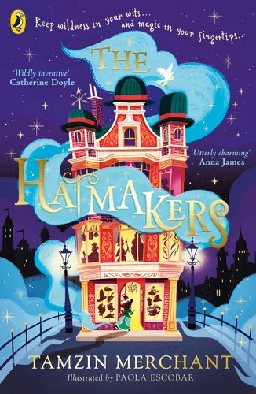 | For fans of books with magic, actor and author Tamzin Merchant's series is ideal. Cordelia’s family have always been milliners and they create all kinds of stunning hats using magical ingredients. Making is a rare and ancient skill and only a few special Maker families remain. But Cordelia’s family is struck by tragedy when her father Prospero and his ship, the Jolly Bonnet, are lost at sea during a mission to collect hat ingredients. Cordelia makes it her mission to find him, but her Uncle Tiberius and Aunt Ariadne have no time to help the little Hatmaker. And when she finds out someone is using Maker magic to start a war, Cordelia has more on her plate than she bargained for!
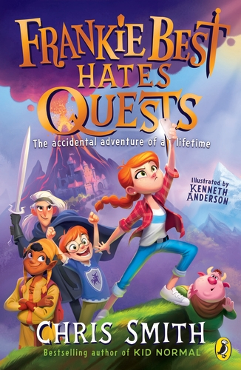 | Frankie Best likes watching YouTube and eating Pot Noodles. She doesn’t like being forced to embark on mega-dangerous quests. Nope, no thank you. But that’s exactly what she must do when what was supposed to be a quiet weekend at her Grandad’s house turns into an epic rescue mission. It’s down to Frankie and her brother Joel to save their Grandad when he is kidnapped by gnoblins (yes, gnoblins!). The pair head off to a magical realm where they encounter crazy creatures, terrifying enemies, and strangest of all – no Wi-Fi!
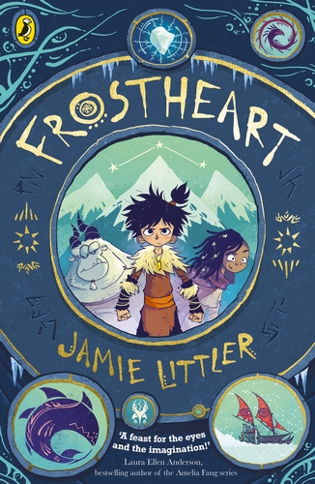 | All aboard the Frostheart for a hilarious and heart-stopping adventure! Young Ash and his yeti guardian Tobu live in the furthest part of the known world, cut off from the rest of humankind by creatures that lurk beneath the Snow Sea. When a group of travellers arrives on his rocky outcrop, he discovers more about his missing parents and realises he has been given the magical power of song weaving. This power sees him whisked aboard the Frostheart sleigh on a journey that will change his life forever.

Non-fiction
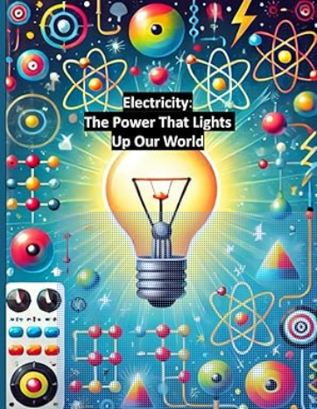 | Embark on an electrifying adventure with "Electricity: The Power That Lights Up Our World," the first book in the "Spark Your Curiosity" series. Designed for kids aged 8-13, this book introduces young readers to the fascinating world of electricity.  Starting with the fundamental question, "What is electricity?", this book takes children on a journey through the history of how electricity was discovered and harnessed. They’ll explore how electricity powers everyday objects, from light bulbs to smartphones, and learn about the different ways it’s used in our daily lives.  But the learning doesn’t stop there! In the final chapter, kids will roll up their sleeves for a hands-on project where they’ll build a simple circuit and see electricity in action. With clear explanations, fun facts, and engaging activities, "Electricity:  The Power That Lights Up Our World" makes learning about electricity fun, easy, and exciting.  By the end of this book, children will not only understand the basics of electricity but also be eager to continue their exploration in the fascinating world of electrical engineering.
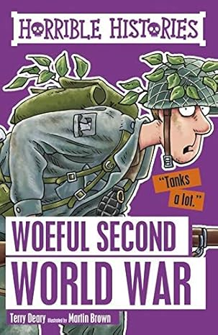 | All the foul facts about the Woeful Second World War are ready to uncover, including:  - why the blitzed Brits ate chicken-fruit, sinkers and nutty;  - what really happened in Dad's Army;  - and how to make a rude noise with a gas mask.  As featured on BBC Bitesize, and refreshed with a fantastic new design, these bestselling titles are sure to be a huge hit with yet another generation of Terry Deary fans.
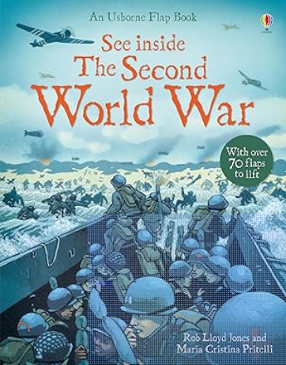 | From tanks rumbling across battlefields to submarines, blitzed cities and D-Day, this extraordinary flap book takes young readers right into the action of the Second World War.  With vivid illustrations and fascinating facts to discover, each flap reveals something new.  Chapters in this book include:  - First strike  - Atlantic terror  - War in the sky  - Blitzed cities  - Firepower  - In the Pacific  - D-Day  - Final months
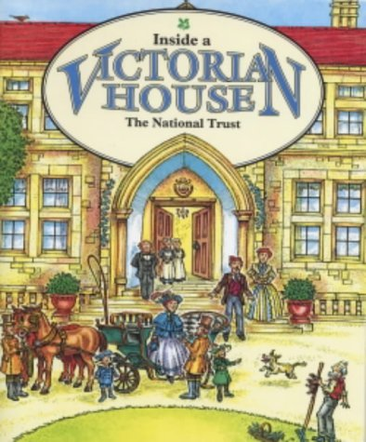 | This is a picture book with explanatory text and captions beside each illustration, taking the reader on a trip round a Victorian house and its estate. Detailed drawings on each page show how the Victorians used to live and what a grand Victorian home would have looked like.

