

Beech Class
Spring Term 1 Homework
Science  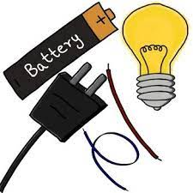  Can you list 10 objects in your house that use electricity?  What rules do you need to follow to make sure you safe when you are using something that is electrical?  Make a poster telling people how to keep safe when using electricity. | Geography  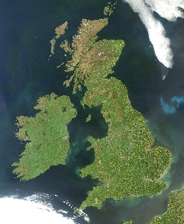  Draw or print out a map of the British Isles. Can you label the countries? Each country has a capital city, can you add them to the map?  As a challenge, draw the flags from the countries in the British Isles and find out at least 1 fact to share with the class. |   Art  Draw portraits of your family. Make sure you look carefully to try and make your portrait look like your subject. What is the colour of their hair and eyes?  Using a mirror and looking very carefully, draw a self-portrait. In the background, draw objects that tell people about you, the things you like, hobbies, etc.
English  Create your own animal character that lives in the woods near Peter Rabbit. Draw a picture and then use adjectives to describe what they are like. | English  Write a letter to Peter Rabbit to try and convince him not to go to Mr McGregor’s garden. Give him some good reasons he should not visit! | English    Write instructions for how to look after a rabbit.
Maths  Year 1: Practise and learn number bonds to 10.  Year 2: Write down and learn all the number bond pairs for any number to 20.  Anyone able to recall all the number bonds will receive 5 dojos | Maths  Play Hit the Button addition to 20 and record your score.  Can you beat it?  https://www.topmarks.co.uk/maths-games/hit-the-button | Maths  Using addition and subtraction, can you write down at least 10 ways to find the number 10?  You can use more than 2 digits.  For example:  20 – 7 – 3 = 10

Compulsory Weekly Homework
All children should be reading at least 3 times a week.  This can be your school reading book, library books or books from home. Please record this in their reading record.  To ensure fluency, the school reading book will be changed after it has been read on two separate occasions at home. | Children have spellings linked to their Phonics learning.  They should practise these at home and our spelling test day will be Thursday.

