Here is a selection of books that you can enjoy with your children to support our new theme ‘Growing and Changing’. These books are great and fun to read with your children.

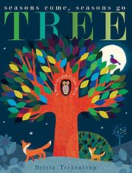
Tree by Britta Teckentrup
This story is about all about the four seasons; Summer, Autumn, Winter and Spring. This book explores how the seasons make the trees change. This book shows how the leaves fall off and how each leaf changes colours throughout the seasons. It is lovely to see all the colour changes.

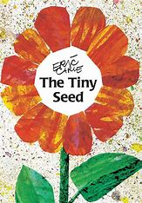
The Tiny Seed by Eric Car
The Tiny Seed is about a seed that is blown away from its parents’ plant. The seed travels across the land and finally falls onto fertile earth. The flower grows into one of the biggest flowers, then the wind blows the flowers seeds which begins their journey to grow into the biggest flowers.

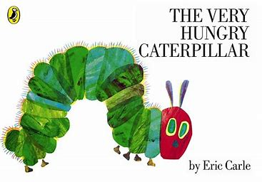
The Very Hungry Caterpillar by Eric Carl
The very hungry caterpillar is a great story to show your children the Life Cycle of a Caterpillar. This book shows how the caterpillar is very hungry and he goes on a journey to find lots of food to eat. Then, he finds himself very full, so he has to go to sleep! The caterpillar makes a cocoon and then hatches into a Butterfly!

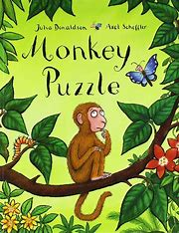
Monkey Puzzle by Julia Donaldson
Monkey Puzzles is a book all about finding different animals within the jungle. One day, the little monkey looses his mother in the jungle. The little monkey goes on a journey to find his mother through the big jungle. On his way, he discovers lots of different jungle animals. What animals can you find with Monkey?

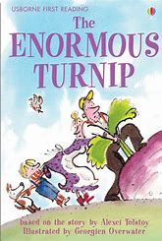
The Enormous Turnip by Aleksey Tolstoy
This book is all about how vegetables grow. One day the farmer planted a turnip seed. As he watered it and the sun shone, the turnip grew. As the days went on, the turnip grew bigger and bigger. The farmer couldn’t get the turnip out, so everyone had to come and help. This book will make you laugh.

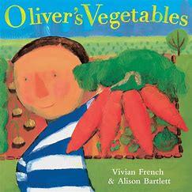
Oliver’s Vegetables by Vivien French
Oliver is on an adventure to like vegetables. Oliver goes to stay with his grandparents and his grandad has planted lots of different vegetables. However, Oliver does not like vegetables. As he explore his Granddad’s Garden, he finds different types of vegetables. They cook the vegetables and Oliver tries these. He loves trying new vegetables now and wants to eat them all!

