**One, Two, Buckle My Shoe** 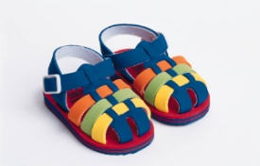

One, two  
Buckle my shoe

Three, four  
Knock at the door

Five, six  
Pick up sticks

Seven, eight  
Lay them straight

Nine, ten  
A big fat hen