**Miss Polly had a dolly** 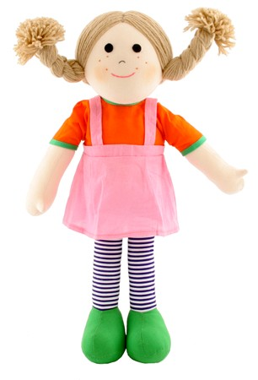

Miss Polly had a dolly  
Who was sick, sick, sick,  
So she called for the doctor  
To be quick, quick, quick;  
The doctor came  
With his bag and his hat,  
And he knocked at the door  
With a rat-a-tat-tat.  
  
He looked at the dolly  
And he shook his head,  
And he said "Miss Polly,  
Put her straight to bed."  
He wrote out a paper  
For a pill, pill, pill,  
"That'll make her better,  
Yes it will, will, will!"