
- Each week, choose one activity from the options below.
- There are more activities than weeks so you do not have to complete all of them; you can decide which ones you do.
- Upload a photo/video of you and your child completing the activity, alongside any comments about what they did and/or said onto Tapestry or take photos/stick work, alongside anything they said in your child’s homework book.
- Please include the activity number so that it is clear which activity you are completing for your homework each week.
- Homework books should be returned to school every Monday and your child will bring these home the same day. Reading packets need to be brought to school every day.
- Please include the activity number so that it is clear which activity you are completing for your homework each week.

Understanding of the World
Activity 1
Blow up some big balloons and create some paper Mache (recipe for paper Mache: How to make paper Mache (papier-mâché) | Good Food). Cover your balloon in paper Mache and let it dry. Once your balloon is dry, use different coloured paints to see if you can recreate one of the planets from our solar system.

Maths
Activity 2
Cut out or make 10 squares. On each of the squares can you write each number from 1 – 10. Can you put these numbers into the correct order. Add some triangles to the top and side and you have made your very own number rocket!

Reading
Activity 3
Gather a big box, a bear, a colander and some boots and join Baby Bear on his space adventure (Whatever Next by Jill Murphy). As you read the story can you join in with the repeated parts of the story.

Maths
Activity 4
Draw one big star on a paper plate – you will need numbers 1 – 10 in total (10 plates in total). Once you have created your star plates, gather a small ball or beanbag and see which number you can throw your ball or beanbag onto. As an additional challenge can you write this number and draw how many stars you need to match the numeral.

Expressive Arts and Design
Activity 5
Use boxes or rolled pieces of paper to create a rocket to take you to the moon.
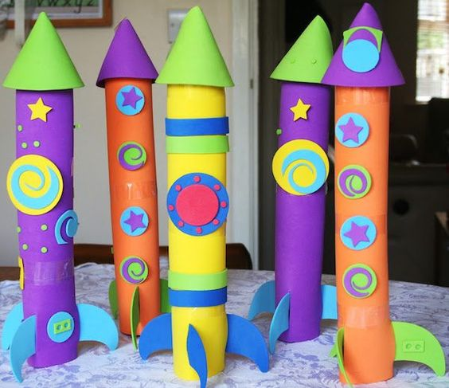

Expressive Arts and Design
Activity 6
Use a long tube or piece of rolled up paper to create a telescope. What can you see through your telescope? Make a list by drawing pictures of what you see and writing the sounds you know. Ask an adult to write any sounds you are unsure of.

Physical Development
Activity 7
Explore the outside environment and become an astronaut. Think about the different ways the astronauts might travel – can you travel in different ways. Can you;
- Crawl, jump, hop, walk in slow motion, walk backwards, take small or big steps.

Communication and Language
Activity 8
Design and create your own astronaut. As you are drawing your astronaut think about what your astronaut might need on their journey to space? Where are they going? What will they see? Use the sounds you know to write your sentences. If you need help ask your grown-ups.

Maths Activities
Borrow a maths challenge bag from us and complete a challenge. There are lots of different bags with activities to support counting, sorting, making patterns, using time and exploring shapes.
Reading Activity
Remember to keep practising your phonics by “saying the sounds and reading the words” in your book for 5-10 minutes every day.

