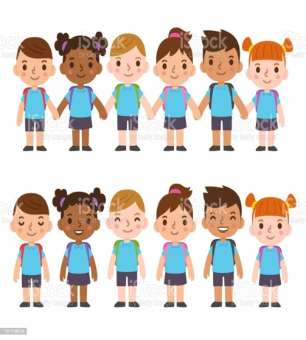
Understanding of the World
Activity 1
Make a map to show how you get from your house to school. Draw all the things you see on your journey and ask your grown up to label them for you.
Expressive Arts and Design
Activity 2
Create a collage of yourself and all of your favourite things. Draw a picture of yourself in the middle and add pictures or drawings of all of the things you like. These can be pictures of your family, your favourite colour or even your favourite toy!

- Each week, choose one activity from the options below.
- There are more activities than weeks so you do not have to complete all of them; you can decide which ones you do.
- Upload a photo/video of you and your child completing the activity, alongside any comments about what they did and/or said onto Tapestry or take photos/stick work, alongside anything they said in your child’s homework book.
- Please include the activity number so that it is clear which activity you are completing for your homework each week.
- Homework books should be returned to school every Monday. Your child will bring them home with them on the same day.

Reading
Activity 3
Gather some creative resources to recreate your own owl puppets from our story ‘Owl Babies’. Read the story ‘Owl Babies’ with your grown up and use your props to help you retell the story.

Communication and Language
Activity 4
Ask an adult to film you singing some of your favourite rhymes. You might sing “Wheels on the Bus” or “10 Green Bottles” or even some of the rhymes we have been learning in class.

Physical Development
Activity 7
Challenge your family to see how many things they can do in 20 seconds (for example hops, bounces, run around the garden). Make a list to show how many each person did.
Communication and Language
Activity 8
Ask a grown up to help you make a special nest for the owl babies. What did you use to make your nest? Why did you choose these objects? As a challenge – Could you recreate mummy owl and her babies to put into the nest?

Understanding the World -
Activity 5
Go for a walk in the forest and collect conkers, pine cones, sticks, stones or leaves. Use your collection to make a face! As a challenge, ask a grown up to help you label each part of your face.
Expressive Arts and Design
Activity 6
Draw a picture of yourself using a mirror. Think about your eyes, ears, mouth, nose and hair. You can use paints, colouring pencils, felt tips or crayons to add colour to your portrait. You could even paint your background your favourite colour!
Reading Activity
Share a picture book together. Talk about the characters in the story and where the story was set. Encourage your child to join in with repeated parts of the story. Talk about what you can see in the illustrations.
Maths Activities
Borrow a maths challenge bag from us and complete a challenge. There are lots of different bags with activities to support counting, sorting, matching and making patterns.

