Attach | A process of joining materials together.
Fabric | Materials that are used to create with.
Puppet | A moveable model of a person or animal.
Design | Planning how something is going to look and work.
Chinese New Year | A very important celebration that happens in China.
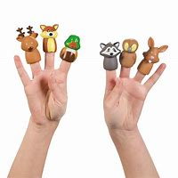
Types of Puppets
Key Vocabulary
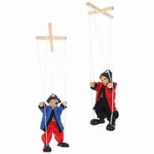
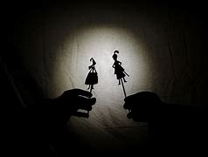

Rod and string Puppets
Shadow Puppets
Finger Puppets
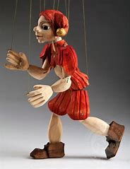
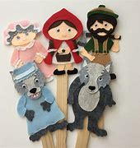
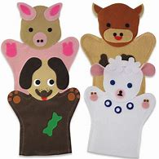

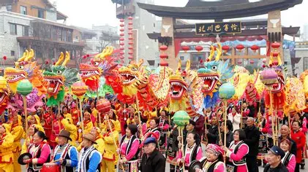
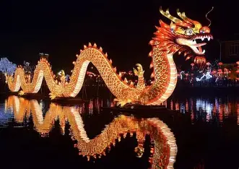
During Chinese New Year people who live in China prepare for speicla celebrations. They decorate their houses with scrolls with good luck messages. They also wear new clothes, eat speicla food and sometimes they may go to the Temple.
What happens during Chinese New Year?
Features of a Dragon
Arms
Head
Hr
Body
Tail
Horns
Hand Puppets
Stick Puppets
Marionette Puppets

