CALCULATION POLICY FOR PARENTS

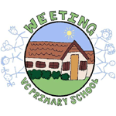

**Weeting Primary School**

This policy has been developed specifically to provide accelerated learning and shows the clear progression of calculations for addition, subtraction, multiplication and division. The methods follow a clear thought process and show visually how each method should be carried out. Our aim is that children become fluent in the fundamentals, reason mathematically to follow an enquiry and can solve problems by applying their mathematics. Children will be encouraged to use mental methods when appropriate, but for calculations that they cannot do in their heads they use an efficient written method accurately. We use the principle of the concrete-pictorial-abstract (CPA) approach for children to have a true understanding of a mathematical concept which is why you can see three different methods for each objective.

We would ask that when you are supporting your child with Mathematics at home that you use these methods. As the methods are not year group specific you will need to ask your child’s class teacher (or your child!) which method they use in class and if you require any further information do not hesitate to ask.

**Addition** 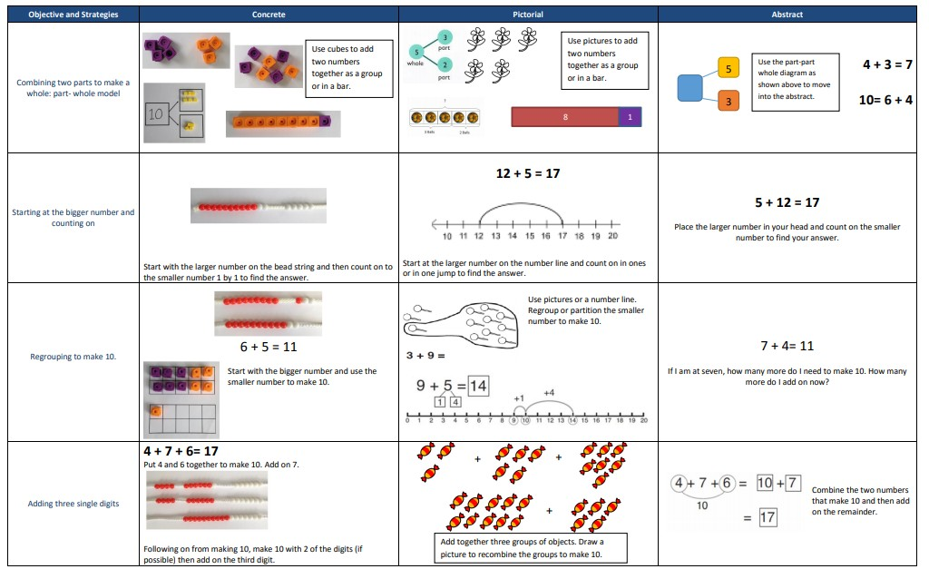

Start with the bigger number then count on 1 by 1

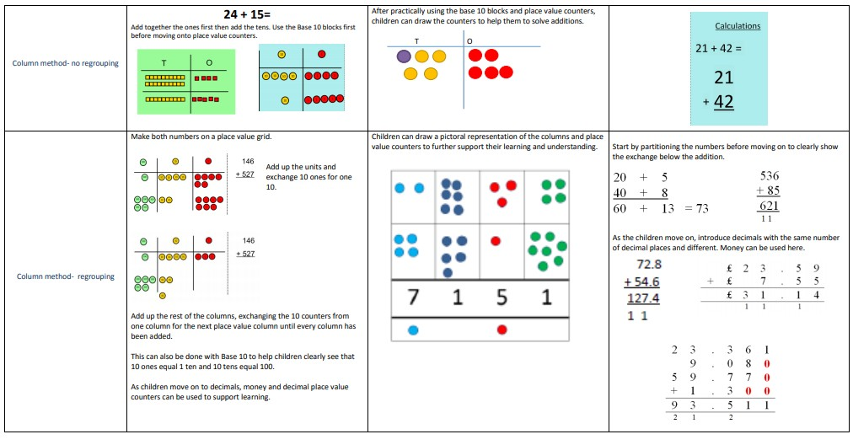

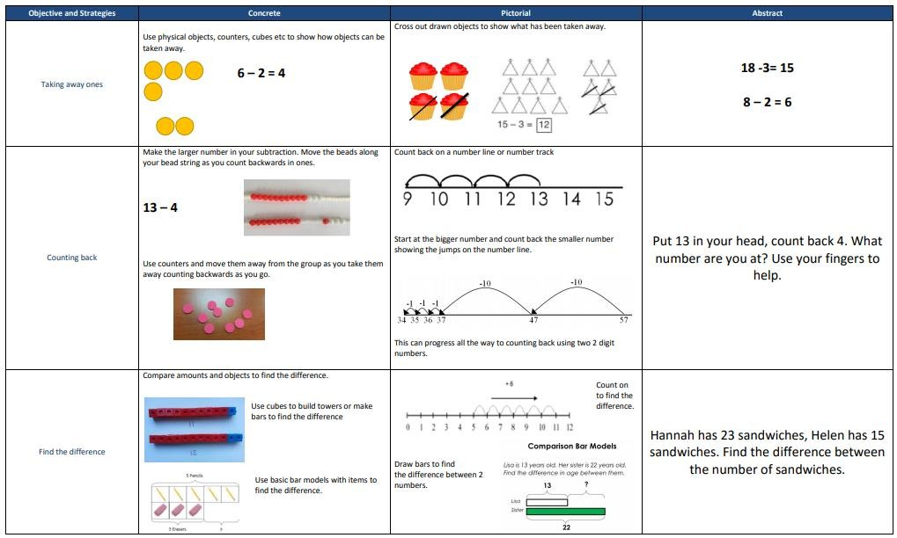

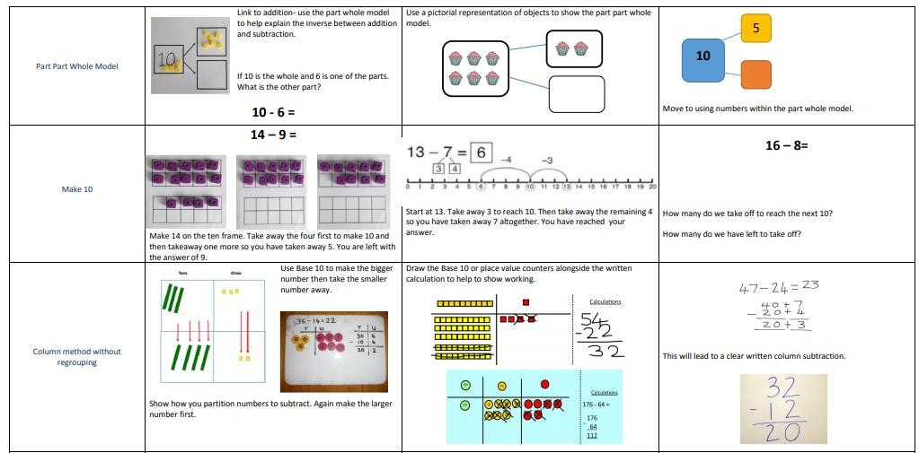

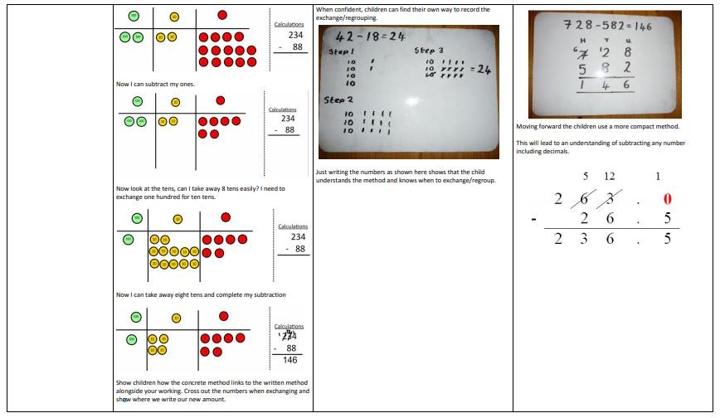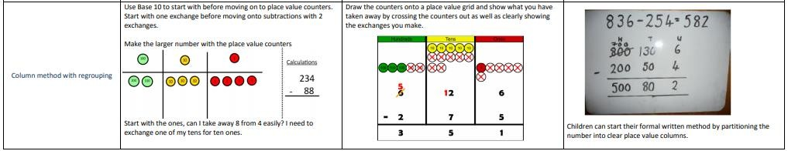

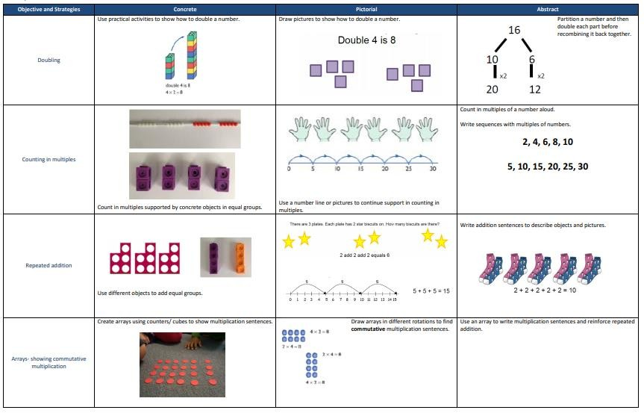

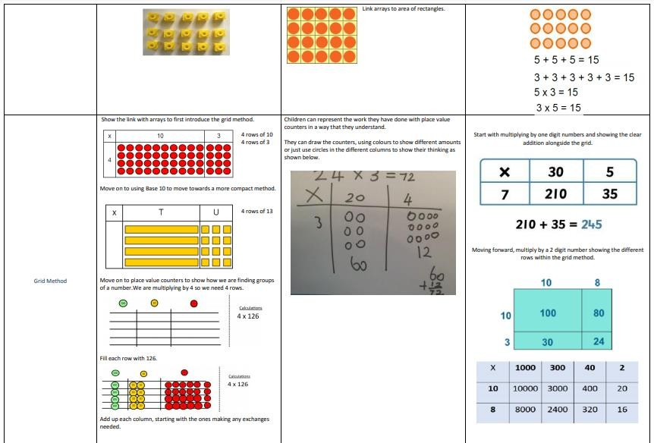

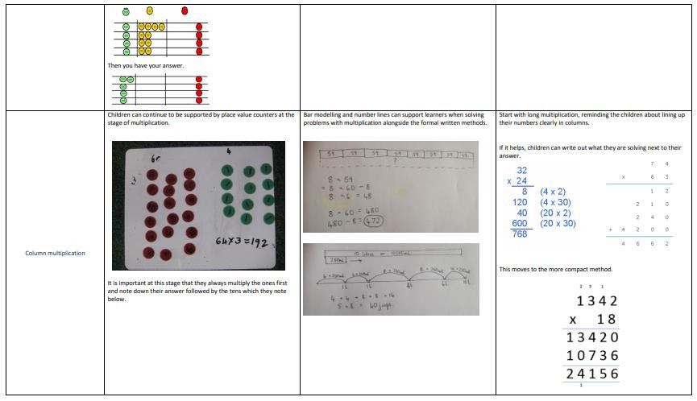

**Division**

