Calculation Policy 2024 - 2025

At Weeting Primary School, we believe that children should be introduced to the processes of calculation through concrete, pictorial, and abstract activities. As children begin to understand the underlying ideas, they develop ways of recording to support their thinking and calculation methods, use methods that apply to special cases, and learn to interpret and use the signs and symbols involved.
Choosing the appropriate strategy is an important tool both for furthering the understanding of ideas and for communicating those ideas to others. A useful written method is one that helps children carry out a calculation and can be understood by others.
This document identifies progression in calculation strategies and highlights which method will be taught in which year group, however it is important to emphasise that children should not be made to go on to the next stage if:
1) they are not ready.
2) they are not confident.
By the end of Year 6, children should be able to choose the most appropriate approach to solve a problem: making a choice between using jottings (an extended written method), an efficient written method or a mental method.
This policy contains the key pencil and paper procedures that will be taught within our school alongside practical resources. It has been written to ensure consistency and progression throughout the school and reflects a whole school agreement.

EYFS (Nursery and Year R) Addition
Objective | Concrete | Pictorial | Abstract
Add a 1-digit number to a 1-digit number | Using objects e.g. counters  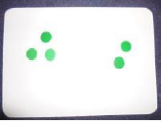  Use commutative law to demonstrate that 3 + 2 is the same as 2 + 3  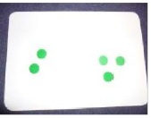  Using Numicon  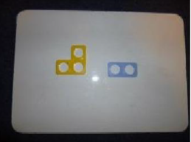  Using a bead string  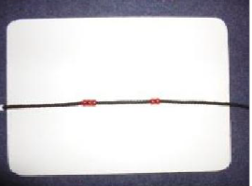  Using 5s and 10s frames  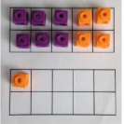 | Drawing objects or dots  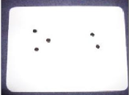 | 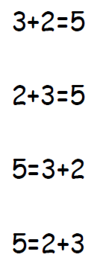
Counting on | Using a number line start at the first number and jump on by the second number.  E.g. 3 + 2  Start at 3 and jump on 2 spaces to find the answer  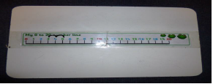
Vocabulary for Addition | add, more, and  make, sum, total  altogether  double  one more, two more … ten more  how many more to make …?  how many more is … than …?  how much more is …?

Year 1 Addition
Objective | Concrete | Pictorial | Abstract
Number bonds of 5, 6, 7, 8, 9 and 10 | Use cubes to add two numbers together as a group or in a bar.  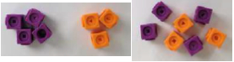  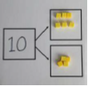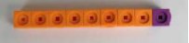  Using Numicon | Use pictures to add two numbers together as a group or in a bar.  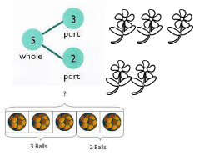   | Use the part-part-whole model (below) to move into the abstract.  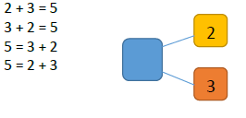
Counting | Using objects  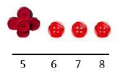 | Use a number line to count on in ones.  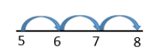 | 5 + 3 = 8
Regrouping to make 10 | Using 10s frames  6 + 5 = 11  Start with the bigger number and use the smaller number to make 10. | 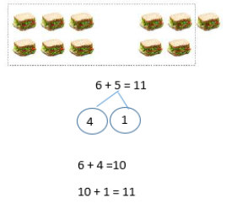 | 6 + 5 = 11
Vocabulary for Addition | As for previous years and:  addition  near double  equals  is the same as  number bonds/pairs  missing number

Year 2 Addition
Objective | Concrete | Abstract | Pictorial
Adding 3 single digit numbers | Using 10s frames and number tracks  4 + 7 + 6= 17  Put 4 and 6 together to make 10. Add on 7.  Following on from making 10, make 10  with 2 of the digits (if possible) then add on the third digit. | Add together three groups of objects. Draw ‘ones’ to recombine the groups to make 10.  Insert picture | Combine the two numbers that make 10  and then add on the remainder.  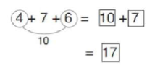
Column method without regrouping | Using a place value grid and base 10  Add together the ones first, then add the tens.  24 + 15 = 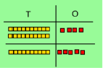  Introducing place value counters for the more able  44 + 15 = 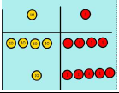 | After physically using the base 10 blocks, children can draw the base 10 to help them to solve additions.  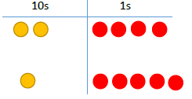 | 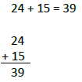
Column method with regrouping | Make both numbers on a place value grid.  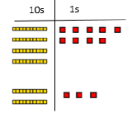  Add up the units and exchange 10 ones for 1 ten.  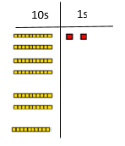 | After physically using the base 10, children can draw the base 10 to help them to solve additions. | 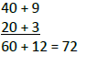
Vocabulary for Addition | As for previous years and:  …one hundred more  facts  tens boundary

Years 3 and 4 Addition
Objective | Concrete | Pictorial | Abstract
Column method with regrouping | Make both numbers on a place value  grid.  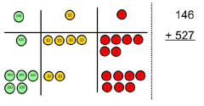  Add up the units and exchange 10 ones  for 1 ten.  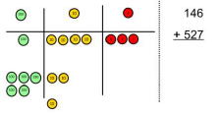  As children move on to decimals, money  and decimal place value counters can be  used to support learning.  NB  By Year 4 children will progress on to  adding four-digit numbers. | Children can draw a pictorial representation of the columns and place  value counters to further support their learning and understanding.  NB  Addition of money needs to have £  and p added separately.  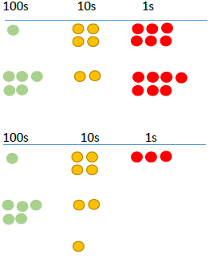 | 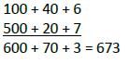  As the children progress, they will move from the expanded to the compacted method.  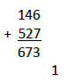  As the children move on, introduce  decimals with the same number of  decimal places and different. Money can be used here.
Vocabulary for Addition | As for previous years and:  hundreds boundary  inverse

Year 5/6 Addition
Objective | Concrete | Pictorial | Abstract
Column method with regrouping | Consolidate understanding using numbers with more than 4 digits and extend by adding numbers with up to 3 decimal places.
Vocabulary for addition | As for previous years and:  ones boundary  tenths boundary

EYFS (Nursery and Year R) Subtraction
Objective | Concrete | Pictorial | Abstract
Subtract a 1-digit number from a 1-digit number | Using objects e.g. counters  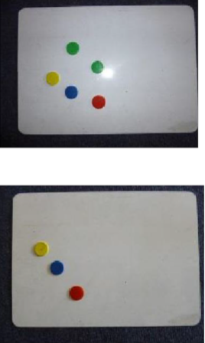  Using a bead string  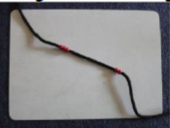  Using 5s and 10s frames | Drawing objects e.g. dots  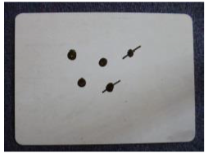 | A written calculation represented in both of the following orientations to show that despite representation, the answer is the same.  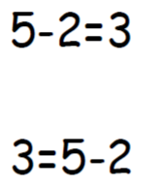
Counting back | On a numbered number line: start at 5 and jump back 2 ones.  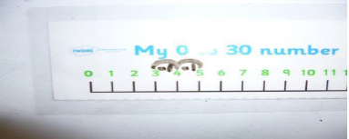
Vocabulary for Subtraction | take away  how many are left/left over?  how many have gone?  one less, two less, ten less …  how many fewer is … than …?  how much less is …?  difference between

Year 1 Subtraction
Objective | Concrete | Pictorial | Abstract
Taking away ones | Use physical objects, counters, cubes etc. to show how objects can be taken away.  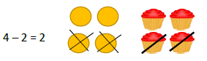 | Cross out drawn objects to show what has been taken away.  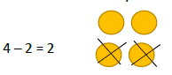 | 4 – 2 = 2
Counting back | Make the larger number in your  subtraction. Move the beads along your  bead string as you count backwards in  ones.  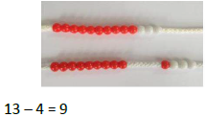 | Count back on a number line or number track.  Start at the bigger number and count  back the smaller number, showing the  jumps on the number line.  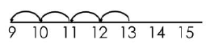 | Put 13 in your head, count back 4. What  number are you at?  Use your fingers to help.
Find the difference | Compare amounts and objects to find  the difference.  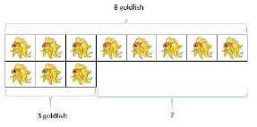  Use cubes to build towers or make bars  to find the difference. Use basic bar models with items to find the difference. | Count on to find the difference.  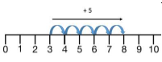  Draw bars to find the difference between two numbers.  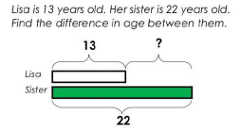 | Hannah has 8 goldfish.  Helen has 3 goldfish.  Find the difference between the number of goldfish the girls have.
Vocabulary for Subtraction | As for previous years and:  subtract  equals  number bonds/pairs  missing number

Year 2 Subtraction
Objective | Concrete | Pictorial | Abstract
Column method without regrouping | 75 – 42 = 33  Use Base 10 to make the bigger number then take the smaller number away.  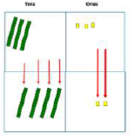  Show how you partition numbers to  subtract. Again, make the larger number first. | Draw the Base 10 alongside the written calculation to help to show working.  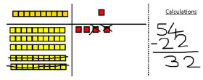 | 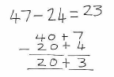  This will lead to a clear written column  subtraction.  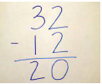
Column method with regrouping | Use Base 10 to start with before moving on to place value counters. Start with one exchange before moving onto subtractions with 2 exchanges.  e.g. 33 – 14 =  Make the larger number with the place value counters  Start with the ones, can I take away 4 from 3 easily? I need to exchange 1 of my tens for 10 ones.  Now I can subtract my ones.  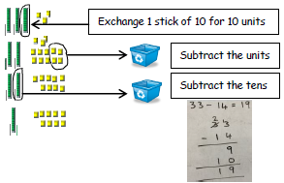 | 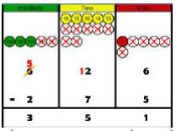  Draw the counters onto a place value grid and show what you have taken away by crossing the counters out as well as clearly showing the exchanges you make.  When confident, children can find their own way to record the exchange/regrouping.  Just writing the numbers as shown here shows that the child understands the method and knows when to exchange/regroup. The place value counters on a grid and written method can be used alongside each other so clearly illustrate the calculation taking place.  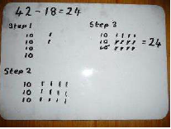 | Children can start their formal written  method by partitioning the number into clear place value columns.  Moving forward the children use a more compact method.  This will lead to an understanding of subtracting any number.
Vocabulary for Subtraction | As for previous years and:  …one hundred less  facts  tens boundary

Year 3 – 6 Subtraction
Objective | Concrete | Pictorial | Abstract
Column method with regrouping | Use Base 10 to start with before moving on to place value counters. Start with one exchange before moving onto subtractions with 2 exchanges.  Make the larger number with the place value counters  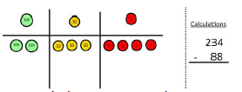  Start with the ones, can I take away 8 from 4 easily? I need to exchange 1 of my tens for 10 ones.  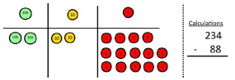  Now I can subtract my ones.  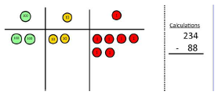 | Draw the counters onto a place value grid and show what you have taken away by crossing the counters out as well as clearly showing the exchanges you make.  When confident, children can find their own way to record the exchange/regrouping.  Just writing the numbers as shown here shows that the child understands the method and knows when to exchange/regroup. | 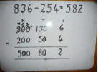  Children can start their formal written  method by partitioning the number into clear place value columns.  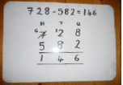  Moving forward the children use a more compact method.  This will lead to an understanding of subtracting any number including decimals.  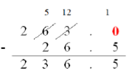
Column method with regrouping | Now look at the tens, can I take away 8 tens easily? I need to exchange 1 hundred for 10 tens.  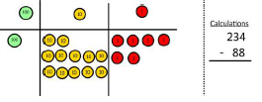  Now I can take away 8 tens and complete my subtraction.  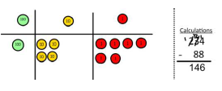  Show children how the concrete method links to the written method alongside your working. Cross out the numbers when exchanging and show where we write our new amount.
Vocabulary for Subtraction | As for previous years and:  hundreds boundary  inverse  ones boundary  tenths boundary

EYFS (Nursery and Year R) Multiplication
Objective | Concrete | Pictorial | Abstract
Doubling numbers | Understanding that doubling a number means multiplying it by 2  E.g. double 3 = 3 x 2  Children create 3 groups of 2 and then add up the total amount.  Using counters  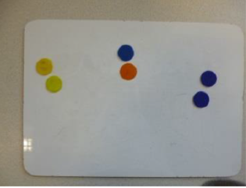  Using Numicon  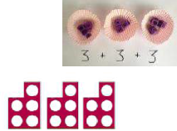 | Drawing dots or objects.  E.g. double 3 = 3 x 2 | Double 3  3 x 2 = 6
Vocabulary for multiplication | doubling  number patterns

Year 1/2 Multiplication
Objective | Concrete | Pictorial | Abstract
Repeated addition | Use different objects to add equal groups.  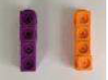 | There are 3 plates. Each plate has 2-star biscuits on. How many biscuits are there?  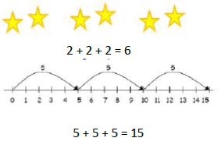 | Write addition sentences to describe objects and pictures.  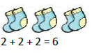
Arrays showing commutative multiplication | Create arrays using counters/cubes to show multiplication sentences.  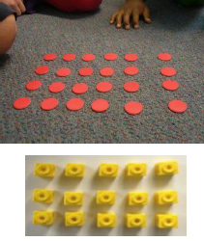 | Draw arrays in different rotations to find commutative multiplication sentences.  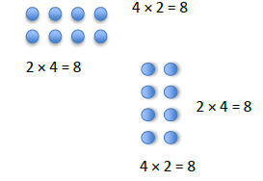  Link arrays to area of rectangles.  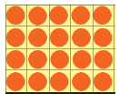 | Use an array to write multiplication sentences and reinforce repeated addition.  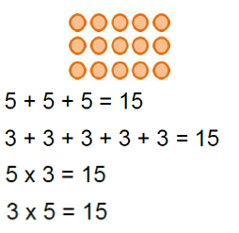
Vocabulary for Multiplication | As for previous years and:  multiplication  multiply  multiplied by  groups of  times  once, twice, three times…ten times  repeated addition  one each, two each…ten each  groups in pairs, threes…tens  equal groups of  row, column  multiplication table  multiplication fact

Year 3/4 Multiplication
Objective | Concrete | Pictorial | Abstract
Grid method | Show the link with arrays to first introduce the grid method.  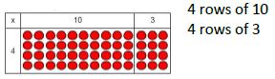  Move on to using Base 10 to move towards a more compact method.  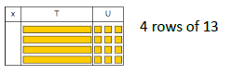  Move on to place value counters to show how we are finding groups of a number. We are multiplying by 4 so we need 4 rows.  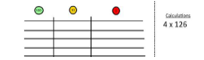  Fill each row with 126  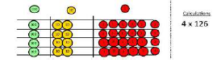  Add up each column, starting with the ones making any exchanges needed.  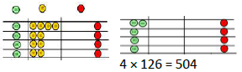 | Children can represent the work they have done with place value counters in a way that they understand.  They can draw the counters, using colours to show different amounts or just use circles in the different columns to show their thinking as shown below.  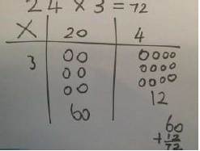 | Start with multiplying by one-digit numbers and showing the clear addition alongside the grid.  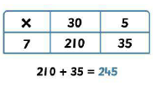  Moving forward, multiply by a 2-digit number showing the different rows within the grid method.  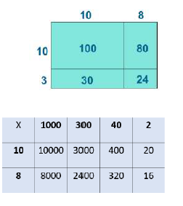
Expanded method | Show the link with arrays to first introduce the expanded method.  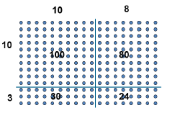 | 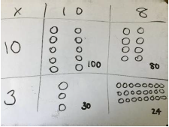 | Start with long multiplication, reminding the children about lining up their numbers clearly in columns.  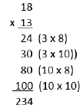
Vocabulary for Multiplication | As for previous years and:  factor  product  inverse  square, squared  cube, cubed

Year 5/6 multiplication
Objective | Concrete | Pictorial | Abstract
Compact method | Children can continue to be supported by place value counters at the stage of multiplication.  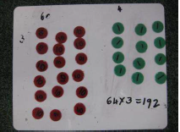  It is important at this stage that they always multiply the ones first and note down their answer followed by the tens which they note below. | Bar modelling and number lines can support learners when solving problems with multiplication alongside the formal written methods.  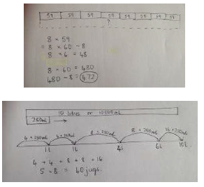 | Start with long multiplication, reminding the children about lining up their numbers clearly in columns.  If it helps, children can write out what they are solving next to their answer.  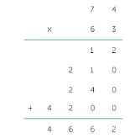  This then moves to the more compact method.  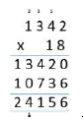
Vocabulary for Multiplication | As for previous years

EYFS (Nursery and Year R) Division
Objective | Concrete | Pictorial | Abstract
Halving numbers using grouping | Understanding that halving a number means splitting it into 2  E.g. 6÷2 (6 divided into 2 groups)  Children put 6 objects or pictures into 2 groups, then count how many are in each group.  Using counters | Drawing dots or objects  E.g. half of 6 = 6÷2  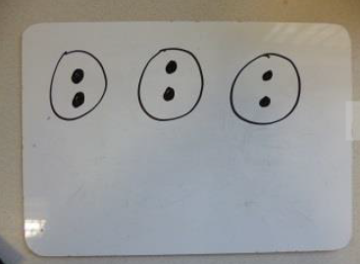 | Half of 6  6 ÷ 2 = 3
Sharing | I have 8 cubes, can you share them equally between two people? | Children use pictures or shapes to share quantities.  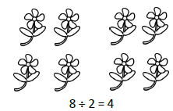 | Share 8 buns between two people.  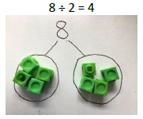
Vocabulary for Division | sharing  halving  number patterns

Year 1/2 Division
Objective | Concrete | Pictorial | Abstract
Sharing | I have 8 cubes, can you share them equally between two people? | Children use pictures or shapes to share quantities. | Share 8 buns between two people.
Grouping | Divide quantities into equal groups.  Use cubes, counters, objects or place value counters to aid understanding.  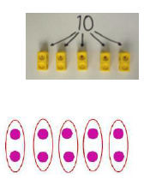 | Use a number line to show jumps in groups. The number of jumps equals the number of groups.  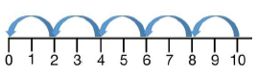  Think of the bar as a whole. Split it into  the number of groups you are dividing by and work out how many would be within each group.  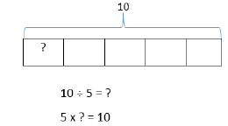 | Divide 10 into 5 groups – how many are in each group?
Vocabulary for Division | As for previous years and:  division  dividing  grouping  array  divide, divided by, divided into  share, share equally  left, left over  one each, two each…ten each  groups in pairs, threes…tens  equal groups of  row, column  division fact

Year 3/4 Division
Objective | Concrete | Pictorial | Abstract
Division with arrays | Link division to multiplication by creating an array and thinking about the number sentences that can be created.  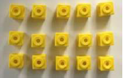  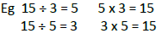 | Draw an array and use lines to split the array into groups to make multiplication and division sentences.  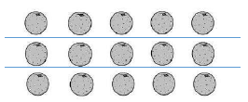 | Find the inverse of multiplication and division sentences by creating four  linking number sentences.  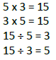
Short division | Use place value counters to divide using the short division method alongside.  96 ÷ 3  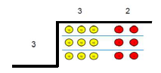  42 ÷ 3  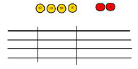  Start with the biggest place value.  We are sharing 40 into three groups. We can put 1 ten in each group and we have 1 ten left over.  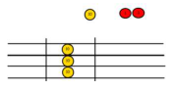  We exchange this ten for 10 ones and then share all of the ones, including the two from the original number, equally among the groups.  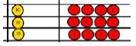  Then look at how many are in each group. | Students can continue to use drawn diagrams with dots or circles to help them divide numbers into equal groups.  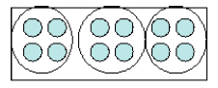  Encourage them to move towards counting in multiples to divide more efficiently. | Begin with divisions that divide equally with no remainder.  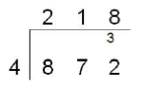
Vocabulary for Division | As for previous years and:  factor  remainder  inverse

Year 5/6 division
Objective | Concrete | Pictorial | Abstract
Division with remainders | 14 ÷ 3 =  Divide objects between groups and see how much is left over.  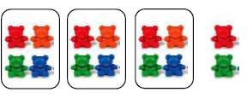 | Jump forward in equal jumps on a number line then see how many more you need to jump to find a remainder.  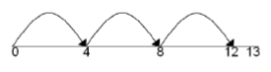  Draw dots and group them to divide an amount and clearly show a remainder.  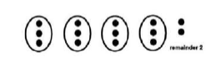 | Complete written divisions and show the remainder using r.  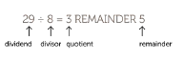
Short division with remainders | 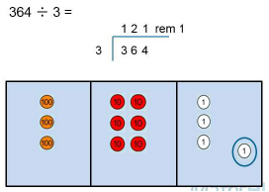 |  | Move onto divisions with a remainder.  Once children understand remainders, begin to express as a fraction or decimal according to the context.  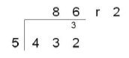  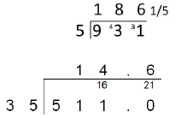
Vocabulary for Division | As for previous years.

Year 6 – long division
Children will use long division to divide numbers with up to 4 digits by 2-digit numbers.
