If you like exploring and learning about Space, then these books will be great fun to read at home!
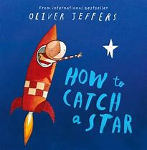
How to catch a star – Oliver Jeffers
How to catch a star is a great book. This book is about a little boy, who loves stars. He wanted to catch the star in the sky. The books show the journey the boy goes on to catch the star, so the star can be his friend.

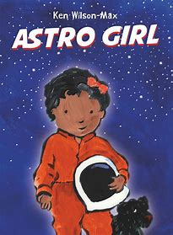
Astro Girl - Ken-Wilson Max
This book is about a girl calls Astrid. She has always wanted to be an astronaut and has loved space. Astrid loves learning about what space is and what different planets are in space. In this book, you will find out that Astrid’s mum is an astronaut and her mum is her hero!

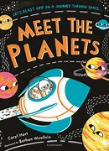
Meet the planets – Caryl Hart
Meet the planets is a book about all the planets that makes up our solar system. The books explore each planet and takes you onto a journey to meet each planet. How many planets can you find in this book?

Star in a Jar – Sam Hay
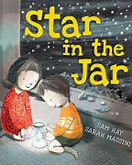
Star in the jar is a fabulous book. This book is a book about a brother and sister and they find a special piece of treasure. They carried their special treasure everywhere, in the night time the special treasure got bright! Later, that evening they looked up to the sky and found that the star is lost and they have to help the star get back home. Could you help the star in the jar to get back home?

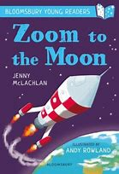
Zoom to the Moon - Jenny McLachlan
Zoom to the moon is a great book if you want to go on an adventure! This book explores the journey we can go on to go to the moon. Come and join the adventure to travel to the moon, let’s see what we see on the way!

