Reading Rockets  Read at least 3 times a week for 10 minutes each time. Parents should sign to record that this has been completed in the reading diary.  Your reading book and diary should be in school every day. | Times tables  Practice two times tables weekly. It can be any of your tables from 2 to 12!  Start by saying your times tables in full.  Then write your times table out in full.  Ask an adult to give you written questions, one at a time, from your chosen times table. Make sure they ask you questions out of sequence! Can you write the answer in 10 seconds? | Spellings  Practice the spellings in your spelling book.  Bring your spelling book back to school on Thursday when you will have your spelling test.  New spellings will be added into your book on Friday. You will either get a new list if you get all your spellings correct or more time to practice the original list. You will need to get 8/10 to move on to your new spelling.
Science  The human body – It is important to eat a healthy, balanced diet.  Draw a picture of a nutritious lunch and explain how each food group helps your body to stay healthy. | Science  Make a fact file about teeth. Include:  How to keep your teeth clean  The function of the different teeth  Some facts about the differences in teeth in carnivores, omnivores and herbivores. | Art  Light and shadow. Choose a fruit or vegetable and place it on a flat surface.  Draw the object.  Use shading techniques to create light and shadow on your image.
Geography  Research San Francisco and London. Draw a table to compare the two cities. What is the same and what is different?  Write a paragraph to explain how transport in the two cities is different due to their physical geography.  Similarities Differences | Art  Choose a picture you like by an artist such as Caravaggio, Cezanne or Vermeer.  Recreate the image in your homework book and explain why you like it and how you have created light and shade effects within the picture.  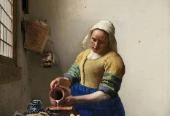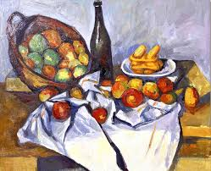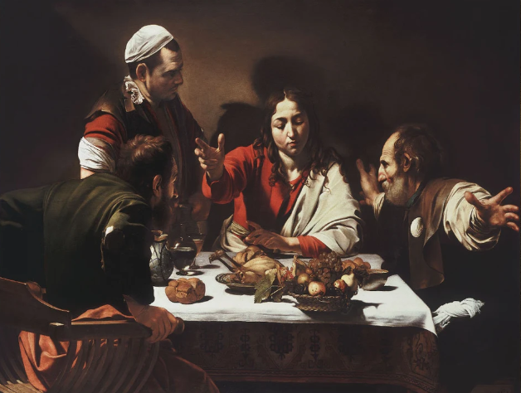  Vermeer Cezanne Caravaggio | Maths  Roll a dice 3 or 4 times and record the digits to make a 3 or 4-digit number. E.g.    452  Which other numbers can you make using these digits? 245, 254, 425, 524, 542  Put your numbers in ascending order (smallest to largest)  245, 254, 425, 452, 524, 542
  R.E.  Think about your beliefs.  What is your world view?  Who influences these? Which texts and sources of authority have influenced your world views?  How are your actions affected by your beliefs?  Draw a mind map or write a paragraph. | English  Stig is a cave man. In the story, he and Barney do not speak the same language, so they communicate using gestures and facial expressions. If Stig could speak English, what do you think he would want to tell Barney? Write a conversation between Stig and Barney. Remember to use the appropriate punctuation. | Geography  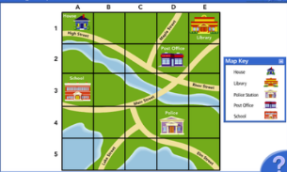  Using squared paper, draw a map of your local area. Remember to include:  Important landmarks  A key with symbols  A scale eg 1cm = 5m

Activities marked with a star must be completed at least 3 times a week. Children are expected to complete 6 tasks from all other challenges (Art, Geography, History and Science) during this half term. Children should return their completed homework task, in their homework books, every Thursday. Books will be marked and returned on Friday.

