Autumn Term Recommended Reads for Oak Class
Stories by David Almond
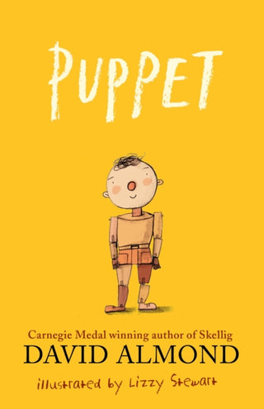 | A heartwarming story that shows anything is possible with imagination and trust. What should a puppet master do when he’s old and alone, and all his puppets are gone? Sylvester makes one last puppet. But this one is different. When the old man speaks to him, Puppet speaks back. And then he walks… While Sylvester shows Puppet the town, the playground and the wonders the world holds, Puppet in turn helps Sylvester to make a new friend, and share his puppet-making skills with the next generation in this wonder-filled story of creation and the circle of life. Illustrated with sequences of wordless spreads by award-winning artist Lizzy Stewart, this is a modern-day classic.
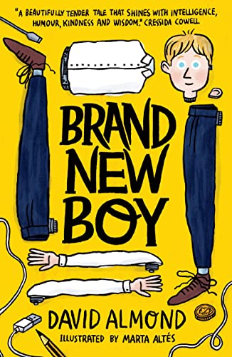 | “Mam, did you think George was,” I say, “a bit … weird?”  “Weird? Yes, I suppose so. But you kids are all a bit weird if you ask me. And to tell the truth, it’d be weird if you weren’t.”  When a new boy joins the class, everyone thinks he’s a bit strange, but he’s brilliant at football and loves crisps, and that’s all that matters to Dan and Maxie. However, the truth about George is stranger than anyone could have imagined ... and more sinister, too. Can his new pals help him to become truly free?
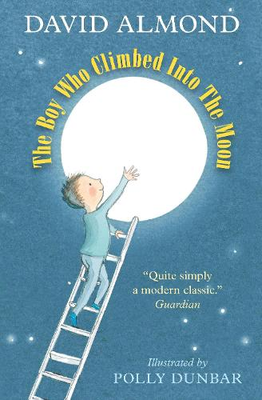 | Paul believes that the moon is not the moon, but is a great hole in the sky. It’s one of many strange ideas that he’s never told anyone (at school he was told that he had no ideas at all), until he meets Molly, his irrepressible neighbour, who begins to convince him that his theory might just change the world. Helped by a very long ladder, some highly irregular characters, two rather worried parents and a great deal of community spirit, Paul takes to the sky. But his astonishing discovery there can’t keep him away for long – what is waiting for him back at home is turning out to be better than he’d ever imagined…
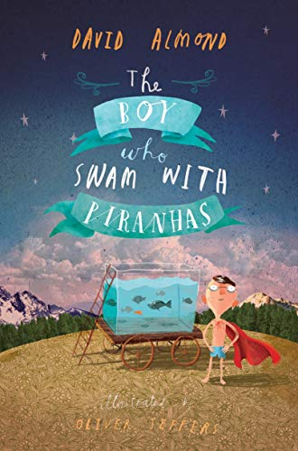 | Stanley Potts is just an ordinary boy, but when all the jobs in Fish Quay disappear his Uncle Ernie develops an extraordinary fascination with canning fish. Suddenly their home is filled with the sound of clanging machinery and the stench of mackerel, and Uncle Ernie's obsession reaches such heights that he would even can Stan's beloved goldfish! Stan, however, has his own destiny, which leads him – via a hook-a-duck stall – to Pancho Pirelli, the blue-caped madman who swims with piranhas. And as Stan delves into the waters, he finally discovers who he really can be.

stories
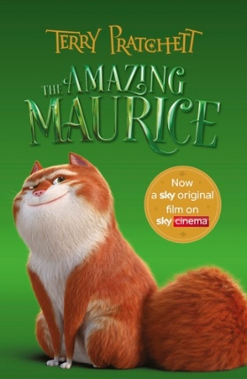 | Terry Pratchett has created a wonderful tail (pardon the pun) about a con artist cat called Maurice and his pack of magical rats. When the rats forage on a wizard’s leftovers they acquire powers never seen before in rodents. They can speak and read and start to make big plans for a comfortable retirement. Maurice is always on the lookout for a get-rich-quick scheme and together with the rats, and young Keith, the ‘piper’, they develop a plan to make big bucks with their very own plague of rats. But things go wrong when they reach the run-down town of Bad Blintz and the educated rodents start to have their own ideas…
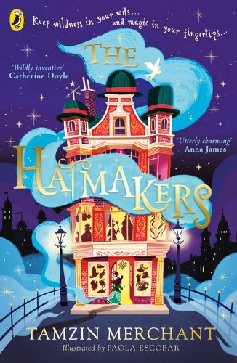 | For fans of books with magic, actor and author Tamzin Merchant's series is ideal. Cordelia’s family have always been milliners and they create all kinds of stunning hats using magical ingredients. Making is a rare and ancient skill and only a few special Maker families remain. But Cordelia’s family is struck by tragedy when her father Prospero and his ship, the Jolly Bonnet, are lost at sea during a mission to collect hat ingredients. Cordelia makes it her mission to find him, but her Uncle Tiberius and Aunt Ariadne have no time to help the little Hatmaker. And when she finds out someone is using Maker magic to start a war, Cordelia has more on her plate than she bargained for!
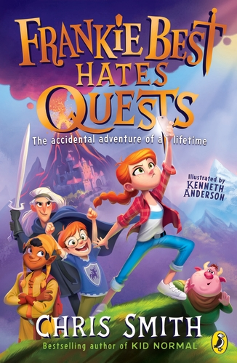 | Frankie Best likes watching YouTube and eating Pot Noodles. She doesn’t like being forced to embark on mega-dangerous quests. Nope, no thank you. But that’s exactly what she must do when what was supposed to be a quiet weekend at her Grandad’s house turns into an epic rescue mission. It’s down to Frankie and her brother Joel to save their Grandad when he is kidnapped by gnoblins (yes, gnoblins!). The pair head off to a magical realm where they encounter crazy creatures, terrifying enemies, and strangest of all – no Wi-Fi!
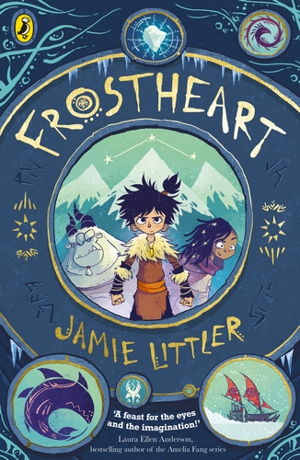 | All aboard the Frostheart for a hilarious and heart-stopping adventure! Young Ash and his yeti guardian Tobu live in the furthest part of the known world, cut off from the rest of humankind by creatures that lurk beneath the Snow Sea. When a group of travellers arrives on his rocky outcrop, he discovers more about his missing parents and realises he has been given the magical power of song weaving. This power sees him whisked aboard the Frostheart sleigh on a journey that will change his life forever.

Non-fiction
Classification
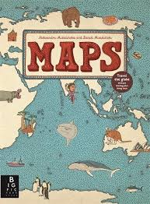 | Explore the world with this lavish book of maps. This collection of 52 highly illustrated maps details not only geographical features and political borders, but also places of interest, iconic personalities, native animals and plants, local peoples, cultural events, and many more fascinating facts associated with each region. This book is a celebration of the world, from its immense mountains to its tiny insects - and everything in between!
Music and religions
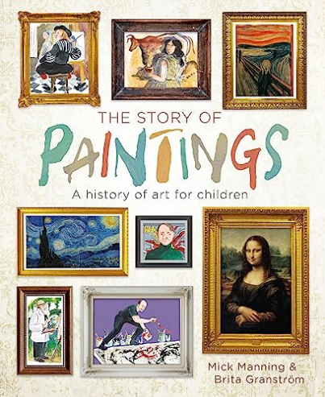 | A friendly and inspiring introduction to art history, telling the stories of the world's greatest paintings and artists from prehistory to the modern day.

