Autumn Term Recommended Reads for Oak Class
Stories by David Almond
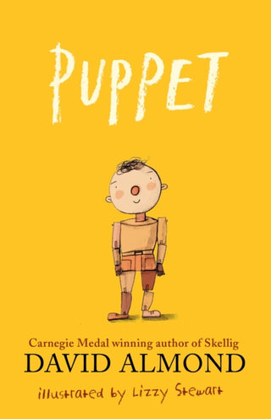 | A heartwarming story that shows anything is possible with imagination and trust. What should a puppet master do when he’s old and alone, and all his puppets are gone? Sylvester makes one last puppet. But this one is different. When the old man speaks to him, Puppet speaks back. And then he walks… While Sylvester shows Puppet the town, the playground and the wonders the world holds, Puppet in turn helps Sylvester to make a new friend, and share his puppet-making skills with the next generation in this wonder-filled story of creation and the circle of life. Illustrated with sequences of wordless spreads by award-winning artist Lizzy Stewart, this is a modern-day classic.
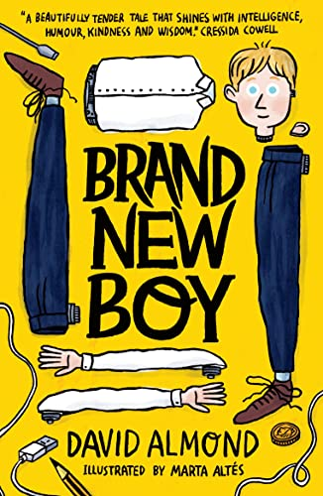 | “Mam, did you think George was,” I say, “a bit … weird?”  “Weird? Yes, I suppose so. But you kids are all a bit weird if you ask me. And to tell the truth, it’d be weird if you weren’t.”  When a new boy joins the class, everyone thinks he’s a bit strange, but he’s brilliant at football and loves crisps, and that’s all that matters to Dan and Maxie. However, the truth about George is stranger than anyone could have imagined ... and more sinister, too. Can his new pals help him to become truly free?
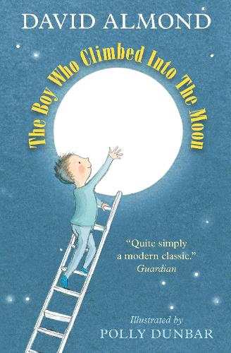 | Paul believes that the moon is not the moon, but is a great hole in the sky. It’s one of many strange ideas that he’s never told anyone (at school he was told that he had no ideas at all), until he meets Molly, his irrepressible neighbour, who begins to convince him that his theory might just change the world. Helped by a very long ladder, some highly irregular characters, two rather worried parents and a great deal of community spirit, Paul takes to the sky. But his astonishing discovery there can’t keep him away for long – what is waiting for him back at home is turning out to be better than he’d ever imagined…
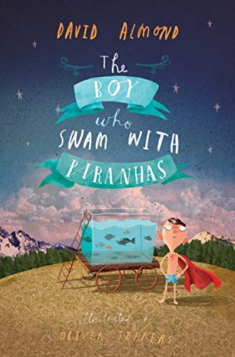 | Stanley Potts is just an ordinary boy, but when all the jobs in Fish Quay disappear his Uncle Ernie develops an extraordinary fascination with canning fish. Suddenly their home is filled with the sound of clanging machinery and the stench of mackerel, and Uncle Ernie's obsession reaches such heights that he would even can Stan's beloved goldfish! Stan, however, has his own destiny, which leads him – via a hook-a-duck stall – to Pancho Pirelli, the blue-caped madman who swims with piranhas. And as Stan delves into the waters, he finally discovers who he really can be.

Adventurous stories
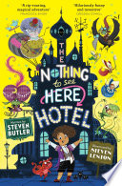 | Welcome to The Nothing to See Here Hotel! A hotel for magical creatures, where weird is normal for Frankie Banister and his parents who run the hotel.  When a goblin messenger arrives at The Nothing to See Here Hotel, announcing the imminent arrival of the goblin prince Grogbah, Frankie and his family rush into action to get ready for their important guest. But it soon becomes obvious that the Banister family are going to have their work cut out with the demanding prince and his never-ending entourage, especially when it turns out the rude little prince is hiding a secret...
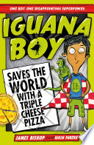 | Dylan has wanted a superpower for as long as he can remember, especially since his brother and sister have got really cool ones. But when his wish finally comes true, Dylan is MIGHTILY disappointed. For Dylan has become ... Iguana Boy. He can talk to Iguanas ... RUBBISH! And when supervillain Celina Shufflebottom kidnaps all the superheroes in London, Dylan must work out how to use his new team of chatty iguanas to save the day. He's going to have to think outside the box, (the pizza box), if he's going to become the hero he's always dreamed of. If he's going to make Iguana Boy cool.
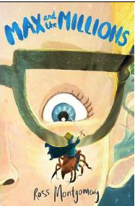 | Max is used to spending time alone - it's difficult to make friends in a big, chaotic school when you're deaf. He prefers to give his attention to the little things in life... like making awesome, detailed replica models. Then Mr Darrow, the school caretaker and fellow modeller, goes missing. Max must follow his parting instruction: 'Go to my room. You'll know what to do.'  There on the floor he finds a pile of sand ... and in the sand is Mr Darrow's latest creation... a tiny boy, no bigger than a raisin, Luke, Prince of the Blues. And behind the tiny boy... millions of others - a thriving, bustling, sprawling civilization!
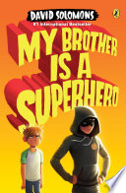 | Luke Parker was just your average comic book fan until his boring, teacher’s pet, helps-old-ladies-across-the-street brother Zack got turned into a superhero. Luke can’t believe the unfairness of it all—he’s the one with the encyclopedic knowledge of everything from Ant-Man to Wolverine! At least he can help Zack—aka Star Guy—with all the important parts of becoming a superhero, like using his newfound powers and deciding whether or not to wear a cape.  But when Star Guy gets into super-size trouble, it’s up to Luke—and his intrepid neighbor, Lara—to rescue his big brother and, with a little luck, help him save the world.

Non-fiction
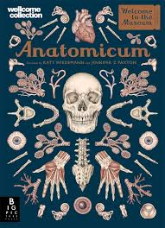 | Step inside the pages of Anatomicum to enjoy the experience of a museum from the comfort of your own home. The 2019 offering from Welcome to the Museum guides readers through the human body, from the muscles we use to show emotion, to the delicate workings of the brain. With sumptuous artwork by Katy Wiedemann and expert text by professor Dr Jennifer Z Paxton, this beautiful book is a feast of anatomical knowledge.
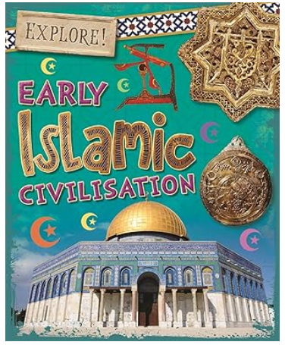 | Early Islamic civilisation spread across the Middle East, Africa, Europe and Asia in the 7th and 8th centuries CE, forming a massive empire. Find out about the birth of Islam, amazing inventions and trade across the empire.  Read about weapons and war, the city of Baghdad, the life of a scribe, science and medicine and find out how to make an Islamic tile design!  Packed with fascinating information, the Explore! series inspires children's curiosity to find out more about the past. A great tool for readers age 8+ or teachers looking for books to support the new curriculum.
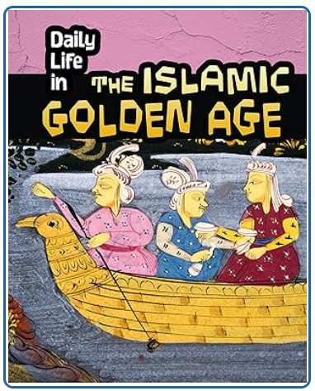 | This book explores what life was really like for everyday people in the Islamic Golden Age,including Baghdad around AD900. Using primary sources and information from archeological discoveries, it uncovers some fascinating insights and explodes some myths. Supported by timelines, maps and references to important events and people, children will really feel they are on a time-travelling journey when reading this book.
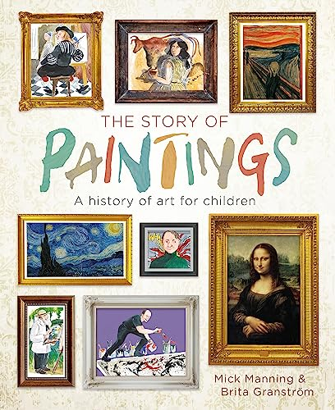 | A friendly and inspiring introduction to art history, telling the stories of the world's greatest paintings and artists from prehistory to the modern day.

