

Beech Class
Autumn Term 2 Homework
Science  Can you think of 10 carnivores (meat-eaters)?  Can you think of 10 (plant eating) herbivores?  How many animals can you think of that walk on 2 legs? How many walk on 4? How many can you name that have no legs? Are there any other ways to sort animals?   | History  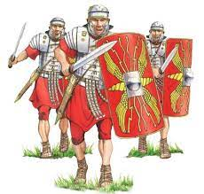  Find out what it was like to be a Roman soldier. What did they wear? What weapons did they use? Can you draw a picture of one and label it?  Queen Boudica was famous for rebelling against the Romans and winning some victories. What can you find out about her and her tribe, the Iceni? |   Art  Matisse created art by cutting out different types of paper.  Can you create a picture by cutting shapes from magazines, newspapers, scrap paper and old packaging?
English  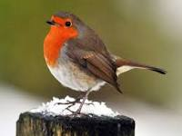  Find out facts about the animal featured in our class text: the robin. Present your facts in a poster or a fact file. | English    Imagine you are a British child in Roman times. Write a diary entry describing how you are feeling when the Romans invade Britain. | English  Poetry can often rhyme. Can you write down some rhyming pairs? Two words that rhyme with each other?  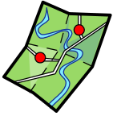  
Maths  Find a collection of objects. Can you count them in 3s?  How many objects do you have in total? How many groups of 3? | Maths  Complete a 100 square to help you with your Maths at home.  You could draw it with chalk on the ground, draw your own with pens, or use a template. | Maths  Practise counting backwards in 10s, 2s, 5s, and 3s, from 100 (or 99 for 3s). Can you do it without making mistakes?  Anyone able to do this in front of the class will earn 5 dojos.

Compulsory Weekly Homework
All children must be reading at home at least 3 times a week. This can be your school reading book, library books or books from home.  Please record this in the reading record.  To ensure fluency, the school reading book will be changed after it has been read twice at home on 2 separate occasions. | Children will be receiving spellings linked to their Phonics learning.  They should practise these at home and our spelling test day will be Thursday.  Children must achieve 8/10 to move on to the next spelling list.

