If you like Transport and learning about different types of transport, then these books are a great read for you and your children. Have a look for our suggestions.
“We all go travelling by” is a book about children’s journey to school. The children play I Spy and say what they see around them as they are travelling on their journey to school. What do you see on your way to school? Come and join the children on their journey to school!
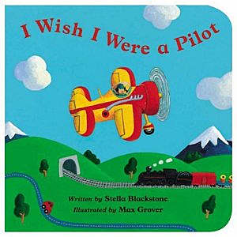
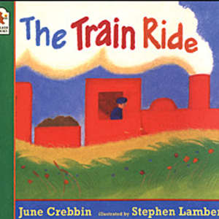
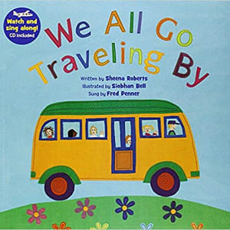
“The Train Ride” is an exciting book about a train journey! The mum and her little girl take a journey on a train. They see lots of different people and lots of different animals! What could you find in this book? Where would you go on your train journey?

This book is about a little boy who really wishes to be a pilot. They learn about what a pilot does and how they fly their plane. What could you do as a pilot? Where would you go on your adventure?
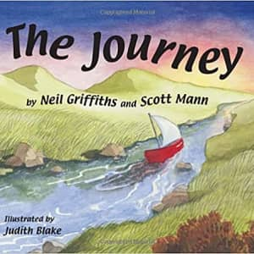
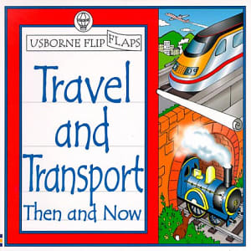
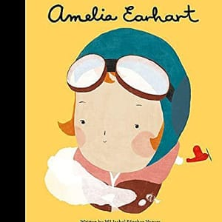
This book is a fact book and will tell you all different facts about Amelia Earhart! Amelia was the first female pilot to fly solo around the Atlantic. How amazing is this!! What do you think she saw whilst on her journey?
“Transport and Travel then and now” is a great book if you want to look back in time at how people used to travel. This book includes lots of different pictures of the different types of transport that were used in the olden days and ones that are used now. You might find some of these really interesting!
One day there was a storm and this little red boat was let free by accident. The boat went on a magical adventure seeing all the different sights. This is a rhyming book as well, which makes it fun and exciting. Come and join us on this journey!

