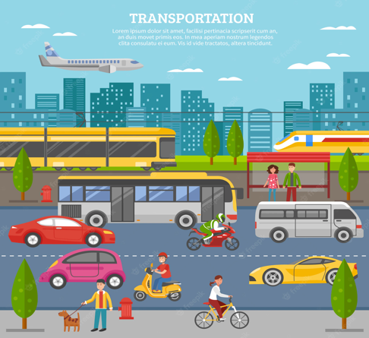

- Each week, choose one activity from the options below.
- There are more activities than weeks so you do not have to complete all of them; you can decide which ones you do.
- Upload a photo/video of you and your child completing the activity, alongside any comments about what they did and/or said onto Tapestry or take photos/stick work, alongside anything they said in your child’s homework book.
- Please include the activity number so that it is clear which activity you are completing for your homework each week.
- Homework books should be returned to school every Monday and your child will bring these home the same day.
- Please include the activity number so that it is clear which activity you are completing for your homework each week.
- Reading packets need to be brought to school every day.

Understanding of the World
Activity 1
Use different junk modelling resources to recreate your own vehicle. What features of your vehicle do you need to include? What type of vehicle are you making? You can paint and decorate your vehicle as well.

Understanding the World
Activity 2
Take a walk around your local area and have a look at the different road signs and vehicles. What different types of transport can you see around your local area? Are there bikes, cars, trucks, lorries?

Reading
Activity 3
Recreate your own version of ‘Mr Gumpy’s Outing’. Create different characters and vehicles that can appear in your story. Who are your characters? Where are they travelling to? What type of transport are they using? Ask your grown up to record your story.

Communication and Language
Activity 4
Work with your grown ups to recreate a new boat for Mr Gumpy to use on the river. You can draw these or use junk modelling resources. What will your boat have to help Mr Gumpy? What will Mr Gumpy need on his boat?

Physical Development
Activity 7
Use different outside resources to construct your own obstacle course. Move around the obstacle course in different ways – can you jump, hop, skip, walk, jog? Test your grown ups too!

Communication and Language
Activity 8
Draw a pictures of your very own vehicle – this can be any vehicle you wish. Work with your grown up to label the different features of your vehicle. What features is your new vehicle going to have? Where is your vehicle going to go?
Mathematics
Activity 5
Have a look around your local area at the different road sings and take pictures of these. Then look at the signs and identify which shapes these signs are. Which shapes can you spot?

Expressive Arts and Design/ Mathematics
Activity 6
Have a selection of 2D shapes (circles, triangles, squares and rectangles) and some paint. Can you use these shapes to print with to recreate your pictures? What shapes have you used?

Maths Activities
Borrow a maths challenge bag from us and complete a challenge. There are lots of different bags with activities to support counting, sorting, making patterns, using time and exploring shapes.
Reading Activity
Remember to keep practising your phonics by “saying the sounds and reading the words” in your book for 5-10 minutes every day.

