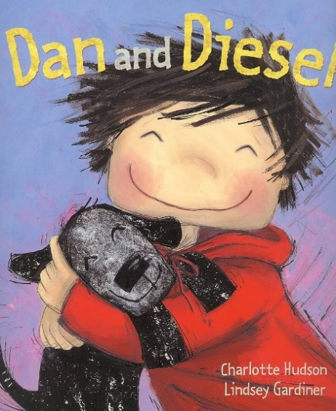**If you have enjoyed the story “Owl Babies” Why not explore these other great stories about all about me. We will be exploring these books throughout this half term in Acorn class.**

**Dan and Diesel by Charlotte Hudson**

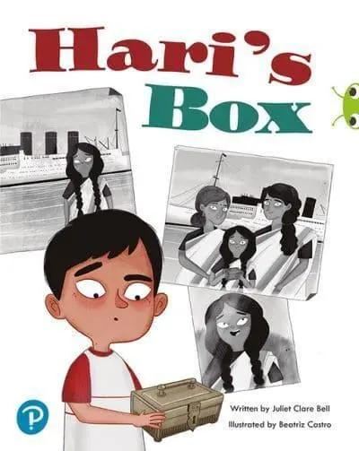Dan's dog Diesel is a wonder dog- he can do anything! Go shopping, play i9n a jazz band, climb mountains, draw pictures in his head. But one day when Diesel is whisked away, everything changes.

**Hari's Bos by Juliet Bell**

It's moving day, and Hari is sad about leaving his old home behind. But when he stumbles over a small shiny box, the story mum tells him changes everything . How has this box been in the family for so long and why is it so special?

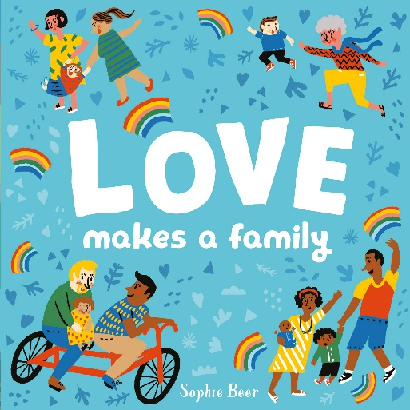

**Love makes a family by Sophie Beer**

This book celebrates the uniqueness of every family and all the amazing things parents and caregivers do for their little ones.

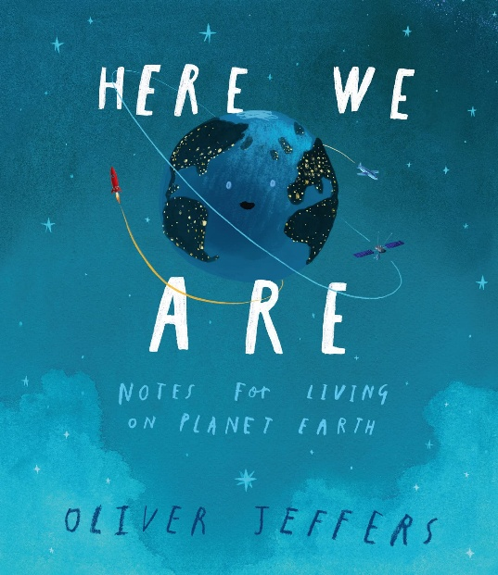

**Here we are by Oliver Jeffers**

Our world can be a bewildering place, especially if you've only just got here. Your head will be filled with questions, so let's explore what makes our planet and how we live on it.

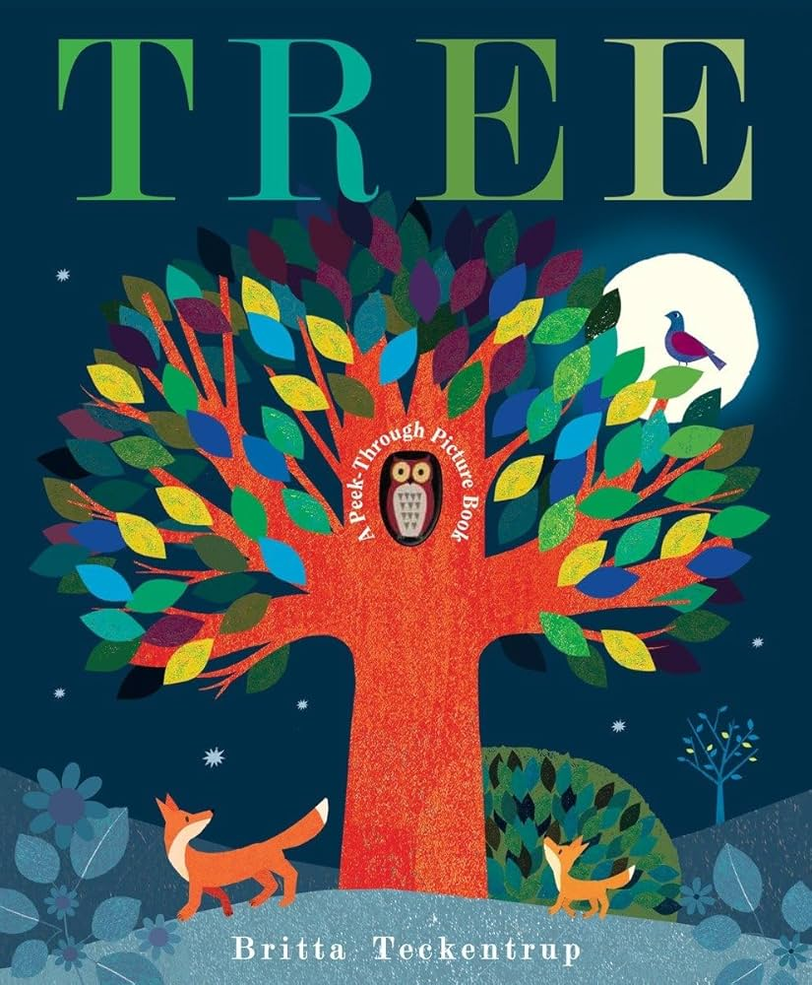

**Tree by Britta Teckentrup**

Explore the beauty of the changing seasons in the peek-through book. Follow the life-cycle of a tree through spring, summer, autumn and winter.

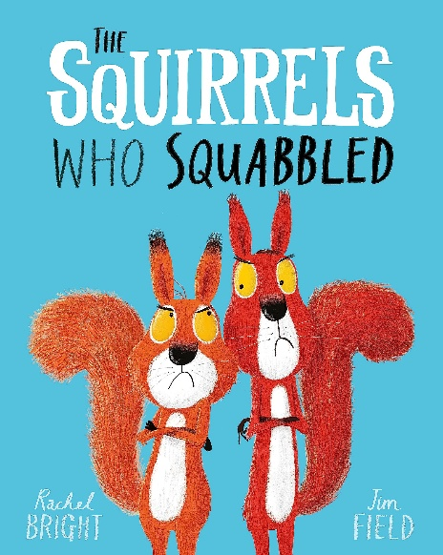

**The Squirrels who squabbled by Rachel Bright and Jim Field**

Greedy squirrels Cyril and Bruce both have their sights on a very special prize- the very las nut of the season! As the nut bounces crazily through the forest, the squirrels race after it, between trees, over boulders, down the river and right to the edge of a water fall! Working together might be the only way to save themselves now...

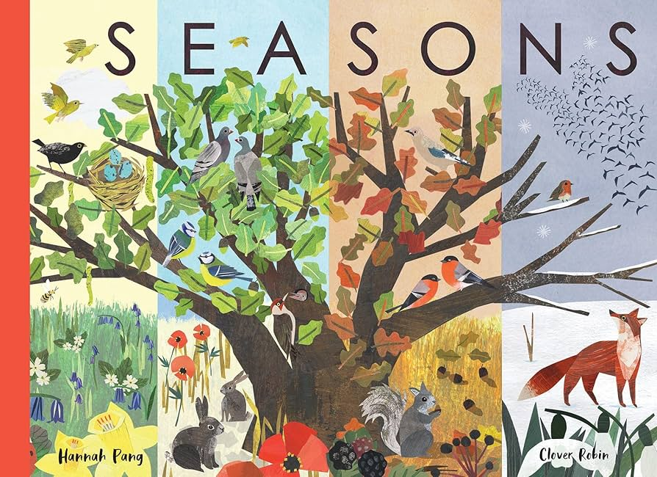

**Seasons by Hannah Pang**

Watch six breath taking landscapes transform in front of your eyes- from Arctic tundra to the African plains, with simple facts and stunning artwork- a perfect book for nature lovers.

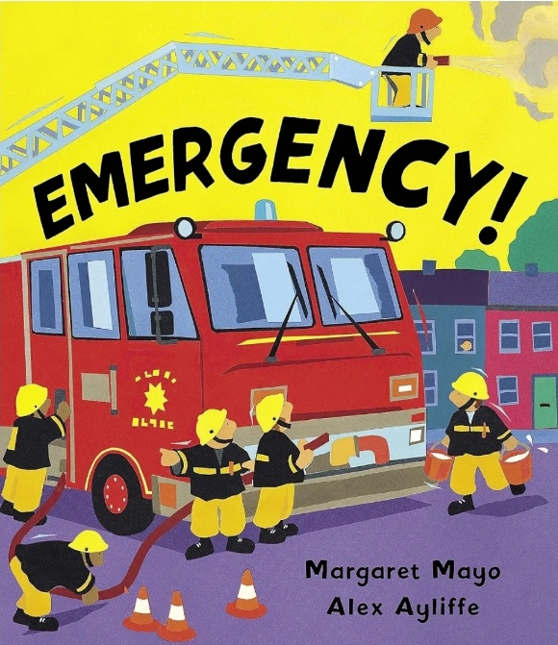

**Emergency! By Margaret Mayo**

It’s all going on in this action-packed picture book! Discover a different emergency vehicle on each page, from fire engines and police cars to lifeboats, breakdown trucks, rescue helicopters and more.