Term | Definition
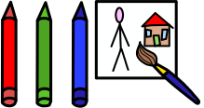  Medias | Different resources to create with.
  Splatter effect | An effect creating by flicking paint onto paper.
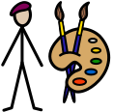  Artist | A person who paints or creates a piece of work.
  Art work | A piece of work that an artist creates.
  Lines | A type of mark making pattern.

Types of lines we are learning about
Key Vocabulary
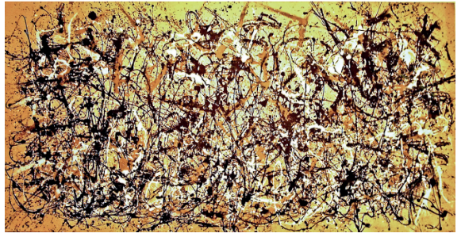
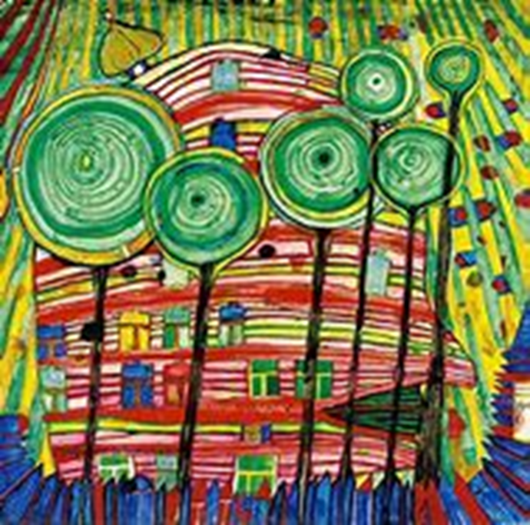


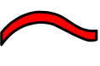


All about our Artists
- Friedensreich Hundertwasser used bright colours in his paintings.
- His paintings used different types of lines such as circular and curved lines.
- Hundertwasser was an Austrian artist and was known for bringing his art work into his building work.

Friedensreich Hundertwasser
- Jackson Pollock is an artist who used splatter and splodge effects.
- He used neutral and vibrant colours in his paintings.
- He was an American artist.
- Jackson Pollock was known for his expressionism and using his technique called the drip technique.
Jackson Pollock
circular
horizontal
long
curved
short
vertical

