If you have enjoyed the story “Mr Gumpy’s Outing”
Why not explore these other great stories about Transport.
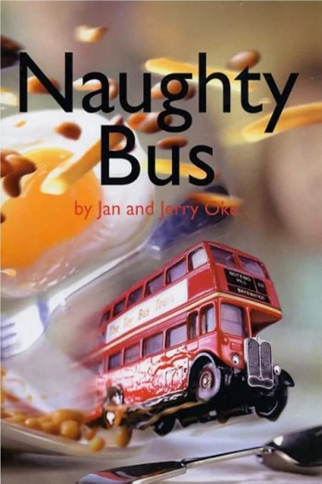
We will be exploring these books throughout this half term in Acorn class.
Naughty Bus by Jan Oke
A young boy receives a toy bus as a present and has great fun exploring the world with his new toy which turns out to be quite a naughty bus- or is it the boy being naughty?!
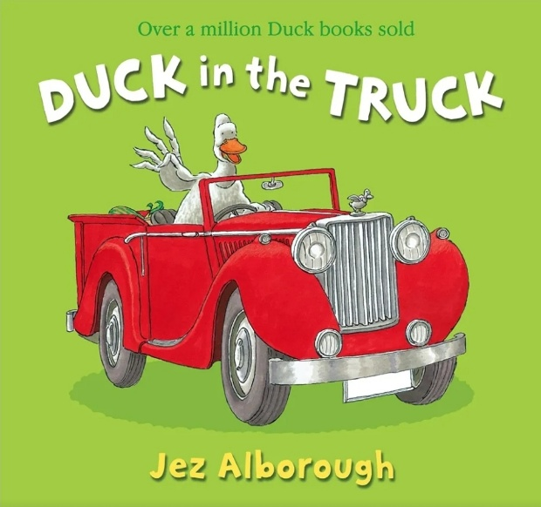
Duck in the Truck by Jez Alborough
This is the tale of a duck in a truck- a truck that was stuck in some yucky brown muck. And a sheep in a jeep and a frog in a bush, saw the truck stuck and gave it a push. But the truck stayed stuck! What now, can you guess? Could a goat in a boat get them out of this mess?
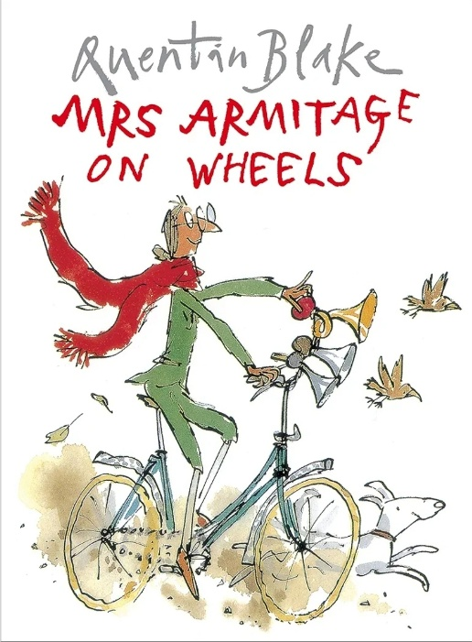
Mrs Armitage on Wheels by Quentin Blake
Mrs Armitage sets off for a quiet cycle with her dog, but she just can’t help thinking of ways to improve her bicycle- see how the many additions she makes ends up causing her some trouble!

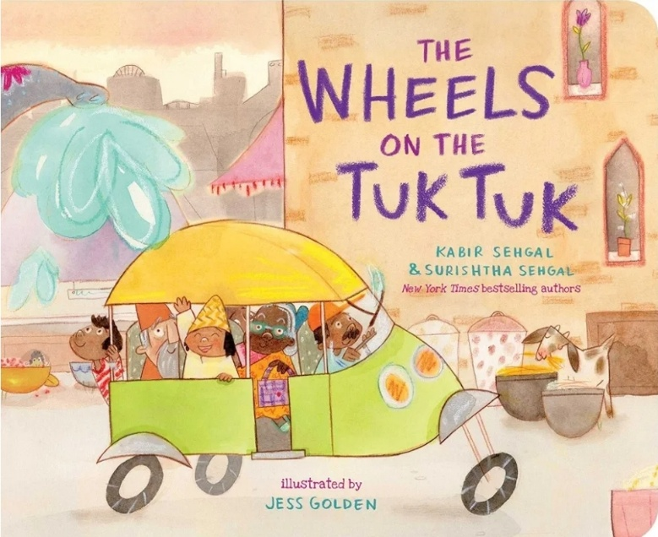
The Wheels on the Tuk Tuk by Kabir Sehgal
Anything can happen as the tuk tuk rolls through the town- from an elephant encounter to a tasty treat to a grand fireworks display! In the midst of all the action, passengers young and old love every minute of their exciting ride, as the wheels of the tuk tuk go round and round.
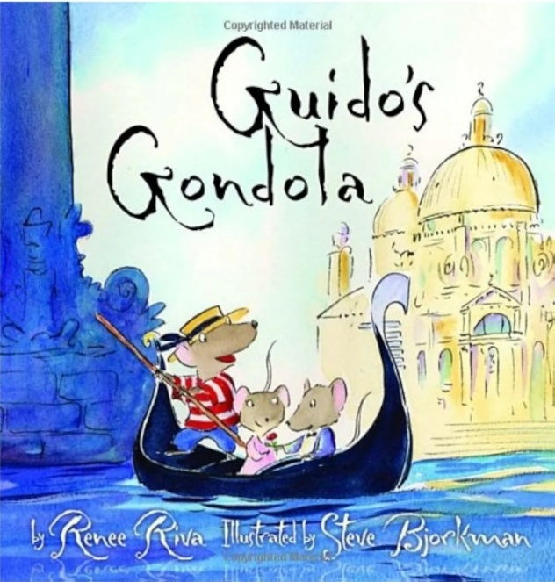
Guido’s Gondola by Steve Bjorkman
Guido spends his days shuttling tourists along the waterways of Venice in a small gondola. The kindhearted young rat enjoys the simple pleasures of his world until his eyes are opened to the possibilities of all that a could be accomplished with a larger faster vessel!
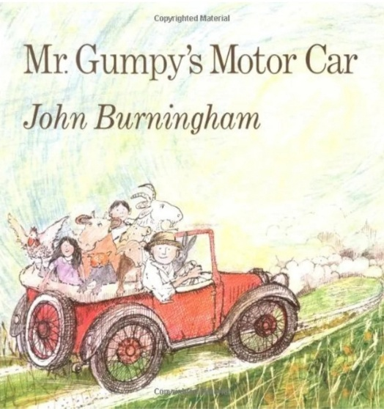
Mr Gumpy’s Motor Car by John Burningham
Mr Gumpy has decided to go for a ride in his motor car, it’s a nice day and the sun is shining, so off he goes. But he only gets as far as the lane before the children, the rabbit, the cat, the dog, the pig, the sheep, the chickens, the calf and the goat ask if they can come along too. Join them on their journey full of ups and downs!

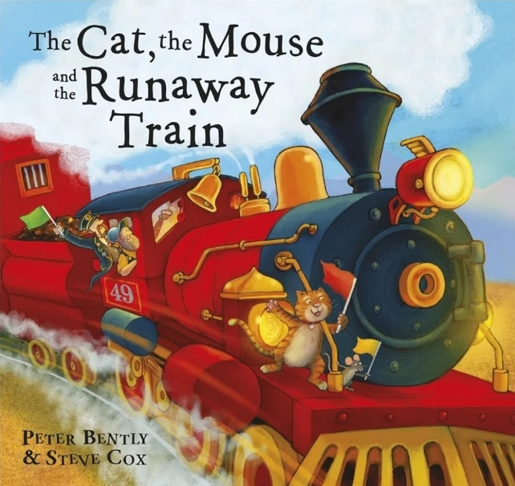
The Cat, the Mouse and the Runaway Train by Peter Bentley
When a naughty little mouse steals cheese from the station master, a battle between cat and mouse follows! But they put their differences a side when a big red steam train comes tearing down the track straight towards them!

