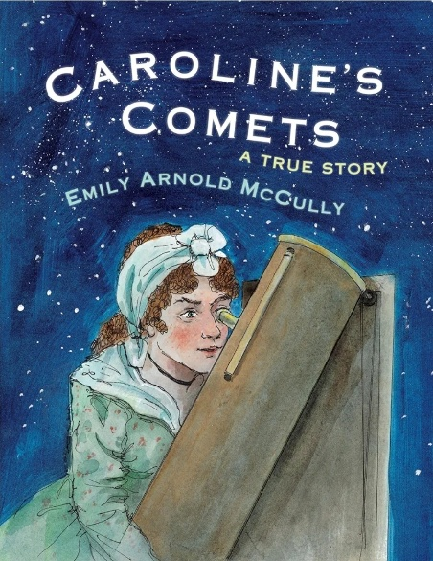
If you have enjoyed the story “Whatever Next!” Why not explore these other great stories about space. We will be exploring these books throughout this half term in Acorn class

Caroline's Comets by Emily Arnold McCully
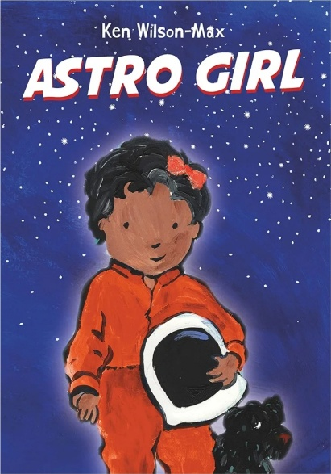
Learn about how Caroline Herschel used her telescope and discovered nebulae, galaxies and was the first woman to discover a comet!

Astro Girl by Ken Wilson-Max
Astrid has always loved the stars and space, with dreams of becoming an astronaut. While her Mama is away her and her Pape have fun role-playing challenges astronauts face during space missions. Astrid of course, can do them all! Then it is time to meet Mama at the airbase, but where has she been?

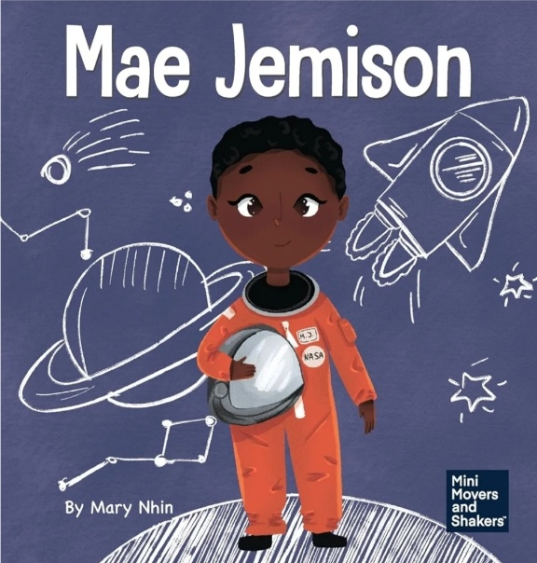

Mae Jemison by Mary Nhin
Meet Mae Jemison, learn about how she worked hard through challenges to reach her dream!

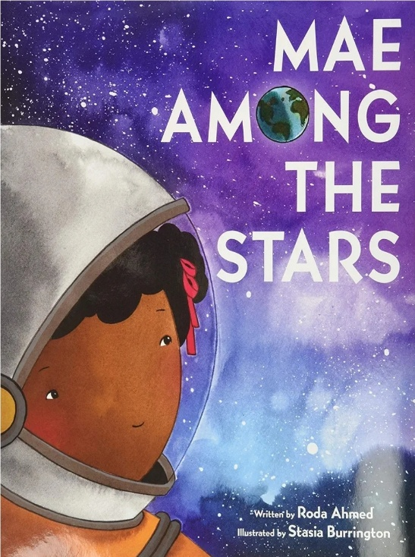
Mae Among the stars by Roda Ahmed
A story inspired by the life of the first African American woman to travel into space- Mae Jemison
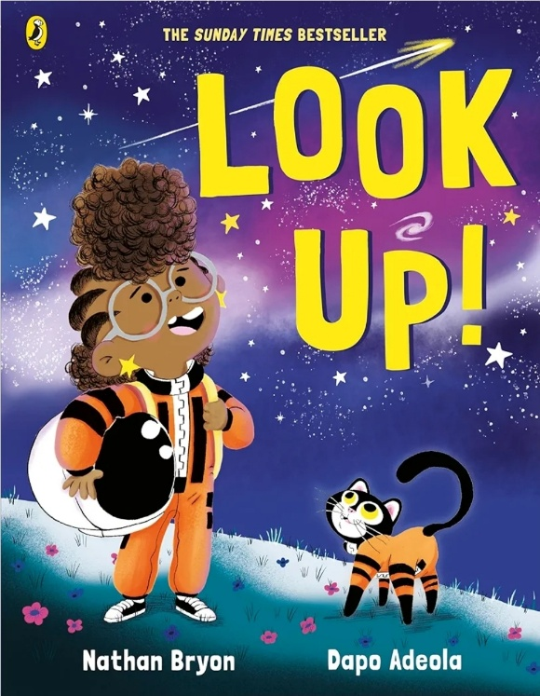
Look Up! By Nathan Bryon
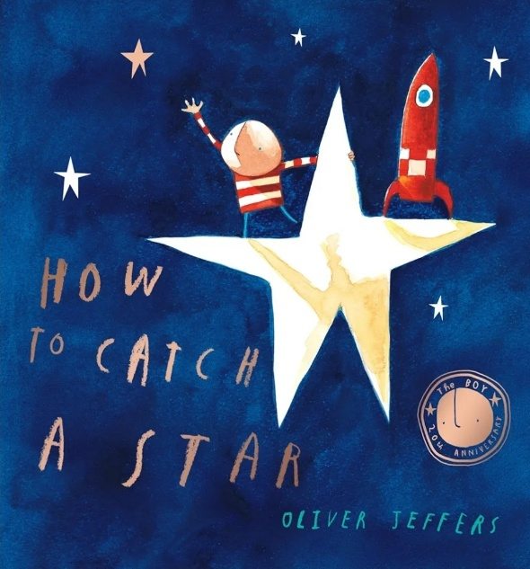
Meet hilarious, science-mad, chatterbox- Rocket. She’s going to be the greatest astronaut, star-catcher, space-traveller that has ever lived. But can she convince her big brother to stop looking down at his phone and start looking up at the stars?

How to Catch a star by Oliver Jeffers
Discover this story of a boy who loved the stars so much, he decided to catch one of his very own!
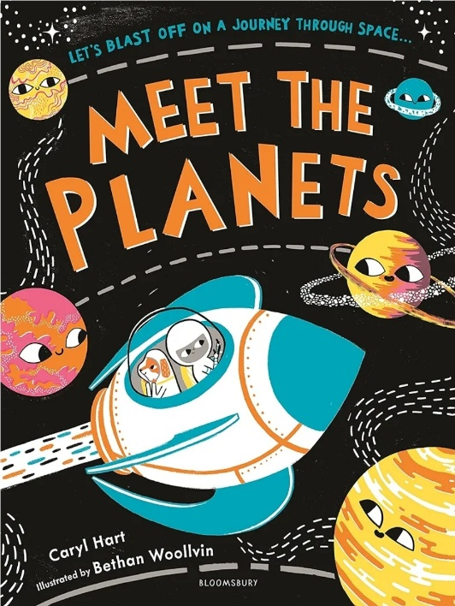
Meet the Planets by Caryl Hart

Zoooooom! We’re off on an exciting adventure in our own rocket to meet all the planets of solar system!
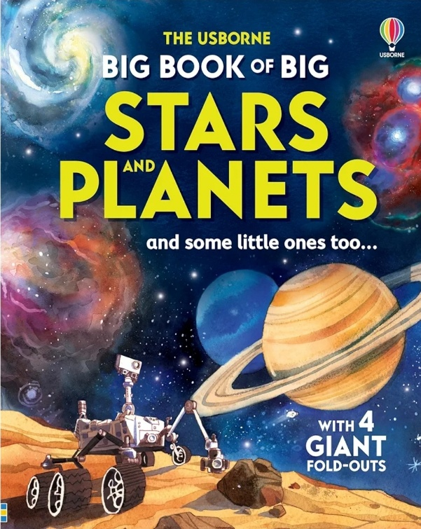

The Usborne Big Book of Stars and Planets
Explore some of the wonders of space- from the sun and the planets in our solar system, to massive stars, vast galaxies and lots, lots more.
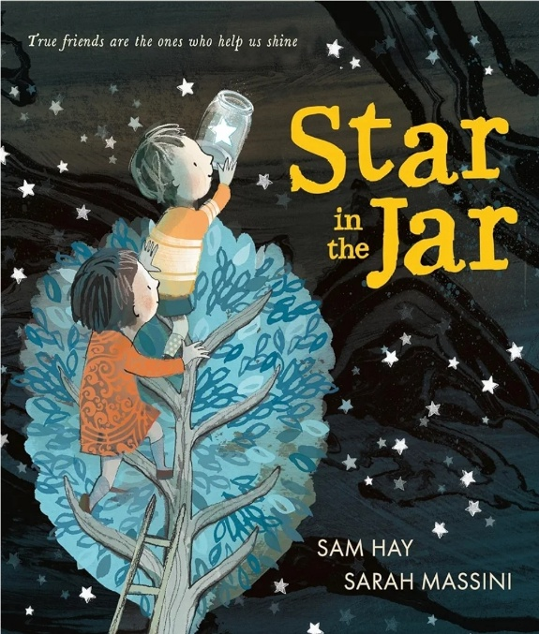
Star in the Jar by Sam Hay
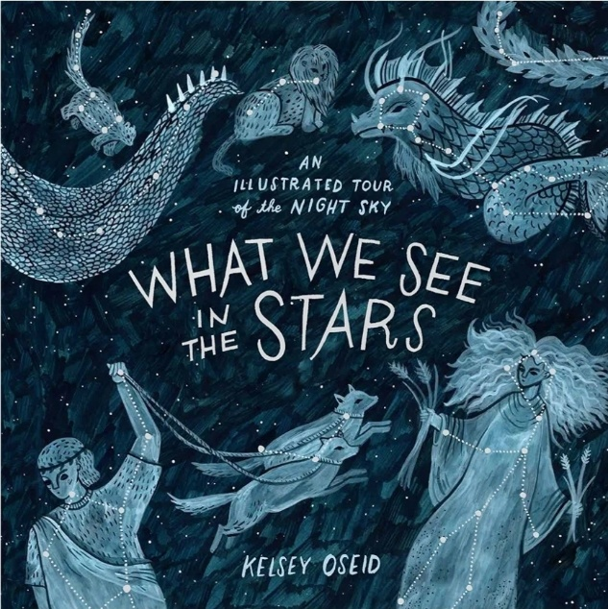
When a little boy stumbles across a special star, he puts it in a jar and along with his sister, takes it on some adventures- including to cinema, to the swimming pool and even to the toilet! But the poor star is sad and misses it’s friends in the sky- can the little boy and his big sister find a way to send the star safely back home?

What we see in the Stars by Kelsey Oseid
Go on a tour of the night sky- explore it’s most brilliant feature- such as constellations, the moon, the bright stars and the visible planets, plus outer planets, nebulae and deep space.

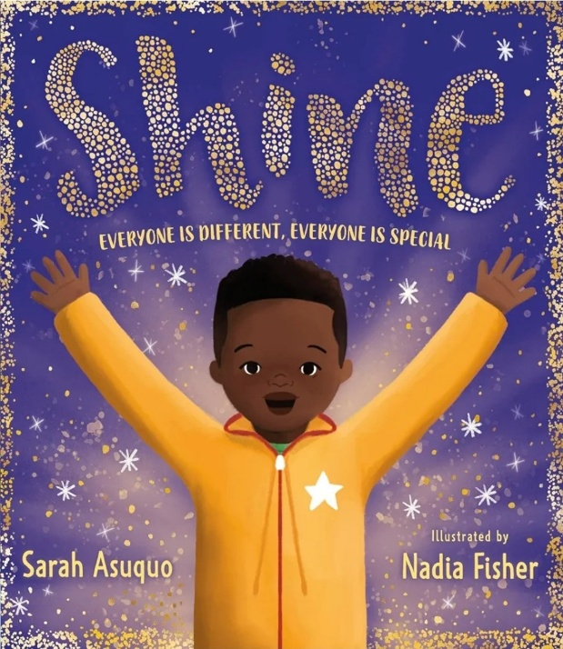

Shine by Sarah Asuquo
When Kai is bullied for being too tall and having a unique scar under her eyes- he begins to wish he was the same as everybody else. With the help of his parents, can Kai learn that the things that make him different are things that make him special and let his light shine through?
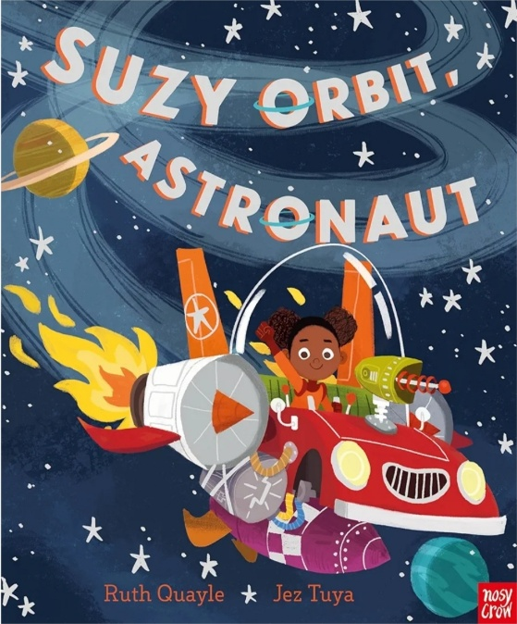
Suzy Orbit, Astronaut by Ruth Quayle
When Suzy Orbit and her boss, Captain Gizmo hear that aliens have been spotted near their space station, they must act fast!
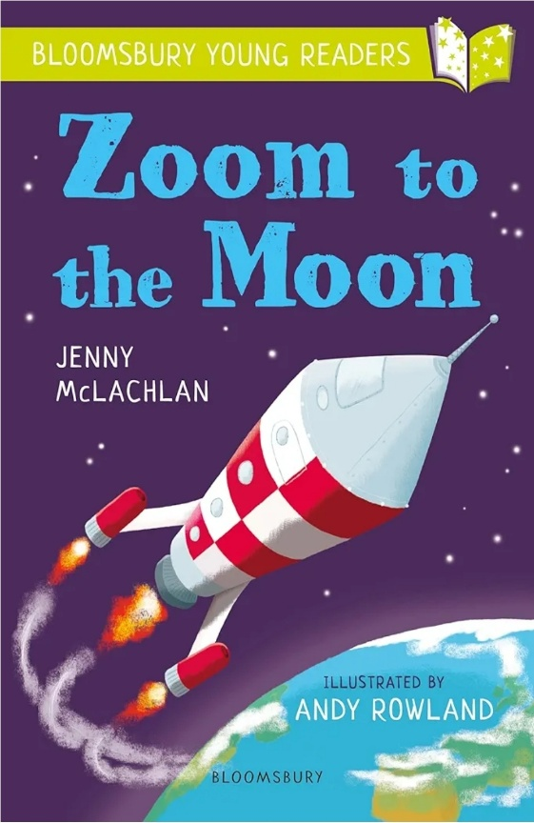
Zoom to the Moon by Jenny McLachlan
On a school trip to the space museum, Reva and Bobby climb into a real rocket named Jupiter Two. The poor rocket has never been into space, so when Reva and Bobby count down and press a big red button, Jupiter Two bursts into life. Soon Reva and Bobby are on their way to the moon!
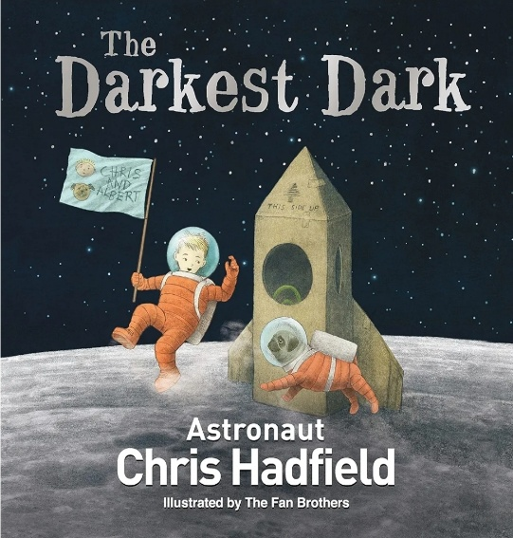
The Darkest Dark by Chris Hadfield
A story inspired by the childhood of real-life astronaut, commander Chris Hadfield- a story will encourage children to dream big, think like an astronaut and embrace the unknown!

