If you have enjoyed the story “The Queen’s Hat” Why not explore these other great stories about Kings and Queens. We will be exploring these books throughout this half term in Acorn class
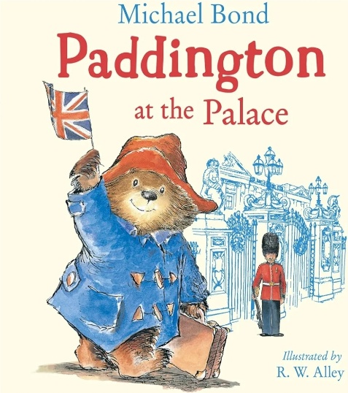
Paddington at the Palace by Michael Bond
When Mr Gruber takes Paddington to the Buckingham Palace to watch the changing of the Guard, there are so many people in the way he can’t see a thing. Luckily, a mysterious someone ‘on high’ appears to like small bears!
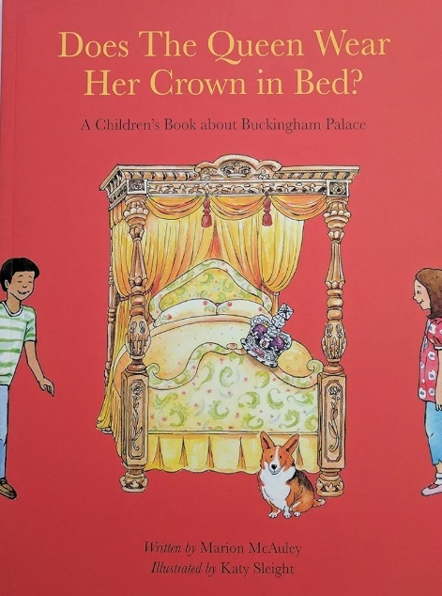

Does the Queen wear her crown in bed? By Marion McAuley
Take a fun look at some of the realities of royal life- explore whether the Queen wear her crown, what she eats and how she lives in the palace.

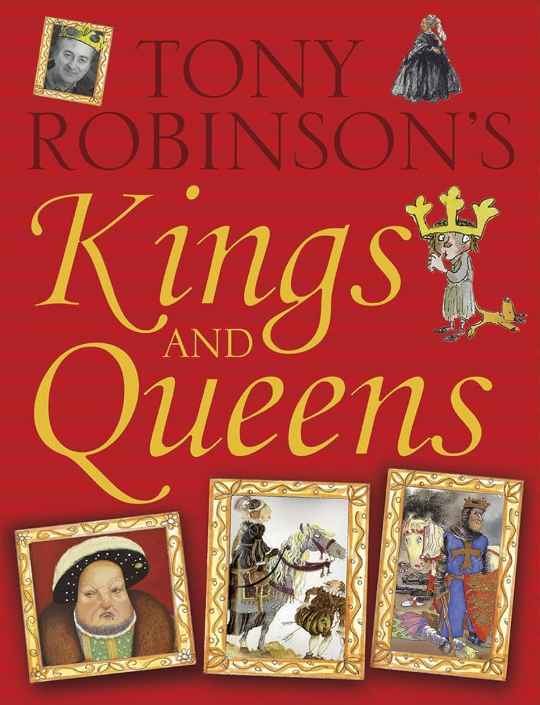
Kings and Queens by Tony Robinson
Explore some fascinating facts such as which King invented the handkerchief? Which King died on the toilet? And who is England’s longest reigning monarch.
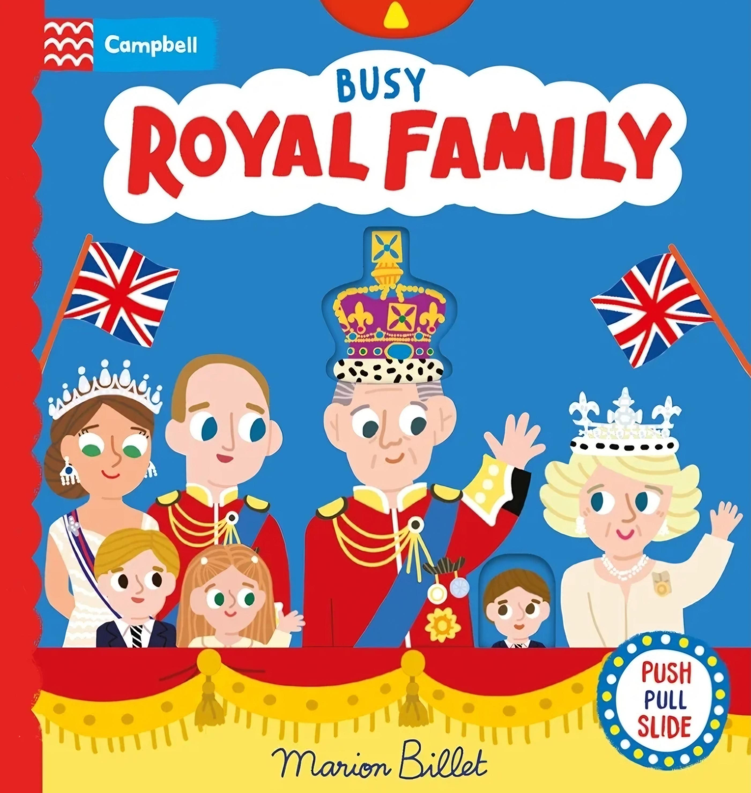
Busy Royal Family by Marion Billet
Push, pull and slide the tabs to help the King choose his outfit, enjoy a day at the races and go on a carriage ride.

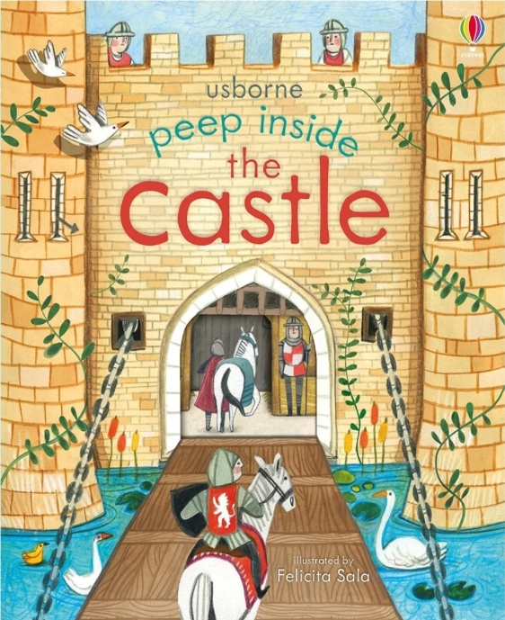

Peep inside a Castle by Usborne
Lift the flaps and peep through the holes in the pages to explore various rooms, what they were used for and by who.
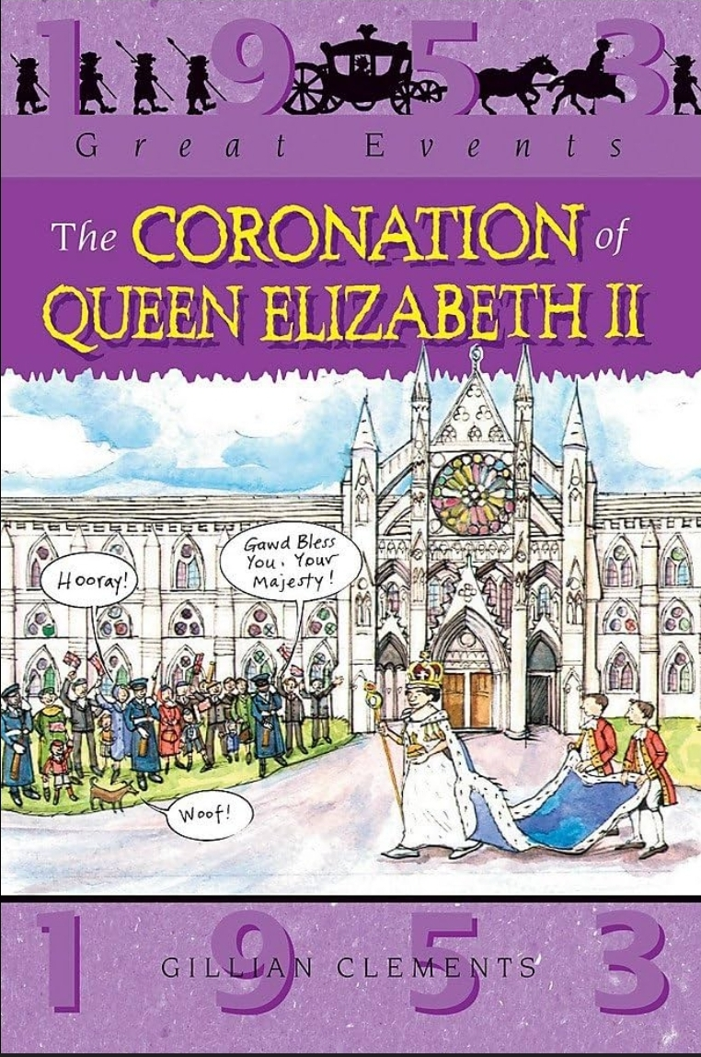

The Coronation of Queen Elizabeth II by Gillian Clements
Delve into the history of our late Queen’s coronation, exploring facts and details about this historic event.

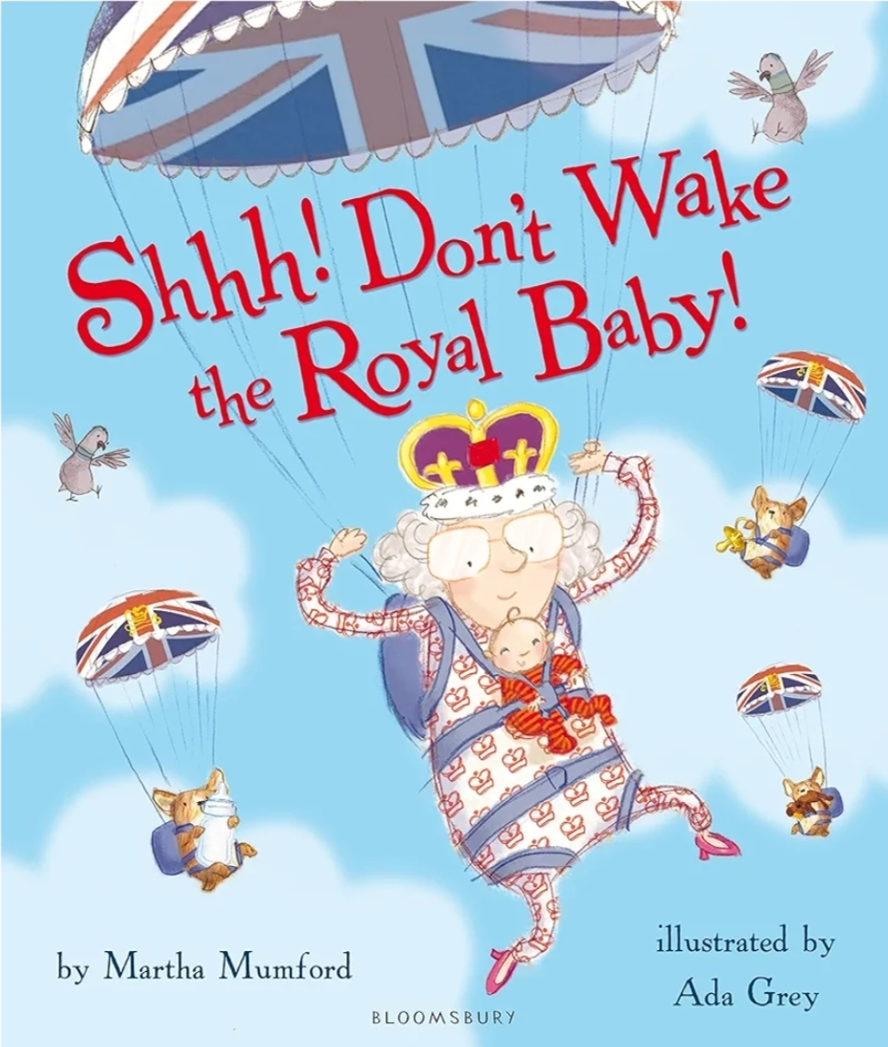
Shhh! Don’t wake the Royal Baby! By Martha Mumford
It’s chaos at the Royal Palace, the Royal Baby just won’t go to sleep!
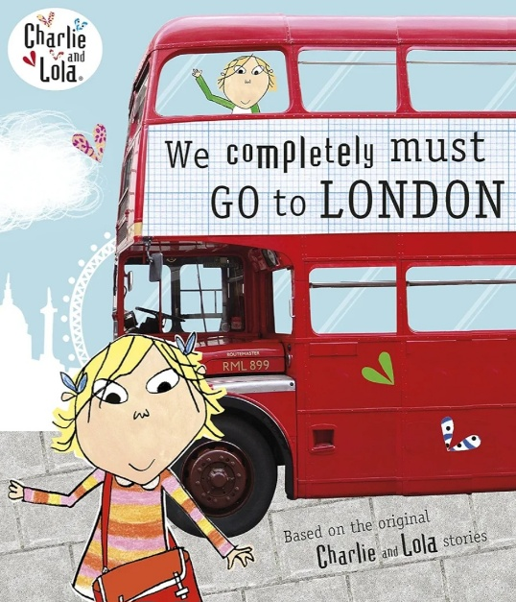
From yip-yapping corgis to marching guards and noisy party planning, the palace is awash with noise. Will it ever be peaceful enough for the baby to sleep?

Charlie and Lola We completely must go to London by Lauren Child
Join Charlie and Lola as they take in all of London’s most famous and best sights!

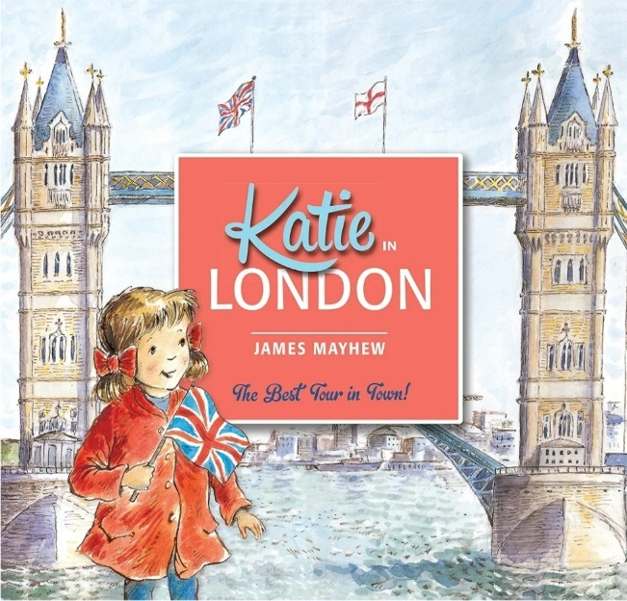
Katie in London by James Mayhew
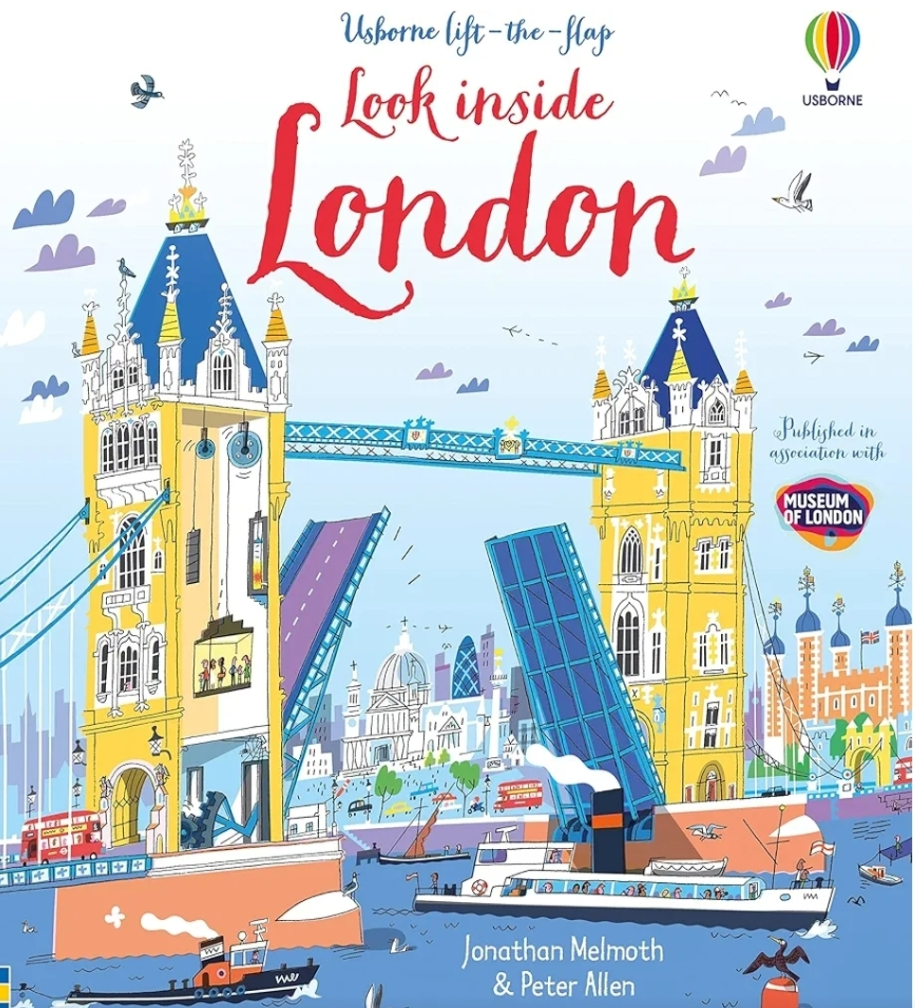
When Katie and her brother Jack visit London with their Grandma, something very unexpected happens....one of the Trafalgar Square lions comes to life and takes them on a wonderful tour of all the best sights!

Look inside London by Usborne
Explore London’s most famous sites- Buckingham Palace, Trafalgar Square and the Tower of London. With lots to spot and talk about- including red telephone boxes, red double decker buses and black cabs.

