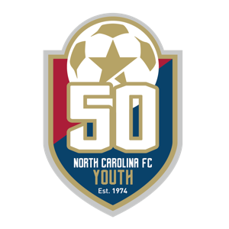

To: visitaleigh.com Showcase Series Clubs From: North Carolina FC Youth
RE: 2025 visitraleigh.com Boys College Showcase

On behalf of North Carolina FC Youth, we would like to request the release of (Player Name) and all club players, from your school, to participate in the 2025 visitraleigh.com Showcase Series. The Boys College Showcase and College Combine will be held in Raleigh, North Carolina on Thursday, December 11 – Sunday, December 14, 2025.

We realize the importance of a player’s education and strive to accommodate the academic calendar as much as possible when planning and scheduling our yearly event structure. The visitraleigh.com Showcase Series, one of the nation’s top college recruiting events, begins on Thursday and may require the participating student/athletes to miss that Thursday and Friday from school.

Players participating in our showcase are exposed to one of the largest concentrations of college coaches on the east coast. Attracting 250+ college coaches last year, many of the players competing in our showcase expanded their college options by participating in our showcase. In addition to the recruiting exposure, players are also able to take advantage of North Carolina’s wealth of universities and colleges. Offering some of the top Division I, II and III schools regionally and nationally, players spend their downtime visiting schools they may not normally have visited.

While we understand the importance of education, we also believe that sport has its place for many of our participants. We hope you will understand and excuse the absence of student/athletes from school that Thursday and/or Friday of the visitraleigh.com Showcase Series.

Please feel free to contact us with any questions. I can be reached at Ryan.Holbrook@NCFCYouth.com or 984-222-1522.

Regards,

Ryan Holbrook
Director, Tournaments and Events
North Carolina FC Youth

3150 Spring Forest Road, Suite 116, Raleigh, NC 27616 | NCFCYouth.com | 919.834.3951

