  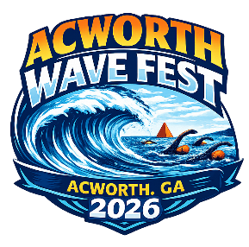 | 2026 Acworth Wave Fest | Hosted By:  Chattahoochee Gold
 | Date(s): 09/19/2026 - 09/20/2026 | 
 | Sanction #: GA26-075/OWS

Meet Director: | Meet Referee: | Admin Official:
Mike Wardwell  mikewardwell@goldswim.com | Jason Frankel  jf18111@gmail.com | Rob Copeland  rob_copeland@comcast.net  Beth Wise  beth.wise@gmail.com

SANCTION: | Held under the sanction of USA Swimming, through Georgia Swimming Inc.
LIABILITY: | In granting this sanction it is understood and agreed that USA Swimming, Inc., Georgia Swimming, Inc., and shall be free from any liabilities or claims for damages arising by reason of injuries to anyone during the conduct of the event.
FACILITY: | Cauble Park on Lake Acworth  4425 Beach Street  Acworth, Georgia 30101
MEDICAL DIRECTOR: | W. Robert Taylor, MD
MEDICAL SUPERVISION: | In addition to the medical director on site, lifeguards will always be on the water while swimmers are competing and/or warming up. In addition, DNR support has been requested.
SESSION SCHEDULE:
  Session # | Date | Name | Warmup | Start
  Clinic | 9-19-2026 | Open Water Clinic | N/A | 12:30 PM
  1 | 9-19-2026 | Relays | 3:30 PM | 4:30 PM
  2 | 9-20-2026 | Individual Events | 8:00 AM | 9:00 AM
MEET FORMAT: | The individual races at this meet will serve as an LSC Open Water Qualifier for the Georgia Swimming Zone Team. The competition will be organized according to these age classifications:  10 & Under  11-12  13-14  15-16  17 & Over  ● Course Type: Open water  ● Event Format: Open water  13 & Over Boys and Girls 5K  11-12 Boys and Girls 2.5K  10 & Under Boys and Girls 1.25K  ● Finals Type: Timed Finals  ● Warmup Lanes: A section of the course will be open for warm-ups.
ENTRY FEES: | ● Meet Fee: $80  ● GA LSC Travel Fund $3.00 / Georgia LSC registered athlete  ● GA travel fee $6.00 / non-Georgia LSC registered athlete
ELIGIBILITY: | MEET TYPE: Open  Open to all registered USA Swimmers.  No swimmer will be permitted to compete unless the swimmer is a member of USA Swimming as provided in USA Swimming Rules and Regulations, Article 302.  Swimmer(s) must be registered with Georgia Swimming to be accepted into this meet. Age as of September 18, 2026, shall determine the swimmer’s age for the Open Water race. Registered athletes from other LSCs may enter, but will not be eligible for Georgia Swimming Awards and Zones spots.. Swimmers must swim up to the age they are trying to qualify in for Open Water Zones
SWIMMERS WITH A DISABILITY: | Athletes with a disability are welcomed, but advance notice of desired accommodation must be provided to the Meet Referee via, the NECESSARY ACCOMODATIONS FORM, which should be submitted by the entry deadline. Failure to provide advance notice may limit the host’s ability to accommodate all requests.
ENTRIES: | Daily Limits: Each swimmer may enter a maximum of (1) individual event and (1) relay event.  Deck Entries: Deck entries will be allowed up to 60 minutes prior to the start of the event.  Entering clubs/swimmers need to remember to check all data BEFORE submitting. Entering club with unattached swimmer also needs to check all entry reports (and any exception reports) that the host returns. It is the responsibility of the entering club/unattached swimmer to heed deadlines and be responsible for the accuracy of club entries.
ENTRY SUBMISSION: | Submit one check payable to: Chattahoochee Gold Swim Team  Entries must be received on or before: 09/09/2026 5:00pm  Entries should be emailed to gold.openwater@gmail.com  Manual Entries must be sent to meet entry coordinator with Athletes full name, age, gender, and USA Swimming ID# by September 15, 2026, at 9 am via e-mail. The e-mailed Entry Report sent to you confirming your entry, along with all subsequent Entry Reports notifying you of changed or updated entries, shall be the official record of your entry. No other information will be considered if there is an entry error or discrepancy.
CHECK IN AND  SCHEDULE: | Saturday, September 19th  *Optional* Open Water Clinic at 12:30 PM  2:30 pm - Race Check in, suit and nail check  3:00 pm – Coaches Meeting  3:00 pm - Safety Briefing with all lifeguards, officials, and volunteers  3:30 pm – Couse open for warm up  4:15 pm - Safety Briefing for Relay  4:30 pm - 4 x 300 M Relay Race  Sunday, September 20th  7:00 am - Race Check in, suit and nail check  7:30 am - Safety Briefing with all lifeguards, officials, and volunteers  7:30 am - Coaches Meeting  7:45 am - 5k Race briefing  8:00 am – Course Open for Warm Up  9:00 am - 5k start with 5 minutes between boys and girls waves  10:45 am - 2.5K & 1.25K Race briefing  11:00 am - 2.5K start (boys and girls)  11:30 am - 1.25K start (boys and girls)  The meet leadership may need to adjust the timings to accommodate for weather, entries, and other factors.
SAFETY: | There will be a mandatory Pre-Race Briefing held before competition begins to discuss the course, rules, and safety procedures. The Referee will remove any swimmer from competition who does not attend the clinic or is found to be inattentive during the clinic. Course will be patrolled by qualified safety personnel.
ATHLETE: | Athletes conduct will be governed by Part Seven of the USA Swimming Rules and Regulations Handbook. Intentional obstruction, interference or intentional contact with another swimmer may be deemed "Unsporting Impedance" and lead to disqualification. Swimmers shall maintain clearance from other swimmers except at the start, turn, and the finish or where the course or race conditions dictate otherwise. Parents and swimmers should be advised that there are a sizable number of entrants. Open water swimmers may expect to involve inadvertent contact with other swimmers. It is important that swimmers keep a cool head while in the water.
RULES: | Current USA Swimming Rules will govern this meet.  - All adults participating in or associated with this meet acknowledge that they are subject to the provisions of the USA Swimming Minor Athlete Abuse Prevention Policy ("MAAPP"), and that they understand that compliance with MAAPP is a condition of participation in the conduct of this competition.  - On Deck USA-S registration will be permitted at the discretion of the Meet Director and/or Meet Referee.  - In compliance with USA Swimming Rules and Regulations, the use of audio or visual recording devices, including a cell phone is not permitted in the changing areas, restrooms, or locker rooms. Per GA Swimming policy, the use of equipment capable of taking pictures (e.g., cell phones, cameras, etc.) is banned from behind the starting blocks during the entire meet, including warm up, competition and cool down periods.  - Deck changes are prohibited.  - Any swimmer entered in the meet must be certified by a USA Swimming member coach as being proficient in performing a racing start or must start each race from within the water without the use of the backstroke ledge. When unaccompanied by a member-coach, it is the responsibility of the swimmer or the swimmer’s legal guardian to ensure compliance with this requirement.  - Operation of a drone or any other flying apparatus is prohibited over the venue (pools, athlete/coach areas, spectator areas and open ceiling locker rooms) any time athletes, coaches, officials and/or spectators are present.
TIMING SYSTEM: | Passive timing system with ankle strap transponders.
OPEN WATER ZONES: | This meet will be a qualifying event for those that are interested in making the GA Swimming Open Water Zones Team. Swimmers interested must apply for the Zones team by Friday, September 15th using the link. The top two (2) swimmers in the age groups below per gender will make the zones team.  11-12  13-14  15-16  Open
TIME LIMITS: | Swimmers must finish within 30 minutes of the first swimmer in their event to be eligible for scoring and award.
WARM-UP PROCEDURES: | An area will be set up for swimmers to warm up. Swimmers found in the water outside of the designated area will be scratched from the meet regardless of whether or not they have completed their events.
CHANGING AREAS: | Except where venue facilities require otherwise, changing into or out of swimsuits other than locker rooms or changing facilities, or other designated areas, is prohibited.
CREDENTIALS: | Only athletes, USA Swimming certified coaches, and USA Swimming officials, in good standing, will be permitted on the competition areas. Coaches and Officials should have proof of active USA Swimming membership with them at all times. Parents not working the meet as a volunteer or other position are not permitted in the competition areas.
COACHES MEETING: | Saturday, September 19th @ 3:00 PM and Sunday, September 20th @ 7:30 AM
OFFICIALS: | Chattahoochee Gold welcomes visiting officials and apprentices and will appreciate help in officiating this competition. There will be an official's meeting 1 hour prior to the start of each session. The official's uniform will consist of a white polo collared shirt, and navy blue shorts, skirts or slacks. All officials must present at check in, their current LSC Officials Certification Card; OR a recently completed Apprentice Form; AND proof of current USA Swimming Non-Athlete membership. Credentials may be required for deck access and hospitality.
AWARDS: | 1st through 3rd place for each age group will receive awards in the relays.  1st through 3rd place for each age group will receive awards in the individual events for: 10 & Under, 11-12, 13-14, and 15 & Over.
SCORING: | No
CONCESSIONS: | N/A
GEORGIA WARM-UP POLICY: | The GA Swimming Warm Procedures and Safety Policies will be followed.
MISC. INFORMATION: | Operation of a drone on state park facilities is not approved without prior consent through the park ranger.  Results and Hy-Tek Team Manager Results file will be posted to gaswim.org.
LODGING: | For those that need lodging, please visit Acworth Tourism for local places to stay.
VENDORS: | Reddiset will be onsite selling event merchandise and swim gear.

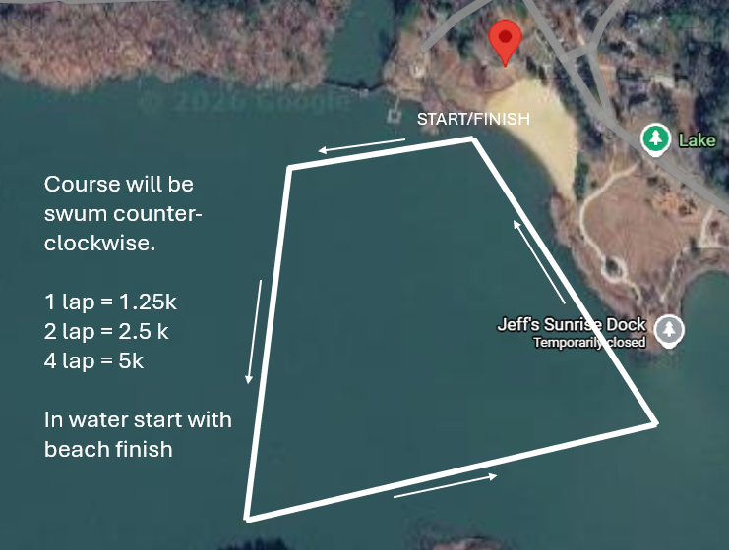
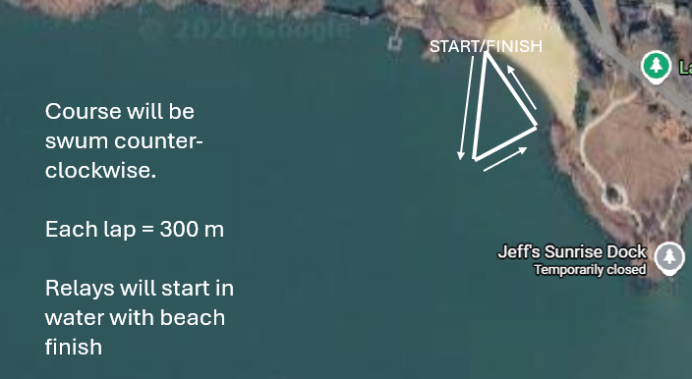
Event Schedule

Saturday, September 19th
Boys | Age | Event | Girls
1 | 15 & Over | 4x300 Relay | 2
3 | 11-14 | 4x300 Relay | 4
5 | 10 & Under | 4x300 Reay | 6

Sunday, September 20th
Boys | Age | Event | Girls
7 | 13 & Over | 5K* | 8
9 | 11-12 | 2.5K | 10
11 | 10 & Under | 1.25K | 12

2026 Acworth Wave Fest: 9/19/2026 - 9/20/2026

Team Name Team abbreviation

Team Address

City State Zip

Head Coach

Head Coach E-mail Head Coach Cell
All coaches from your team must be listed and have valid USA Swimming credentials.
1st Coach 2nd Coach

3rd Coach 4th Coach

Meet Fees | $80 x (number of athletes)
GA LSC Travel Fund | $3.00 x (number of athletes) | =_________
Non-GA LSC registered athletes | $6.00 x (number of athletes) | =_________
 | TOTAL | =_________

Submit one check payable to: Chattahoochee Gold Swim Club
Entries must be received on or before 09/09/2026 05:00pm
Email entries to: entries@goldswim.com

WAIVER, ACKNOWLEDGMENT AND LIABILITY RELEASE:
I, the undersigned coach, or team representative, verify that all swimmers and coaches listed on the enclosed entry are registered with USA Swimming.
I acknowledge that I am familiar with the safety rules of USA Swimming and Georgia Swimming regarding warm-up procedures and that I shall be responsible for the compliance of my swimmers with those rules during this meet.

I have reviewed RULE 302.4 FALSE REGISTRATION and understand that if a swimmer who is not properly registered with USA Swimming competes in a sanctioned competition, Georgia Swimming Inc. may impose a fine of up to $100.00 per event against the individual, member coach or member club submitting the entry.

Signature/Title Date

