 | 2026 Gatorfest | Hosted By:  Chattahoochee Gold
 | Date(s): 10/25/2026 - 10/25/2026 | 
 | Sanction #:

Meet Director: | Meet Referee: | Admin Official:
Mike Wardwell  mikewardwell@goldswim.com | Jason Frankel  jf18111@gmail.com | Kelly Griendling  kelly.griendling@gmail.com

SANCTION: | Held under the sanction of USA Swimming, through Georgia Swimming Inc.
LIABILITY: | In granting this sanction it is understood and agreed that USA Swimming, Inc., Georgia Swimming, Inc., and shall be free from any liabilities or claims for damages arising by reason of injuries to anyone during the conduct of the event.
FACILITY: | Laura S. Walker State Park (Boat Ramp side of the lake)  5653 Laura Walker Rd  Waycross, Georgia 31503
MEDICAL DIRECTOR: | W. Robert Taylor, MD
MEDICAL SUPERVISION: | In addition to the medical director on site, lifeguards will always be on the water while swimmers are competing and/or warming up. In addition, DNR support has been requested, as well as on-site EMS from Ware County.
SESSION SCHEDULE:
  Session # | Date | Name | Warmup | Start
  1 | 10-25-2026 | Open Water Individual Events | 9:00 AM | 10:00 AM
MEET FORMAT: | ● Course Type: Short Course Yards  ● Event Format: The Open Water Race serves as the LSC Open Water Qualifier for Georgia Swimming Zone Team. The competition will be organized according to these age classifications:  10 & Under  11-12  13-14  15-16  17 & Over  Event Format: Open water  13 & Over Boys and Girls 5K  11-12 Boys and Girls 2.5K  10 & Under Boys and Girls 1.25K  ● Finals Type: Timed Finals  ● Warmup: A section of the course will be made available for warm-ups.
ENTRY FEES: | ● MEET FEE: $75  ● PARKING FEE: $10/VEHICLE  ● GA LSC Travel Fund $3.00 / Georgia LSC registered athlete  ● GA travel fee $6.00 / non-Georgia LSC registered athlete
ELIGIBILITY: | MEET TYPE: Open  Open to all registered USA Swimmers.  No swimmer will be permitted to compete unless the swimmer is a member of USA Swimming as provided in USA Swimming Rules and Regulations, Article 302.  Swimmer(s) must be registered with Georgia Swimming to be accepted into this meet. Age as of October 25, 2026, shall determine the swimmer’s age for the Open Water race. Swimmers must swim up to the age they are trying to qualify in for Open Water Zones.
SWIMMERS WITH A DISABILITY: | Athletes with a disability are welcomed, but advance notice of desired accommodation must be provided to the Meet Referee via, the NECESSARY ACCOMODATIONS FORM, which should be submitted by the entry deadline. Failure to provide advance notice may limit the host’s ability to accommodate all requests.
ENTRIES: | Daily Limits: Each swimmer may enter a maximum of (1) individual event.  Deck Entries: Deck entries can be made up to 60 minutes prior to the start of the event.
CHECK IN: | Athletes will have suits and nails checked as well as marked with race numbers at race check in.
CLERK of COURSE: | 8:00a-8:30a- Race Check in, suit and nail check  8:30a- Safety Briefing with all lifeguards and officials  8:45a-9:15a- Course Open for Warm Up  9:20a- 5k Race briefing  9:30a- 5k start with 5 minutes between boys and girls waves  11:00a- 2.5K 1.25K Race briefing  11:10- 2.5K start (boys and girls)  11:20p- 1.25K start (boys and girls)
ENTRY SUBMISSION: | Submit one check payable to: Chattahoochee Gold Swim Team  Entries must be received on or before: 10/18/2026 5:00pm  Entries should be emailed to gold.openwater@gmail.com  Manual Entries must be sent to meet entry coordinator with Athletes full name, age, gender, and USA Swimming ID# by October 18, 2026, at 5pm via e-mail. The e-mailed Entry Report sent to you confirming your entry, along with all subsequent Entry Reports notifying you of changed or updated entries, shall be the official record of your entry. No other information will be considered if there is an entry error or discrepancy.
RULES: | Current USA Swimming Rules will govern this meet.  - All adults participating in or associated with this meet acknowledge that they are subject to the provisions of the USA Swimming Minor Athlete Abuse Prevention Policy ("MAAPP"), and that they understand that compliance with MAAPP is a condition of participation in the conduct of this competition.  - On Deck USA-S registration will be permitted at the discretion of the Meet Director and/or Meet Referee.  - In compliance with USA Swimming Rules and Regulations, the use of audio or visual recording devices, including a cell phone is not permitted in the changing areas, restrooms, or locker rooms. Per GA Swimming policy, the use of equipment capable of taking pictures (e.g., cell phones, cameras, etc.) is banned from behind the starting blocks during the entire meet, including warm up, competition and cool down periods.  - Deck changes are prohibited.  - Any swimmer entered in the meet must be certified by a USA Swimming member coach as being proficient in performing a racing start or must start each race from within the water without the use of the backstroke ledge. When unaccompanied by a member-coach, it is the responsibility of the swimmer or the swimmer’s legal guardian to ensure compliance with this requirement.  - Operation of a drone or any other flying apparatus is prohibited over the venue (pools, athlete/coach areas, spectator areas and open ceiling locker rooms) any time athletes, coaches, officials and/or spectators are present.
CREDENTIALS: | Only athletes, USA Swimming certified coaches, and USA Swimming officials, in good standing, will be permitted on the deck. Coaches and Officials should always have proof of active USA Swimming membership with them. Parents not working at the meet as a volunteer or other position are not permitted on deck.
OFFICIALS: | HOST CLUB welcomes visiting officials and apprentices and will appreciate help in officiating this competition. There will be an official's meeting 1 hour prior to the start of each session. The official's uniform will consist of a white polo collared shirt, navy blue shorts, skirts or slacks with white socks and white shoes. All officials must present at check in, their current LSC Officials Certification Card; OR a recently completed Apprentice Form; AND proof of current USA Swimming Non-Athlete membership. Credentials may be required for deck access and hospitality.
AWARDS: | Awards for top finishers in each of the following age groups: 10 & Under, 11-12, and 13 & Over.
SCORING: | No scoring
CONCESSIONS: | None
GEORGIA WARM-UP POLICY: | The GA Swimming Warm Procedures and Safety Policies will be followed.
MISC. INFORMATION: | Everyone must pay the parking fee prior to parking their vehicle. There will be QR codes to scan when entering the boat ramp.

Event Schedule

Boys | Age | Event | Girls
1 | 13 & Over | 5K* | 2
3 | 11-12 | 2.5K | 4
5 | 10 & Under | 1.25K | 6
* 5 minutes between boys and girls wave
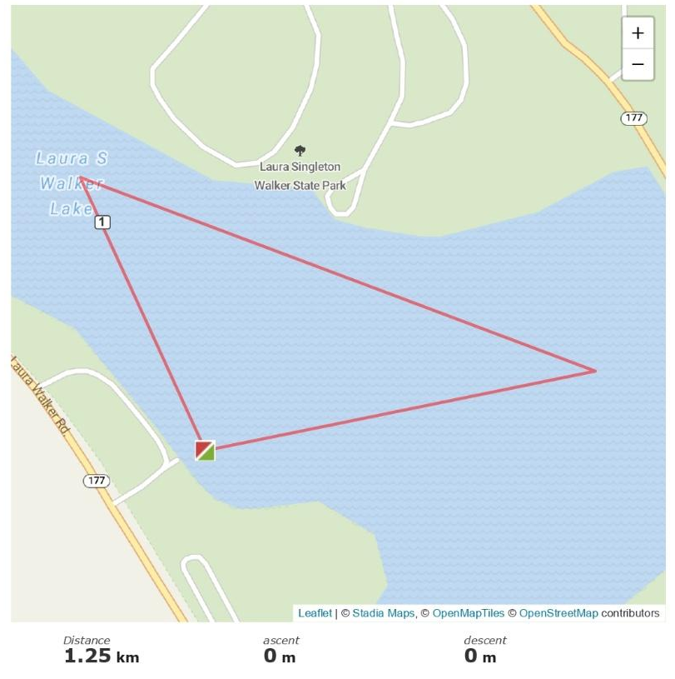

2026 Gatorfest: 10/18/2026

Team Name Team abbreviation

Team Address

City State Zip

Head Coach

Head Coach E-mail Head Coach Cell
All coaches from your team must be listed and have valid USA Swimming credentials.
1st Coach 2nd Coach

3rd Coach 4th Coach

Meet Fee | $75.00 x (number of athletes) | =_________
GA LSC Travel Fund | $3.00 x (number of athletes) | =_________
Non-GA LSC registered athletes | $6.00 x (number of athletes) | =_________
 | TOTAL | =_________

Submit one check payable to: Chattahoochee Gold Swim Team
Entries must be received on or before 10/07/2026 05:00pm
Email entries to: gold.openwater@gmail.com

WAIVER, ACKNOWLEDGMENT AND LIABILITY RELEASE:
I, the undersigned coach, or team representative, verify that all swimmers and coaches listed on the enclosed entry are registered with USA Swimming.
I acknowledge that I am familiar with the safety rules of USA Swimming and Georgia Swimming regarding warm-up procedures and that I shall be responsible for the compliance of my swimmers with those rules during this meet.

I have reviewed RULE 302.4 FALSE REGISTRATION and understand that if a swimmer who is not properly registered with USA Swimming competes in a sanctioned competition, Georgia Swimming Inc. may impose a fine of up to $100.00 per event against the individual, member coach or member club submitting the entry.

Signature/Title Date

