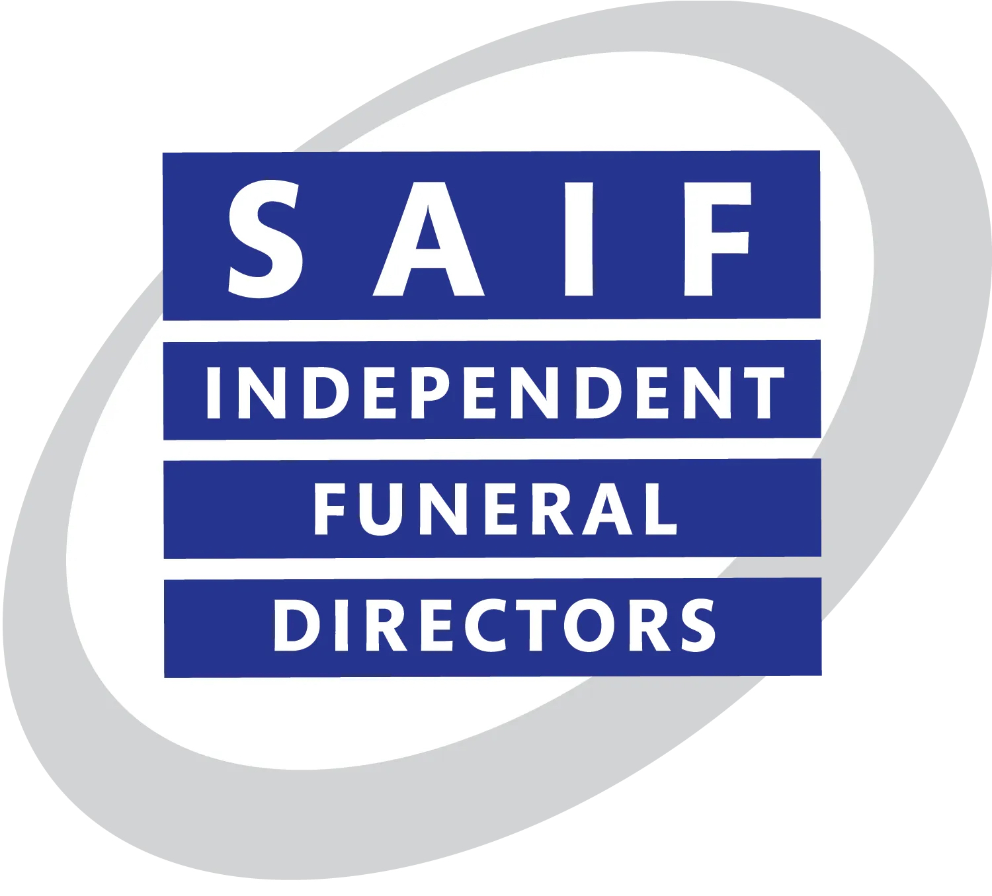
David Scott (Blairgowrie) Ltd
Funeral Directors & Monumental Agents

Complaints Procedure
Our commitment to clients
We aim to ensure that:

- Making a complaint is as easy as possible and we treat your complaint seriously
- We deal with your complaint promptly and in confidence
- We learn from complaints and use them to review and improve our service.

What is a complaint?
A complaint is when you tell us you are not happy about any part of the service and/or the products we provide.

How to make a complaint
If you wish to make a complaint you can contact Mr W. Mackay, in any of the ways listed below:

By email: enquiries@dscottfunerals.co.uk

In writing to: David Scott (Blairgowrie) Ltd, 65 High Street, Blairgowrie. PH10 6DF

In person (by appointment only): David Scott (Blairgowrie) Ltd, 65 High Street, Blairgowrie. PH10 6DF

Your complaint will be acknowledged within 3 days and fully investigated within 5 working days.
If you are unhappy with the response, you can contact Mr W. Mackay in any of the ways listed below:

By email: enquiries@dscottfunerals.co.uk

In writing to: David Scott (Blairgowrie) Ltd, 65 High Street, Blairgowrie. PH10 6DF

If You are Still Unhappy

If you are still unhappy with our response you can contact The National Society of Allied & Independent Funeral Directors (SAIF) in any of the ways listed below, quoting our membership number 734:

By email: standards@saif.org.uk

In writing to: The National Society of Allied and Independent Funeral Directors,

SAIF Business Centre, 3 Bullfields, Sawbridgeworth, Herts CM21 9DB

By phone: 0845 230 6777 or 01279 726 777

By fax: 01279 726 300

Your complaint will be acknowledged within 7 days then fully investigated. Timescale for findings and final response will vary depending on each individual case and investigation.

Please note that The National Society of Allied and Independent Funeral Directors (SAIF) will not investigate a complaint unless the internal complaints procedure of the Funeral Directors has been exhausted.

If you are still unhappy with the response and final decision of The National Society of Allied and Independent Funeral Directors (SAIF) you can request that your complaint be referred to The Inspector of Funeral Directors. For more information please visit - www.saif.org.uk

