GARZA DRIVING SCHOOL
2822 N. CLOSNER BLVD STE B
EDINBURG, TX. 78539
956-318-5141
Teen Driver’s Education Program

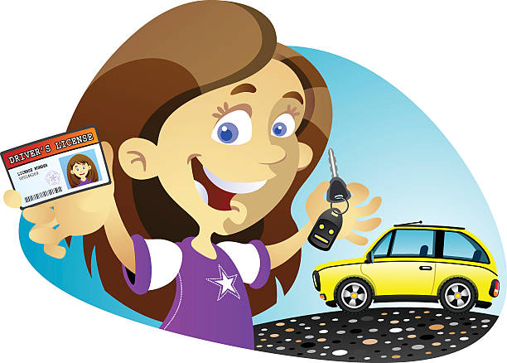

Course cost $450.00
Can be paid in full or 2 payments:
1st half payment due on day of registration.
2nd half payment due by the 3rd week of class.
Phase 1: Classroom – 24 hours
Regular Course: 2 weeks Mon. – Thurs. 5pm-8pm
(Students are allowed to miss up to 10 hours of class time. Missed time must be completed within the 6-month contract time frame.)

Fast Track Course: 4 days (only available during holidays or summer)

Phase 2: In-Car Instruction – 14 total hours
- 7 hours of driving and 7 hours of observation
  - Driving appointments one week in advance on Mondays at 1 pm.
  - You MUST bring your LEARNER’S PERMIT and CORRECTIVE LENSES (if required) to every lesson.
  - Failure to bring permit/corrective lenses when scheduled will result in a NO-SHOW fee.
  - Cancellation of lesson must be made 3 hours prior to driving lesson start time.
  - NO-SHOW fee is $25.00 each time.

Requirements by D.P.S. for
Learner’s Permit:

- Verification of Enrollment (V.O.E.) from the attendance office of the last school attended.
- School ID
- Original birth certificate
- Original Social Security card
- Must pass a vision test at D.P.S. (don’t forget your glasses/contacts)
- Parent or Legal Guardian must be present at D.P.S
- $16.00 D.P.S. Fee
- DEE - certificate (from Garza Driving School)
- DL-14B application form (from Garza Driving School)
- DL-5 application form (from Garza Driving School)
- 2 bills for Proof of Residence (in the name of the parent/legal guardian going to D.P.S. with student)

*DO NOT GO TO D.P.S WITHOUT ANY OF THESE ITEMS*

