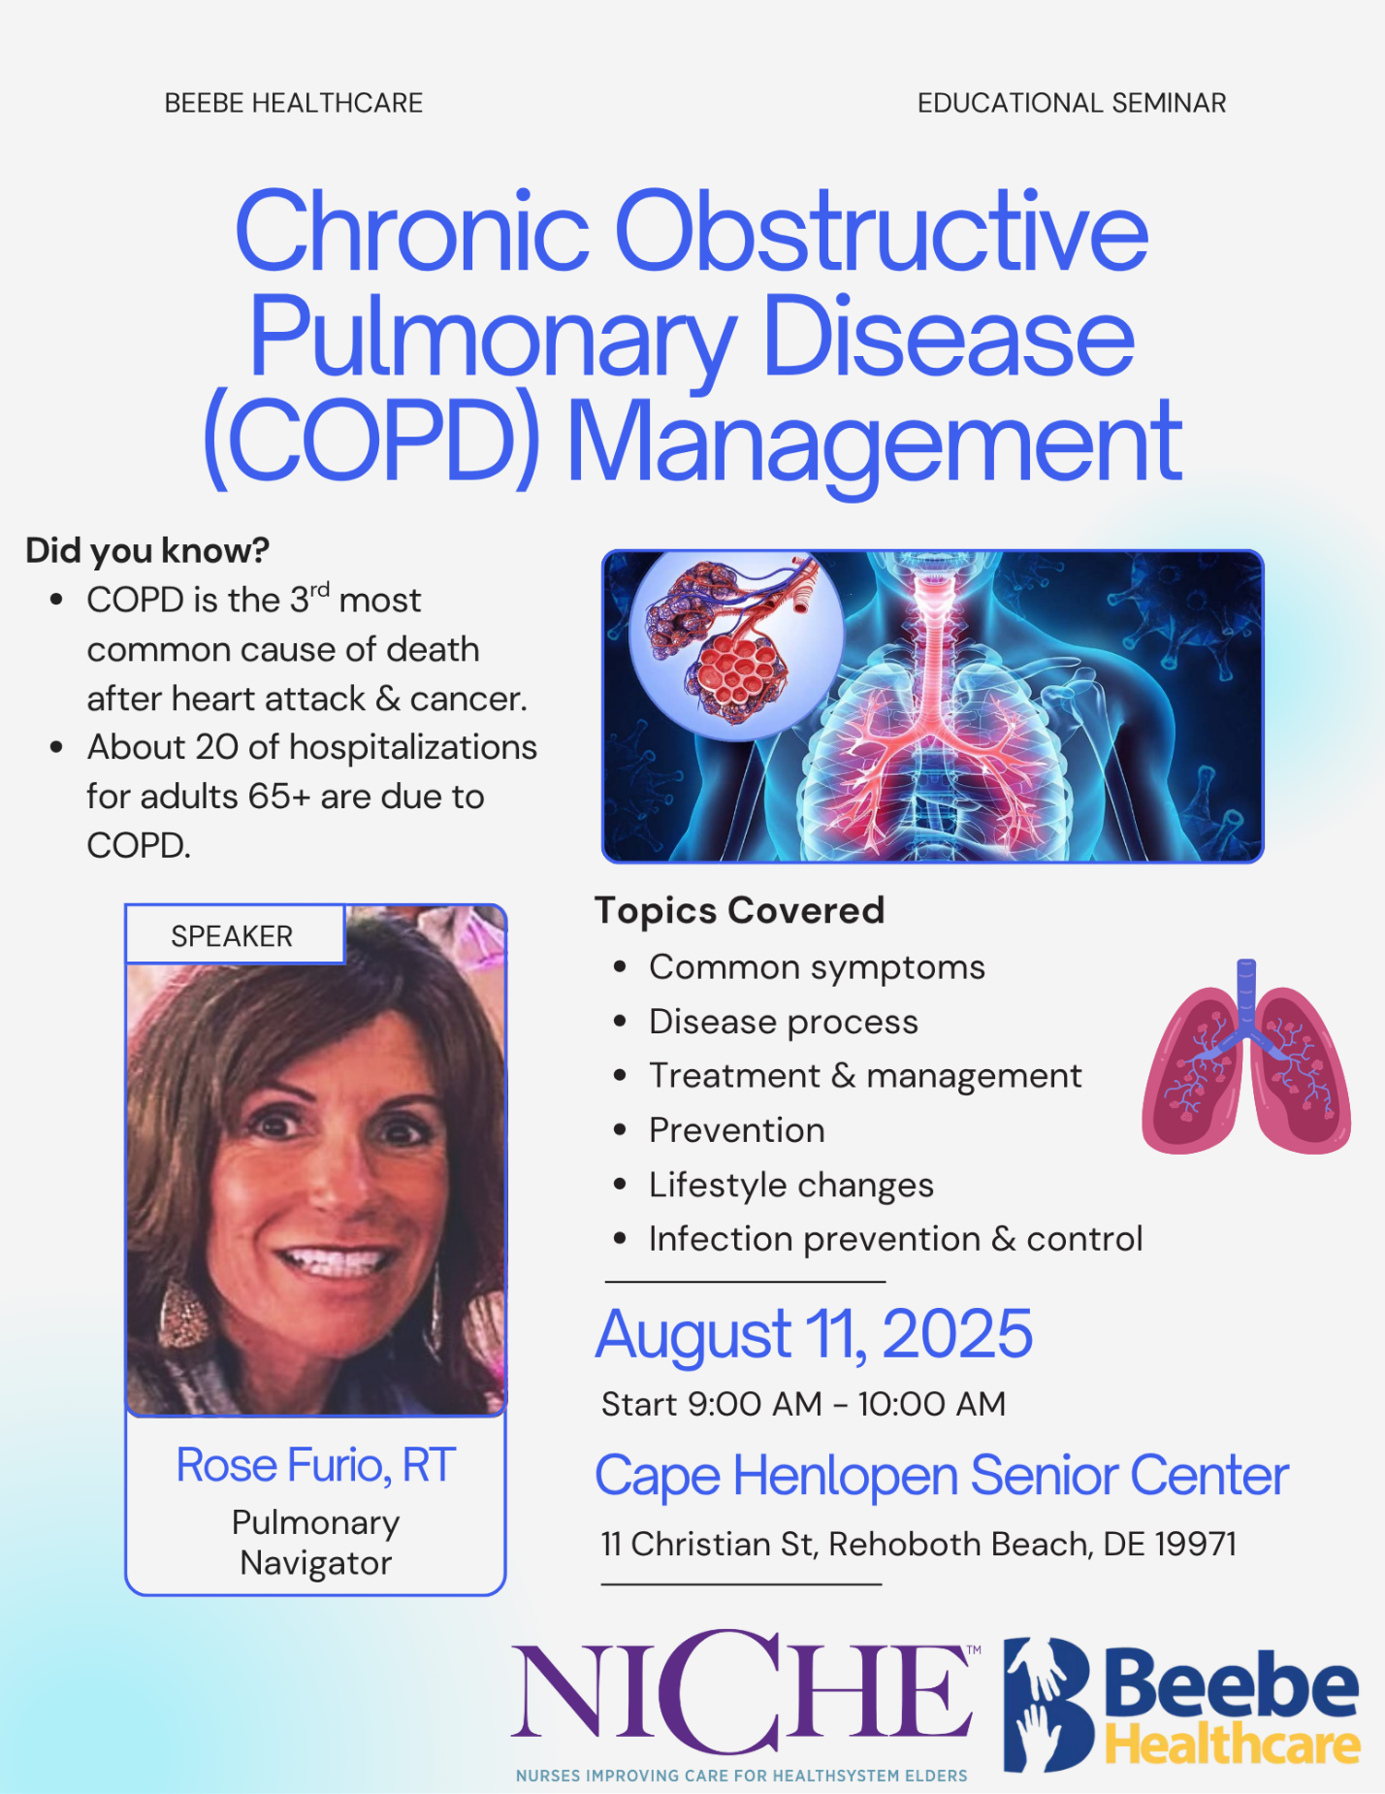

**To register call Cape Henlopen Senior Center at 302-227-2055**

**To register call Cape Henlopen Senior Center at 302-227-2055**