September 2026
Summer Edition
Volume 9

Deer Valley

Home Health

Highlights:

CEO 1
Articles 2-10
Spotlight 11-12
HR 13
Compliance 13
Nursing 13
DMH/ISL 14
CDS 14
In- Home 14
Employees 15
Birthdays 16
Anniversaries 17
Upcoming Events 18
In the Community 19-22
Activities 23-25

From the desk of Lady Ada Taylor, CEO

Greetings, Friends and Family!

Welcome to September 2026! Back-to-school season is here! Students are heading back into the classroom, and while it may not be every young person's favorite time of year, many parents are certainly welcoming the return to school. As the long, hot days of summer begin to fade, we'll soon enjoy the pleasant breeze of early fall. We also celebrate Labor Day, honoring the hardworking men and women whose contributions help keep our country moving forward.
I continue to stay busy each day with book signings, speaking engagements, and leadership training. My next book signing will take me to Washington, D.C. for the Congressional Black Caucus Annual Legislative Conference. From there, we'll travel to Atlanta for four days of training while continuing work on my upcoming documentary and film adaptation.
If you haven't already, I encourage you to pick up a copy of my latest book and study guide, From the Concrete Reservation to the Crown Jewel, available at millionairesclubstl.com. Production on the documentary and film, scheduled for release in late 2027, is progressing well, and we will soon begin auditions for actors and actresses interested in participating.
Our 1st Annual Deer Valley Community Day, held on Saturday, August 29th, was an incredible success! We were blessed to welcome so many families from throughout the community who came out to enjoy free book bags, school supplies, crayons, coloring books, hot dogs, hamburgers, games, health resources, and much more.
A heartfelt thank you goes out to our staff, volunteers, vendors, sponsors, and everyone who attended. Your support helped make this event truly memorable. We captured many wonderful photos and videos throughout the day, so be sure to visit our Facebook page to relive some of the highlights!
Thank you for continuing to make Deer Valley Home Health your trusted leader in compassionate home health care. If you know someone who could benefit from our services, we're here to help. Kim is available to assist with referrals Monday through Friday, 8:30 a.m. to 4:30 p.m. Phone: (314) 355-3679, Ext. 217 Office: Suite 105
As always, thank you for your continued trust and support. We look forward to serving you, your family, and our community for many years to come.
Lady Ada, CEO





Blood Cancer Awareness Month 2026

Blood Cancer Awareness Month is observed every September to raise awareness about blood cancers, which include leukemia, lymphoma, myeloma, and other hematologic malignancies. This month-long campaign focuses on educating the public about the signs and symptoms of blood cancers, the importance of early detection, and the latest advances in research and treatment. It also serves as a time to honor the courage of those affected by blood cancer, including patients, survivors, and their families, and to advocate for increased funding for research and support services.

What is Blood Cancer Awareness Month?
Blood Cancer Awareness Month is a global campaign that aims to highlight the impact of blood cancers and to spread knowledge about the various types of blood cancers that affect millions of people worldwide. The campaign seeks to improve public understanding of these cancers, promote early diagnosis, and support ongoing research efforts. Throughout September, numerous organizations and advocacy groups come together to host events, share educational resources, and provide support to those affected by blood cancer.

Main Types of Blood Cancers

Leukemia and lymphoma are cancers that affect the blood and lymph system, respectively.

Leukemia starts in the cells that form blood. Normally, most blood cells develop from cells in the bone marrow called stem cells. In a person with leukemia, the bone marrow makes abnormal white blood cells (leukemia cells). Unlike normal blood cells, leukemia cells don’t die when they should. They can crowd out normal white blood cells, red blood cells, and platelets. Consequently, it’s hard for normal blood cells to do their work.

Experts estimated that 66,890 new cases of leukemia would be diagnosed in the United States in 2025 and 23,540 would die from this disease, according to the National Cancer Institute (NCI).
There are several types of leukemia. The four main types of leukemia are:
- acute myeloid leukemia (AML), which affects myeloid cells and grows quickly;
- chronic myeloid leukemia (CML), which affects myeloid cells and grows slowly;
- acute lymphocytic leukemia (ALL), which affects lymphoid cells and grows quickly; and
- chronic lymphocytic leukemia (CLL), which also affects lymphoid cells, but grows slowly.

CLL is one of the most common types of leukemia in adults. ALL is the most common type of leukemia in children.

Lymphomas begin in cells of the lymph system, which is a part of the immune system. Lymph tissue is found throughout the body. As a result, lymphoma can begin almost anywhere. The disease occurs in two types: Hodgkin and non-Hodgkin lymphomas.
Both types can occur in adults and children. An estimated 80,350 people in the United States will develop non-Hodgkin lymphoma in 2025, according to the NCI. Approximately 19,390 people will die from non-Hodgkin lymphoma. For Hodgkin lymphoma, 8,720 new cases and 1,150 deaths are estimated for 2025, according to the NCI.

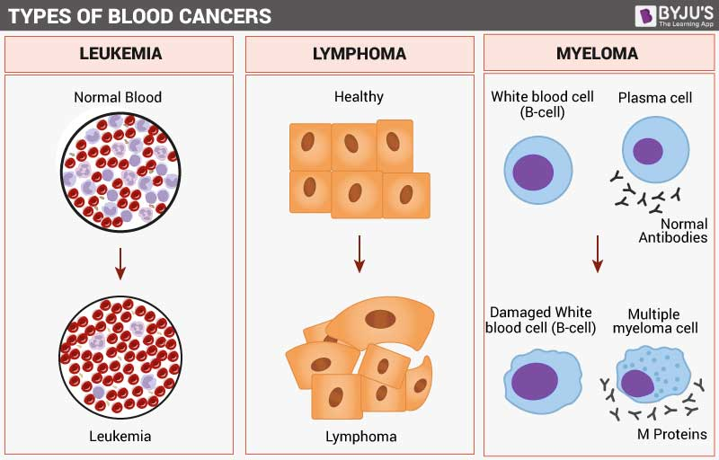

Blood cancer symptoms
Some common bone marrow and blood cancer symptoms include:
- Fever, chills
- Persistent fatigue, weakness
- Loss of appetite, nausea
- Unexplained weight loss
- Night sweats
- Bone/joint pain
- Abdominal discomfort
- Headaches
- Shortness of breath
- Frequent infections
- Itchy skin or skin rash
- Swollen lymph nodes in the neck, underarms or groin

Causes of blood cancer
Blood cancer is caused by mutations in the genetic material—the DNA—of blood cells. Other risk factors vary based on the specific type of blood cancer.
Risk factors for developing acute myeloid leukemia (AML), the most common form of leukemia in adults, include:
- Advancing age
- Gender: being male
- Exposure to industrial chemicals such as benzene
- Smoking
- History of cancer treatment
- Exposure to high doses of radiation
- History of other blood cancers
Risk factors for developing Hodgkin lymphoma include:
- History of infection with Epstein-Barr virus (EBV), which causes infectious mononucleosis (mono)
- Advancing age
- Gender (being male)
- Family history of Hodgkin lymphoma
- Compromised immune system
Risk factors for developing non-Hodgkin lymphoma include:
- Exposure to certain industrial chemicals, herbicides and insecticides
- History of chemotherapy
- Radiation exposure
- Compromised immune system
- History of autoimmune diseases such as rheumatoid arthritis or lupus
Risk factors for developing multiple myeloma include:
- Advancing age
- Gender (being male)
- Race: Higher risk among African Americans
- Obesity or extra body weight

How is blood cancer diagnosed?
A diagnosis often starts with a physical examination to check the patient's general health. The care team reviews the patient's health history, examines his or her body and lymph nodes, and looks for signs of infection or bruising.
Different types of tests and procedures may be used to diagnose blood cancer. What each patient needs depend on the type of blood cancer suspected. The care team may recommend testing and evaluating all the results along with the patient to make a diagnosis.

Biopsies
A biopsy is a test that collects samples of cells for examination by a pathologist in a laboratory. For some types of blood cancer, like lymphoma, the patient may need a lymph node biopsy that obtains a sample of lymph tissue or an entire lymph node.
Testing the bone marrow, where blood cells are formed, can help diagnose certain types of blood cancer. Doctors use a procedure called bone marrow aspiration to remove a small sample of bone marrow, blood and bone from either a hip bone or breastbone. The sample is sent to a lab and checked for abnormal cells or changes in genetic material.

Imaging scans
Imaging scans are more helpful for some types of blood cancer than others. A scan may spot an enlarged lymph node, which is a common symptom of lymphoma, but it’s not usually used to diagnose leukemia, a blood cancer that doesn’t cause visible tumors. Still, scans may help whether cancer has affected other parts of the body.
Scans include:
- Computed tomography (CT) scan
- Magnetic resonance imaging (MRI)
- Positron emission tomography (PET) scan
- X-ray
- Ultrasound

Blood tests
A complete blood count (CBC) shows the cell count of different components of blood, such as white blood cells, red blood cells and platelets.
Blood chemistry tests measure levels of key substances in the blood. Abnormal levels of certain proteins, for example, may offer information about the patient's condition. If multiple myeloma is suspected, doctors may want to check the patient's blood calcium level. For possible lymphoma, an enzyme called lactate dehydrogenase (LDH) may be measured.

Blood cancer treatment
Treatment for blood and bone marrow cancers depends on the type of cancer, the patient's age, how fast the cancer is progressing, where the cancer has spread and other factors. Some common blood cancer treatments for leukemia, lymphoma, and multiple myeloma include those listed below.
Stem cell transplantation: A stem cell transplant infuses healthy blood-forming stem cells into the body. Stem cells may be collected from the bone marrow, circulating blood and umbilical cord blood.
Chemotherapy: Chemotherapy uses anticancer drugs to block the growth of cancer cells in the body. Chemotherapy for blood cancer sometimes involves giving several drugs together in a set regimen. This treatment may also be given before a stem cell transplant.
Radiation therapy: Radiation therapy may be used to destroy cancer cells or to relieve pain or discomfort. It may also be given before a stem cell transplant.

An Overview of Sickle Cell Disease
There are many types of inherited blood disorder:
Sickle cell disease is a genetic blood disorder that causes severe pain and health complications. While there is no cure, treatments can help manage symptoms and improve quality of life. In the U.S., sickle cell disease affects about 1 in 365 African American births and 1 in 16,000 Hispanic American births but is rare in Caucasian and Asian populations.
Sickle cell disease is genetic, and due to the pattern of inheritance, it can affect you or your child even without a family history of the condition. There are a few different types of sickle cell disease, including sickle cell anemia and hemoglobin SC disease. The diagnosis is typically made with infant screening blood tests.
There is no cure for sickle cell disease, but the condition can be managed with a variety of treatment strategies.

Symptoms
A sickle cell crisis, which is an episode characterized by severe pain and distress, is the most prominent symptom of the condition. You may experience sudden effects of a crisis, with rapid worsening within a few hours.
This condition can also cause chronic problems, such as impaired childhood development and persistent fatigue. With sickle cell disease, serious health effects can occur due to blood clots and/or low oxygen.
Common effects of sickle cell disease include:
- Acute pain: You may experience sudden, sharp pain, lasting for days or weeks. This can affect your abdomen, back, arms, legs, or joints.
- Chronic pain: You can also experience chronic pain. This is often a deep, dull pain.
- Frequent infections: This illness can make you more vulnerable to infections because it damages the immune system.
- Jaundice: Your skin and eyes can develop a yellowish discoloration.
- Effects of anemia: Anemia often causes fatigue and pale skin, and it can also lead to shortness of breath.
- Growth problems: Children and adults with sickle-cell anemia may have a smaller than expected height and weight as a result of chronically low oxygen levels during childhood.
- Swelling of the hands and/or feet: This swelling can be painful, and it can occur during a crisis or when you are not experiencing a sickle cell crisis.
- Gallstones: Red blood cell breakdown, a common issue that occurs with sickle cell crisis, can increase the risk of gallstones.
- Priapism: Males who have sickle cell disease can experience painful erections due to blood flow problems in the penis. This is a medical emergency because it can result in permanent damage to the penis.
Diagnosis
Most states in the U.S. perform a standard newborn screening blood test on all babies. This test can identify whether your baby has abnormal hemoglobin.
There are several types of sickle cell disease, and they differ based on the specific hemoglobin defect. A blood test can differentiate the types of sickle cell disease.
Types of sickle cell disease include:
- HBSS: This is the most severe type, also often called sickle cell anemia. It is characterized by having two copies of the gene that codes for hemoglobin S, which is a defective hemoglobin protein.
- HBSC: The type of sickle cell disease occurs when you have hemoglobin S protein and hemoglobin C protein.
- HBSB+: This develops due to the presence of hemoglobin S protein and one defective beta globin gene that leads to reduced levels of beta globin and (relatively) increased levels of alpha globin.
- HBSB-: This develops due to the presence of hemoglobin S protein and an absent beta globin gene that leads to absent levels of beta globin and more markedly increased levels of alpha globin.
- HBSD: This type of sickle cell disease occurs when you have hemoglobin S and defective hemoglobin D protein.
- HBSO: This type of sickle cell disease occurs when you have hemoglobin S protein and defective hemoglobin O protein.
- HBSE: Hemoglobin S and hemoglobin E protein produce this type of sickle cell disease.
- Sickle cell trait (SCT): You can have SCT with one defective hemoglobin gene and one normal hemoglobin gene.
While the different hemoglobin defects are caused by a genetic inheritance pattern, the various types of sickle cell disease are diagnosed with a blood test that examines the hemoglobin protein in your blood or your baby’s blood sample.

Treatment
It is important that you maintain regularly scheduled visits with your healthcare provider if you have sickle-cell disease. And you may also need to have prompt medical attention for the treatment of acute symptoms, like pain or infections.
Treatments used in sickle cell disease include;
- Pain management: Pain from sickle-cell anemia is treated with pain-killing drugs and intravenous fluids.
- Penicillin: Young children, up to age 5, are often given oral penicillin daily to prevent pneumonia.
- Hydroxyurea: The anticancer drug hydroxyurea can reduce the frequency of painful sickle cell crises and help prevent acute chest syndrome.
- Blood transfusions: Sometimes blood transfusions are needed on an urgent basis to correct anemia or treat the effects of splenic sequestration. Additionally, blood transfusions can be scheduled on a recurring basis to help prevent complications of sickle cell disease. There are serious side effects of having frequent transfusions, however, including iron overload.
- Bone marrow transplant: Bone marrow transplantation may cure sickle cell disease in some people. Keep in mind that donated tissue must come from a healthy matched blood relative, and the procedure has many risks.
Sickle cell disease can increase the risk of certain complications during pregnancy (such as blood clots), so you will need to have close prenatal care so that issues can be prevented, detected, and treated.
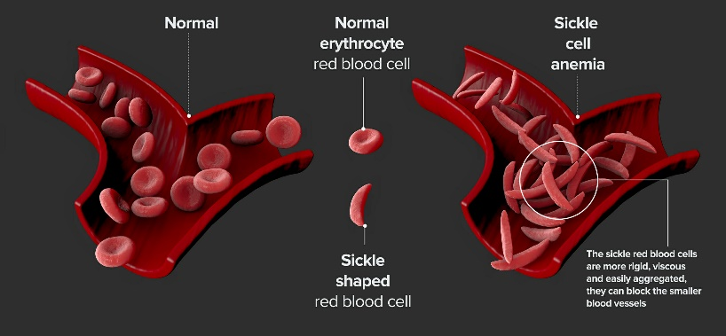
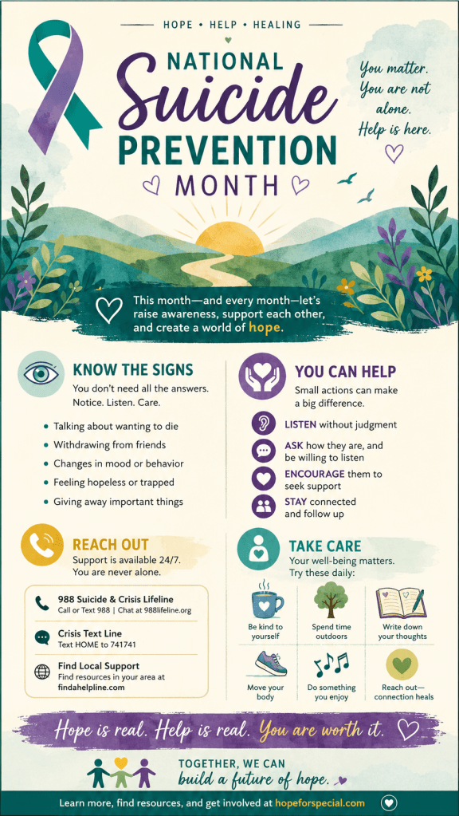


I would like to nominate our Liaison Team, Angela Ellerson and Natalie Scott, for their outstanding dedication and commitment to Deer Valley Home Health Services.

Angela and Natalie play a vital role in extending Deer Valley's reach throughout the community by building meaningful relationships and ensuring that individuals, families, healthcare professionals, and community partners are aware of the services we provide. Their passion for serving others goes far beyond marketing our organization; they are true ambassadors of our mission.

Whether they are volunteering at local food pantries, sponsoring back-to-school drives, hosting bingo events at senior centers, participating in health fairs, or supporting other community initiatives, they consistently demonstrate compassion, professionalism, and a genuine desire to make a positive impact. They represent Deer Valley with pride and embody our commitment to serving the communities where we live and work.

Their efforts have produced measurable results. Our referral numbers have increased, our community presence has grown significantly, and more people are recognizing Deer Valley once again as "Your Number One Home Health Provider." This success is a direct reflection of the countless hours, creativity, and dedication they invest in promoting our organization and strengthening relationships throughout the community.

Angela and Natalie exemplify teamwork, servant leadership, and excellence in everything they do. Their unwavering commitment to both Deer Valley and the communities we serve makes them highly deserving of this nomination. I am proud to recognize the Liaison Team for their exceptional contributions and the positive difference they continue to make every day.


I would like to nominate Briana Campbell. She is smart, independent, reliable, and dependable. She is there when you need her. Whether you need a client, a bit of information or a hug, Briana's got you covered. Since taking over the PC Risk Manager position, she has continued to excel in taking care of and protecting employees and clients alike.


I would like to nominate Jada Haskin in Billing. Jada is a REAL TEAM PLAYER! Jada has the upmost positive attitude and energy. Thank you for always lending a hand with a smile. Your generosity strengthens our team and creates a joyful atmosphere. Jada's hard work does not go unnoticed. Thank you for being such a great coworker who is willing to help the team. I appreciate your hard work and dedication.

Kim Hamm has made a positive impact by improving communication and bringing the team together through consistent updates on new client admissions and client losses. She works closely with the liaisons to coordinate referrals and ensures that everyone is informed about the activities within the Intake Department. Kim also goes above and beyond to support the Risk Managers by making sure they have all the necessary documentation and information needed to successfully open new clients. Her proactive communication, teamwork, and dedication have helped create a more efficient and collaborative intake process.
Thank You, Ladies, For All You Do, Your Flowers 


Human Resources Department
For current employees, please make sure the Human Resources Department has an updated address, email, and phone numbers on file.

Any questions regarding the hiring process including prerequisites, training, or general questions, please call Ashley Lane, our Human Resource Director, on 314-219-1214, prior to coming to the HR office.

Please check Paycom regularly for communications from the Human Resources, Accounting and Compliance departments.

Please allow 48 hours for all document requests and employment verifications. They must be faxed or emailed to HR@deervalleyhomehealth.com

Ashley Lane, Human Resources Director
alane@deervalleyhomehealth.com | Office: 314-219-1214

Compliance Department
If you have any questions about the Code of Conduct and Ethics or about any policies or practices of Deer Valley Home Health, you should raise the questions to a manager/supervisor or with our Compliance Officer, Chrissy Hych-Jones, or the Compliance hotline, at 833-785-8200.

Nursing/Private Duty In-Home Care
Deer Valley Home Health Services has openings for LPN’s, RNs, and CNAs to work in our Private-Pay Nursing and Healthy Child & Youth programs. We offer a competitive salary with health benefits and a savings plan. To apply, please visit our website www.deervalleyhomehealth.com . For specific questions about the programs, please call our Clinical Nursing Supervisor, April Hooten at 314-761-7441.

Department of Mental Health (DMH) and

In-Home Care/Individualized Supportive Living (ISL)

If you have any questions about the Department of Mental Health In-Home programs, please call the program manager Veronica Shannon on 314-773-4433. For more information about the Department of Mental Health, visit: Individual, Family & Guardian Info | dmh.mo.gov.

Consumer Directed Services (CDS)

If you have been in the hospital or have a change in your health status, you may be eligible for an increase in units. Please reach out to our Intake Coordinator, Kim Hamm, on 314-219-1221. You may also contact (314) 219-1213 Darnell Jones for North County, (314) 450-7294 Terrell Jones for South, and (816) 643-4300 Chasatie Fisher for Kansas City.

In- Home Services (IHS)

If it is time for your Medicaid Reassessment and/or Home Healthcare Reassessment, please make sure you respond to the State correspondence within ten business days to avoid interruption in your services, which may include cancellation.
If you have been in the hospital or have a change in your health status, you may be eligible for an increase in units. Please reach out to your Risk Manager, Briana Campbell 314-219-1337.



Honesty Funches DSP Tamara Gant DSP
Tashayla Stewart CNA Amira Almaliki DSP
Jordan Williams PCA Maria Jones PCA
Christina Williams DSP Clinton Billups DSP
Paula Clay PCA Majorie Johnson DSP
Damesha Reid DSP Jasmine Brown PCA
Myecia Hill DSP Beunka Haynes PCA
Taquisha Thomas DSP

welcome to the DVHH TEAM!!


Surlander Scott | 09.01 | Angela Peoples | 09.16
Donna Russell | 09.04 | Lakesha Ford | 09.17
Carlotta McDaniel | 09.07 | Shontel Kennard | 09.19
Kathy Simmons | 09.08 | Darnell Jones | 09.20
Arletta Jackson | 09.08 | Felicia Isbell | 09.22
Kim Hamm | 09.10 | Florence Wilson | 09.24
Laren Vashawn White | 09.10 | Tania Clark | 09.26
Martha Coe | 09.10 | Kayla Gilcrease | 09.26
Maya Hobbs | 09.13 | Keyanna Martin | 09.28
Latrice Moore | 09.15





Laren White | 1 Year | Andrea Sims | 7 Years
Orlando Williams Jr. | 1 Year | Tania Clark | 8 Years
Casandra Churchman | 1 Year | Terrell Jones | 9 Years
Sabrina Washington | 1Year | Tamike Meredith | 9 Years
Catherine Wood | 4 Years | Theresa Lucas | 12 Years
Brandi Kaufman | 4 Years | Jacqueline Harris Crenshaw | 12 Years
April Scott | 4 Years | Richard Cox | 16 Years
Rochelle Gilmore | 5 Years

Thank You for All That You Do!!!

Up Coming Events

St. Louis Adventist every Tuesday & Thursday 10am - 2pm

Wellston Center every Friday 8am - 12pm

New Journey Baptist Food Pantry every Wednesday 12pm - 3pm

Chapel of Exceptional Food Pantry every Tuesday & Thursday 10am - 12pm

13th Annual Women’s Empowerment Seminar September 25th, 9am - 2pm

GNCC – Women in Power Networking Lunch September 8th, 12pm- 1:30pm

It’s Just Networking 2 September 3rd, 8:30am – 10:00am

GNCC – Membership Luncheon September 16th, 11am- 1pm

VetNet Connect Meeting – September 18th, 8:30am-10:00am

Pagedale Festival September 12th, 11am- 4pm

Midtown Community Resource Fair Day September 11th, 10am – 1:30pm

Wellness Spa Day September 17th, 11am – 2pm

Food Pantry Days:
Circle of Lights- Food
314-382-8759

Episcopal Church of All Saints
314 367-2314

Focus Gateway City
314 884-0394

Hope Church
314 869-7777

Team Food Pantry
314 831-0879
Urban League
314-388-9840

Heat Up Saint Louis
314-241-0001

Carondelet Park Rec Complex (SHOWERS FREE)
314 768-9622

GIFT CARD AGENCIES:
Salvation Army
Urban League

Community of Hope
314 887-5941
Food Pantry

Basic Needs:
Community Action Agency of STL County
314-863-0015

Guardian Angel Settlement Association
314-773-9027
www.mydss.mo.qov/foodassistance SVDP - call 211 for
local resources

TEAM Food Pantry 314-831-0879

Housing/Shelter:
Apartment Finder
www.apartmentfinder.com

Beyond Housing
314-533-0600

MO Housing Development Commission
314-877-1350

St. Louis Housing Authority
314-531-0184

St. Louis County Housing Authority
314-428-320
Networking In the Community
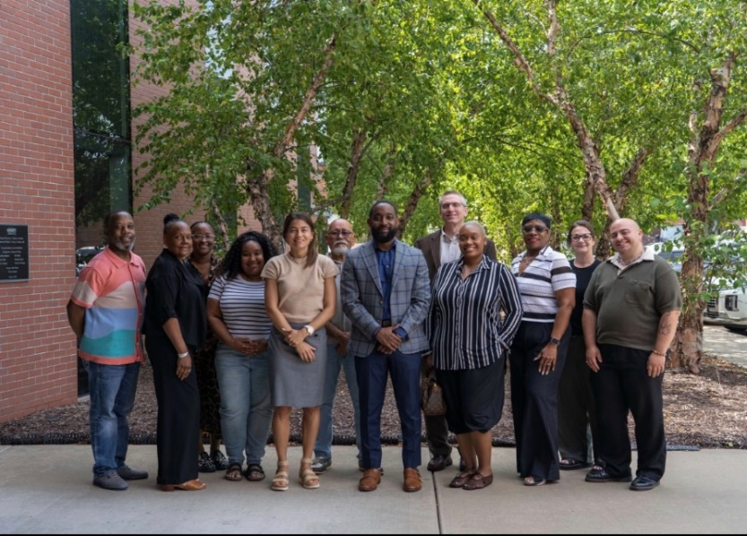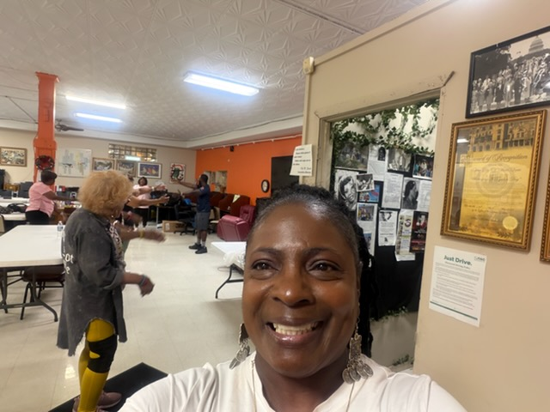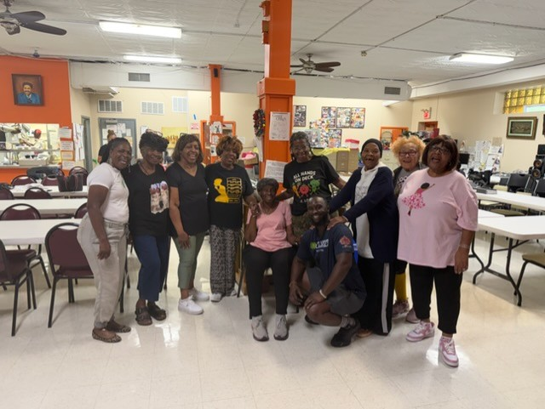

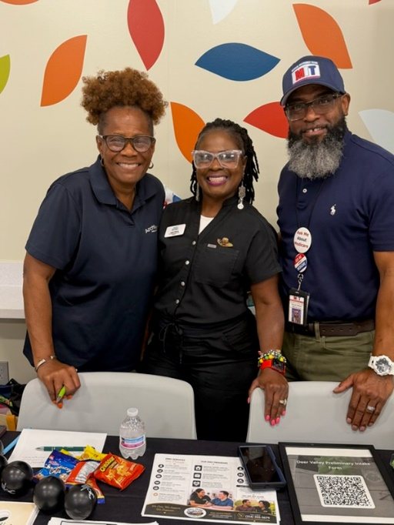
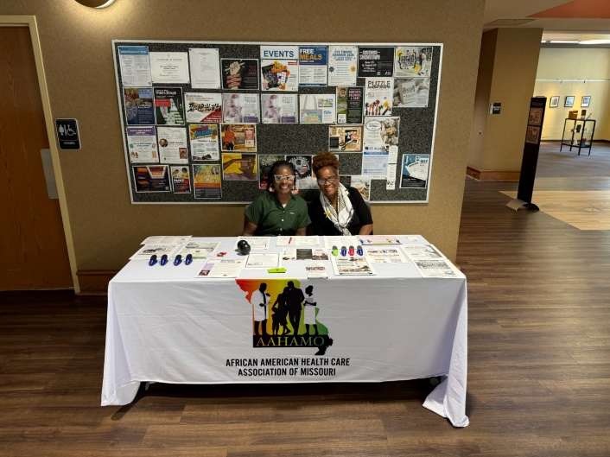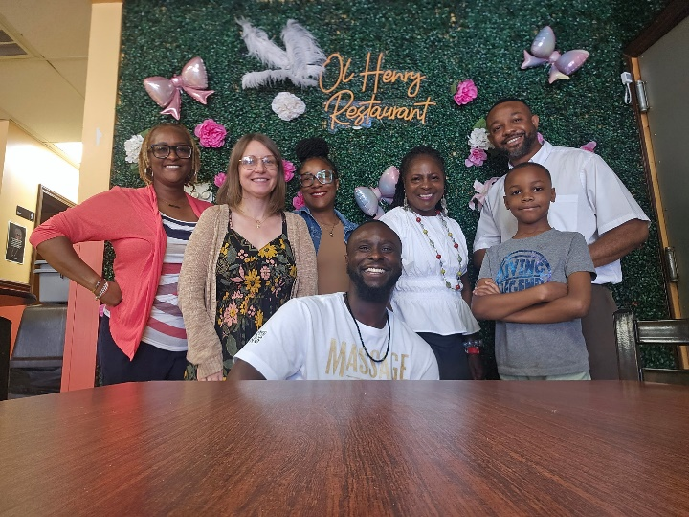

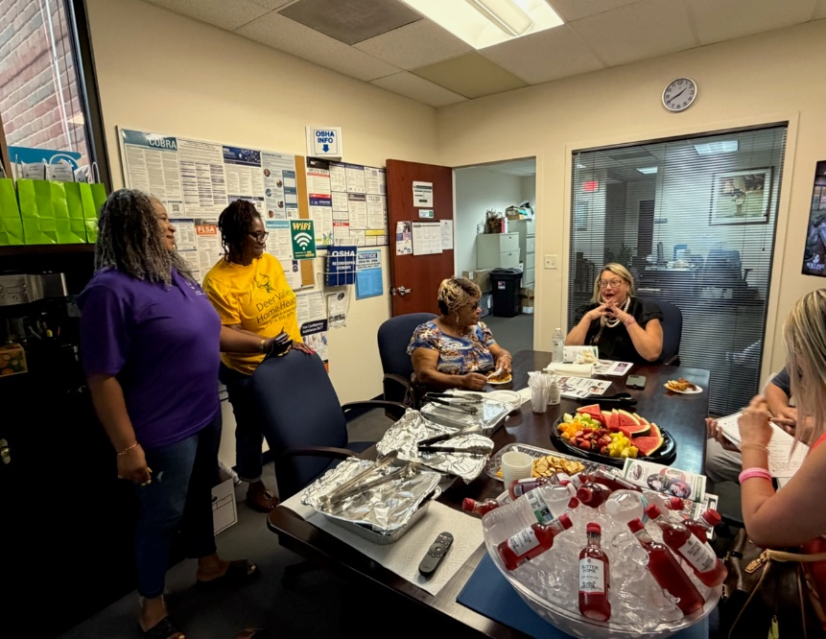

In the Community
