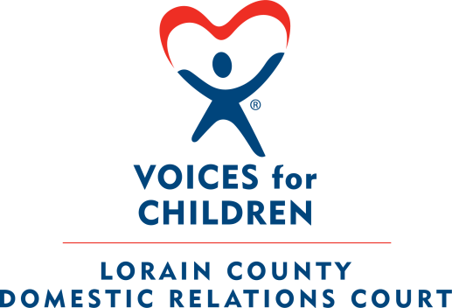


COURT APPOINTED SPECIAL ADVOCATE - GUARDIAN AD LITEM PROGRAM

Lorain County Justice Center
225 Court St. 2nd Floor
Elyria, OH 44035
Attn.: Voices for Children
(440) 329-5556

SECTION I. – CASA/GAL APPLICATION

Date Submitted:

Last Name: (Maiden Name if applicable):
First Name:
Middle Name:
Name Preference:

Date of Birth:
Social Security Number:
Race/Ethnicity:

Home Address:
City:
State: Length of residency in Ohio:
Zip Code:
Home Phone:
Cell Phone:
Email Address (Home):
Emergency Contact Number: (Name, Phone Number & Relationship)
Employment and Volunteer Experience

Current Employment: (i.e. Full Time, Part Time, Retired, Student, etc)
Work Title:
Workplace:
Work Address:
Phone (Work): May We Call You at Work? ________
Email (Work):

Past Employment: (Please attach a resume listing current and past employment and volunteer experience for at least the last five years.):

List Any Current or Past Volunteer Experience with Youth and /or the Courts:
Do You Currently Volunteer in any Capacity?
If Yes, Indicate Agency, Position, and Hours:

Education/Training Experience

Education Completed:
Field of Study: (i.e. Major, Minor, Trade, Vocation)
List any additional areas of training/expertise/skills/foreign language:
List any skills you have that may be of value to our program:

Personal Information

How Did You Learn about the Voices for Children Program?
Why Do You Wish to be a Volunteer Guardian ad Litem?
Have You Ever Applied or Volunteered for a CASA/GAL Program in Ohio or the U.S.?
If Yes, Which Programs? (Provide All):

Do You Have a Prior or Current History with any Children Service Agency?
If Yes, Name County, State and Explain Circumstances:

Have You Ever Been Charged or Convicted in a Court of Law?
If Yes, List Offenses, Dates of Offenses, Circumstances and Dispositions:
Do You Agree to Report Any Current or Future Arrests to the Program Director?

Do You Hold a Valid Ohio Driver License?
Do You Carry Car Insurance in Accordance with Ohio Law?

Do You Have Any Health Problems or Disabilities?
If Yes, Please Explain your Circumstances:
Are You Currently Taking any Type of Medications?
If Yes, Please Explain:
Are you currently seeing a Counselor or Therapist?
If Yes, Discuss Treatment Plan:
SECTION II – REFERENCE INFORMATION SHEET
* Please do NOT Include Family Members as References*
*Please Include Mailing Addresses for References*

Reference #1:

Name:
Address:
Phone (Home):
Phone (Work):
Relationship to the Reference:
For How Long?

Reference #2:

Name:
Address:
Phone (Home):
Phone (Work):
Relationship to the Reference:
For How Long?

Reference #3:

Name:
Address:
Phone (Home):
Phone (Work):
Relationship to the Reference:
For How Long?



RELEASE OF INFORMATION POLICY

I hereby give my informed consent to the Voices for Children – Court Appointed Special Advocate Program (CASA) to complete a thorough investigation of my character and fitness to be a CASA Volunteer. I understand that by signing this release I authorize inquiries to be made concerning my suitability as a volunteer to references that I have provided, which may include my past and present employers. I further authorize police checks, Bureau of Criminal Investigations checks, and Child Protective Services Agencies History Check. I understand that the information requested in this application and other information may otherwise be obtained will be used only for the purpose of deciding my fitness and suitability to serve as a CASA Volunteer and may be shared with other CASA Programs, if appropriate. I further understand that Ohio Law may require additional background checks and/or investigations and to sign all necessary releases or resign as a CASA Volunteer.
This release is good until revoked by me, in writing, at any time before it has been acted upon.
Criteria used in this selection of CASA Volunteer will be such to ensure that each accepted applicant is able to meet the responsibilities of a CASA Volunteer. No individual will be rejected because of ethnicity, gender, handicap, nationality, race, religion, sexual orientation, age, if at least 21 years of age, or marital status.
I understand that the Voices for Children – CASA Volunteer Program reserves the sole right to determine which individuals are suitable to become CASA Volunteer. Individual who has been convicted of a felony, who have been convicted of any criminal act involving drugs or alcohol within the past five (5) years and/or who have a history with a Child Protective Service Agency may not be accepted as a CASA Volunteer. An individual who has been adjudicated to have abused or neglected a child including, but not limited to, any sexual offense, abuse, child endangerment, neglect, or who has been involved in related acts that would pose a risk to children or to the program’s credibility will not be accepted as a CASA Volunteer.

Signature: _______________________________ Date of Signature: _____________

Social Security #: ____________________ Date of Birth: _______________________

□ I do
possess a concealed carry permit.
□ I do not

Print Name________________________________

Social Security #__________________

Date of Birth_______________________________

Signature_________________________________ Date____________________________

Once you complete the application then SAVE it on your computer. Then email the Application as an ATTACHMENT to the following email address:

timgreen@vfclc.org

Thank You for your Interest in the Program. Our staff will contact you immediately to provide you with further information, answer any questions you may have and set up an interview at our office once your application is processed and filed.

Our upcoming Fall 2025 Pre-Service Training Classes for

New CASA Volunteers are scheduled for:

October 4, 11, 18, & 25, 2025

Find Us and Like us on Facebook:
Voices for Children – Lorain County Casa/Gal

