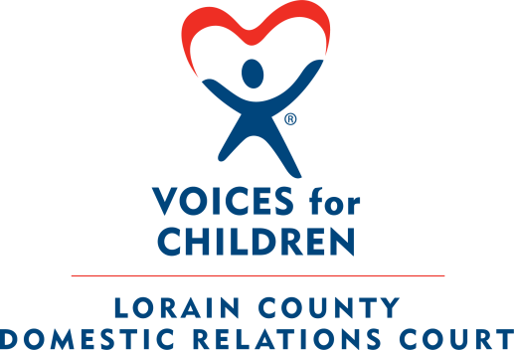

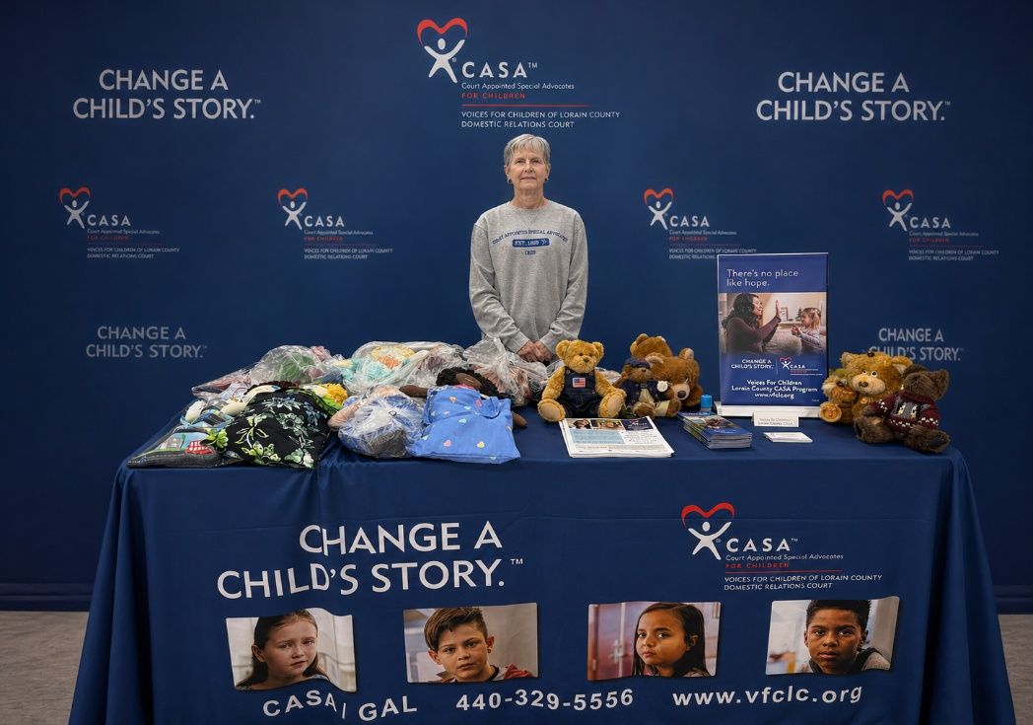

Lorain County CASA/GAL Volunteer Program
Court Appointed Special Advocate/Guardian ad Litem

2025 Annual Report

Honorable Judge Sherry L. Glass
Honorable Judge Lisa I. Swenski
Honorable Judge Frank J. Janik

Court Administrator – Emily Kirsch



BOARD OF DIRECTORS



Voices for Children is a member of the National CASA/GAL Association and abides by the principals and standards set forth by theses organizations. The Voices for Children Board of Directors is a 501 C 3 Not for Profit corporation in Lorain County that supports the efforts of the Court Appointed Special Advocate program by raising funds and supporting the staff in areas of public relations, volunteer recruitment, retention and training.

The Board of Directors meet the first Thursday of each month at 6:00pm on Zoom. The Board of Directors accepts applications for Board Appointments throughout the year.

Board Officers
President: Fred Courtright
Vice President: Bill Hamilton
Secretary: Joan Kahanca
Treasurer: Ron Dauphin

Board Members
Susan Petz
David Cooper
Ed Wacker
Kathy Bevaque
Lucy Bunsey
Stephanie Rector

CASA-GAL VOLUNTEER DEMOGRAPHICS - 2025



Total number of Active CASA Volunteers: 125

Gender of CASA Volunteers: (Female - 113) (Male - 13)

Race/Ethnicity of CASA Volunteers:

- African American: 11
- Asian: 2
- Caucasian: 107
- American Native: 2
- Multi-Racial: 3

- Hispanic: 6
- Non-Hispanic: 119

Age of CASA Volunteers:

- 21-29: 3
- 30-39: 8
- 40-49: 28
- 50-59: 27
- 60 +: 59

Highest Education level completed for CASA Volunteers:

- High School: 6
- Some College: 29
- College Graduate:40
- Post-Graduate: 43
- Unknown/Other: 7

Employment status of CASA Volunteers:

- Full Time: 48
- Part Time: 19
- Student: 4
- Retired: 37
- Not Employed: 13
- Unknown/Not Disclosed: 4

Total number of New CASA Volunteers trained in 2025: 16

Gender of New CASA Volunteers: (Female - 16) (Male - 0)

Race/Ethnicity of New CASA/GAL Volunteers:

- African American: 0
- Caucasian: 15
- Asian: 1
- Hispanic: 1
- Non-Hispanic: 15

Total number of New CASA Volunteers assigned a case in 2025: 14

CASA VOLUNTEER ACTIVITY - 2025

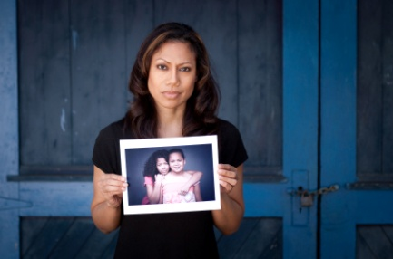

Hours contributed by CASA GAL Volunteers: 7783 hours

Miles driven by CASA GAL Volunteers: 27,713 miles

- Average length of time CASA GAL Volunteers stays with the program: (73.3 months or 6.1 years)

- Average length of Active CASA GAL Volunteers Case Assignments: (15.9 months)

- Average number of cases a CASA GAL Volunteer is appointed to at one time: (1.35 cases)

- Average number of children a CASA Volunteer is appointed to at one time: (2.65 children)

CHILDREN SERVED DEMOGRAPHICS - 2025

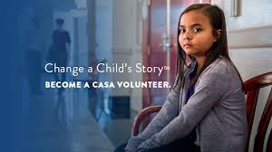

Number of Children served by CASA Volunteers: 333

Total number of Cases served by CASA Volunteers: 169

Gender of the Children served:

- Female: 179
- Male: 154

Age of the Children served:

- Birth to 5: 105
- 6-11 years: 127
- 12-15 years: 64
- 16-17 years: 28
- 18 and above: 9

Race/Ethnicity of the Children served:

- African American: 52
- Caucasian: 241
- Multi-Racial: 40

- Hispanic:38
- Non-Hispanic: 295

NEW CHILDREN SERVED – DEMOGRAPHICS - 2025



Total number of New Children assigned to a CASA Volunteer: 169

Gender of the New Children served:

- Female: 97
- Male: 72

Race/Ethnicity of the New Children served:

- African American: 31
- Caucasian: 121
- Multi-Racial: 17

- Hispanic: 20
- Non-Hispanic: 149

Age Range of the New Children served:

- Birth to 4 years: 52
- 5 to 8 years: 35
- 9-12 years: 45
- 13+ years: 37

CLOSED CASE INFORMATION – CHILDREN 2025



Total number of children whose cases were closed: 124

Number of children whose cases closed with the program for each of the following reasons:

- Remained with Parent(s) throughout life of the case: 18

- Reunification with Parent(s): 15

- Placed with Legal Guardians: 72

- Adopted: 6

- Case closed with program before outcome for child determined: 8

- Child Aged Out of System: 5

- Transfer to another Agency: 0

