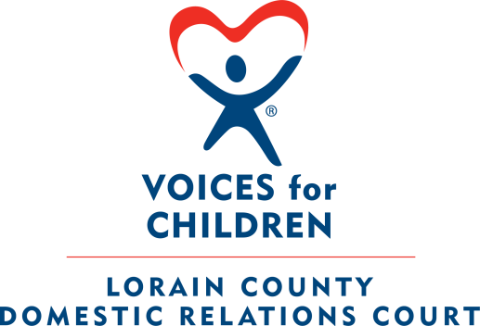



**Lorain County CASA/GAL Volunteer Program**

**Court Appointed Special Advocate/Guardian ad Litem**

**2024 Annual Report**

**Honorable Judge Sherry L. Glass**

**Honorable Judge Lisa I. Swenski**

**Honorable Judge Frank J. Janik**

**Court Administrator – Emily Kirsch**





**BOARD OF DIRECTORS**



**Voices for Children** is a member of the National CASA/GAL Association and abides by the principals and standards set forth by theses organizations. The Voices for Children Board of Directors is a 501 C 3 Not for Profit Corporation in Lorain County that supports the efforts of the Court Appointed Special Advocate program by raising funds and supporting the staff in areas of public relations, volunteer recruitment, retention and training.

The Board of Directors meet the first Thursday of each month at 6:00pm on Zoom. The Board of Directors accepts applications for Board Appointments throughout the year.

**Board Officers**

**President:** Fred Courtright

**Vice President:** Bill Hamilton

**Secretary:** Joan Kahanca

**Treasurer:** Ron Dauphin

**Board Members**

Susan Petz

David Cooper

Danielle Moore

Kathy Bevaque

Lucy Bunsey

Stephanie Rector

**CASA-GAL VOLUNTEER DEMOGRAPHICS - 2024**



Total number of **Active** CASA Volunteers: 126

**Gender** of CASA Volunteers: (Female) 109 **(**Male) 17

**Race/Ethnicity** of CASA Volunteers:

* African American: 12
* Asian: 3
* Caucasian: 102
* Hispanic: 7
* American Native: 2
* Multi-Racial: 0

**Age** of CASA Volunteers:

* 21-29: 2
* 30-39: 9
* 40- 49: 29
* 50-59: **26**
* 60 +: 60

Highest **Education** level completed for CASA Volunteers:

* High School: 12
* Some College: 31
* College Graduate: 45
* Postgraduate: 38

**Employment** status of CASA Volunteers:

* Full Time: 51
* Part Time: 15
* Full Time Student: 2
* Part Tine Student: 6
* Retired: 36
* Not Employed: 16

Total number of **New CASA Volunteers** trained in 2024: 26

**Gender** of New CASA Volunteers: (Female) 25 **(**Male) 1

**Race/Ethnicity** of New CASA/GAL Volunteers:

* African American: 2
* Caucasian: 21
* Hispanic: 1
* Multi-Racial: 2

Total number of **New CASA Volunteers** assigned a case in 2024: 20

**CASA VOLUNTEER ACTIVITY - 2024**

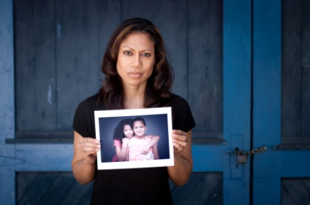

Hours contributed by CASA GAL Volunteers: 8,730.5

Miles driven by CASA GAL Volunteers: 36,665

* Average length of time CASA GAL Volunteers stays with the program: **(68) months**
* Average length of Active CASA GAL Volunteers Case Assignments: (**15.8) months**
* Average number of cases a CASA GAL Volunteer is appointed to at one time: **(1.4)**
* Average number of children a CASA Volunteer is appointed to at one time: **(2.9)**

**CHILDREN SERVED DEMOGRAPHICS - 2024**

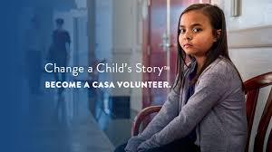

Number of Children served by CASA Volunteers: 360

Total number of Cases served by CASA Volunteers: 360

**Gender** of the Children served:

* Female: 175
* Male: 185

**Age** of the Children served:

* Birth to 5: **111**
* 6-11 years: 144
* 12-15 years: **64**
* 16-17 years: **31**
* 18 and above:**10**

**Race/Ethnicity** of the Children served:

* African American: 52
* Caucasian: 239
* Hispanic: 25
* Multi-Racial: 44

**NEW CHILDREN SERVED – DEMOGRAPHICS - 2024**



Total number of **New Children** assigned to a CASA Volunteer: **117**

**Gender** of the New Children served:

* Female: 62
* Male: 55

**Race/Ethnicity** of the New Children served:

* African American: 7
* Caucasian: 83
* Hispanic: 12
* Multi-Racial: 15

**Age Range** of the New Children served**:**

* Birth to 5 years:42
* 6 to 11years: 44
* 12-15 years: 19
* 16-18 years: 12

**CLOSED CASE INFORMATION – CHILDREN 2024**

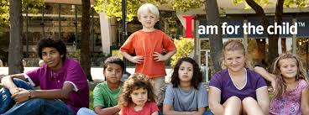

Total number of children whose cases were closed: 197

**Number of children whose cases closed with the program for each of the following reasons:**

* Remained with Parent(s) throughout life of the case: **7**
* Reunification with Parent(s): 40
* Placed with Legal Guardians: 100
* Adopted: **17**
* Case closed with program before outcome for child determined**: 27**
* Child Aged Out of System: 5
* Transfer to another Agency: 1