Tracking your day
Noticing what is already nicotine-free

Notice
No one starts from scratch. Everyone has some nicotine-free times already such as sleeping or showering. Let’s find yours. Notice the time, activities, places, people and thoughts that are already part of your day without nicotine.

Zones
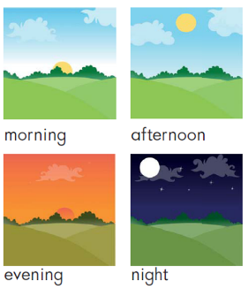
Break your day into zones. Track a zone. Just like your confidence number, tracking helps you see your starting point.
Morning is the time from waking till noon.
Afternoon is the time between noon and dinner
Evening is the time between dinner and sleep
Night is the time between bedtime and waking

Tracking
We are tracking time nicotine-free and what is already nicotine-free, not smokes or vapes. For each zone, find your longest nicotine-free time. Then notice the activities, places, people and thoughts in that zone that are already part of your day without nicotine.
Time: e.g. longest time nicotine-free —between one smoke or vape and the next
Activity: e.g. out walking
Place: e.g. at the marae
People: e.g. visiting Nan
Thoughts: e.g. thinking of pēpi
Keep track in whatever way works for you — in your mind, on your phone or on paper. Look for patterns in what helps or might help you be nicotine-free.
Morning  Longest time: ________  Activity: __________________________________  Place: ____________________________________  People: __________________________________  Thoughts: ________________________________ | Afternoon  Longest time: ________  Activity: __________________________________  Place: ____________________________________  People: __________________________________  Thoughts: ________________________________
Evening  Longest time: ________  Activity: __________________________________  Place: ____________________________________  People: __________________________________  Thoughts: ________________________________ | Night  Longest time: ________  Activity: __________________________________  Place: ____________________________________  People: __________________________________  Thoughts: ________________________________

