Try nicotine-free time
A different way to think

The power of habits
Nicotine becomes attached to the things we do, feel and think. Over time, these links can make smoking or vaping feel automatic. We can find ourselves using nicotine from habit, even when we aren't craving it.

New habits
The same process can work in the other direction. Nicotine-free can become attached to the things we do, feel and think; to times of day, places and the people we love. Over time, these links can make being nicotine-free feel automatic, too.
Each new nicotine-free habit is a stepping stone. Getting used to being nicotine-free here and there, and then more and more, is how we build a life where nicotine no longer has a place.

Start with sleep
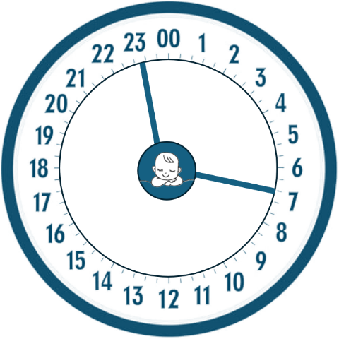
Nicotine-free time is the time between one smoke or vape and the next. For most people, sleep is already a nicotine-free zone. Think of a 24-hour day — sleep takes about 8 hours of it. That’s 8 hours when things are going well — an 8-hour zone of protection around pēpi.
If you feel unsure, start small. Name sleep as a nicotine-free zone. It is a simple first step that can build confidence for the next one. Naming things as nicotine-free starts an important change in thinking.

Have a go
Try this naming approach with other things. Find a time, activity, place, person or thought that is already nicotine-free. Name it. Repeat it. Grow the protection. That is the idea. Small changes gather and get bigger until nicotine has no space in your day.
So, what is already nicotine-free in your day? When do you never smoke or vape? Make a list.
 | Ideas for what to make nicotine-free next
Time  Activity  Place  Person  Thoughts | add minutes after waking or before bed  getting dressed, having breakfast, using your phone  bedroom, bathroom, kitchen or whole house  someone special - partner, child  sleep is nicotine-free / I am nicotine-free when …

