Understanding Stress
The role of nicotine

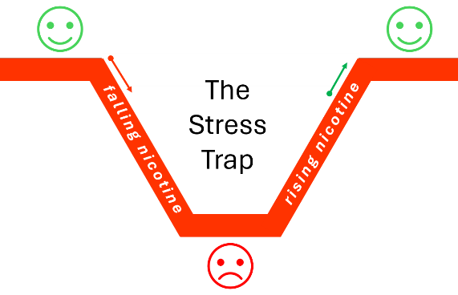
Keeping balance
Our bodies are always working to keep things in balance. This is called homeostasis. Think about food. When you are hungry, you may feel tired, distracted, cranky. You eat. Your body gets what it needs, and you feel better. Our bodies like a steady supply of what they need.

I am nicotine. This is how I work.
When you smoke or vape, my levels go up. Body feels calmer, more settled, able to cope. Then my levels start to fall. Body notices. The falling levels start a craving. Craving is a kind of stress. As it builds, body may feel tense, irritable, less able to cope. So, you smoke or vape again.
My levels go up again. Body feels better for a while. The craving is calmed.
Calm—stress, calm—stress, calm—stress throughout your day.
I am the stress strap. That is my role. That is all I can do. I can only relieve the craving I have caused.

The extra stress
Nicotine adds extra stress through your day from the rise and fall of nicotine and the cravings that come with it.
Think about how you feel just after a smoke or vape, when your nicotine levels are restored. That is how your body can feel when nicotine is gone. No distractions from needing nicotine.

You or nicotine — who is in charge?
Nicotine may seem to be helping with all the stress in your life. But it cannot fix worries, tiredness, relationships, pregnancy concerns, money, work or everyday problems.
You are already dealing with those. Nicotine is only dealing with one thing: the craving it created.

