


Ukrainian Summer school on Vaccinology
17 July
8.15 – 8.45 | Introduction. Representation of school.  ESPID promo. | Fedir Lapii, Yevgenii Grechukha
8.45 – 9.45 | Basics of immune response | Yarina Romanishina
9.45 – 10.15 | Classification of drugs for immunoprophylaxis. Components of vaccines | Yevgenii Grechukha
Q & A (15 min)
Break (15 min)
10.45 – 11.45 | Basic concepts of immunoprophylaxis. The issue of epidemiology. Program questions for vaccination.  Legal principles of immunoprophylaxis | Ludmila Slobodianyk
11.45 – 12.45 | Introduction of vaccine into practice: from idea to immunization schedule. Immunization schedule | Fedir Lapii
Q & A (15 min)
Lunch 13.00 – 14.00
14.00 – 14.30 | Hepatitis B | Mykola Garas
14.30 – 15.00 | Tuberculosis and BCG | Mariia Dolynska
15.00 – 15.30 | Measles, mumps, rubella, varicella | Nadiya Gigalova
Q & A (15 min)
Break (15 min)
16.00 – 16.30 | Diphtheria and Tetanus | Yrii Stepankivskii
16.30 – 17.00 | Pertussis | Oleksandr Mazulov
17.00 – 17.30 | Poliomyelitis. Rotavirus infection | Fedir Lapii
Q & A (20 min)

18 July
8.30 – 9.45 | Immunization of individuals with underlying medical conditions | Alla Volokha
Q & A (15 min)
10.00 – 11.30 | Contraindications for vaccination | Larisa Kostuchenko
Q & A (15 min)
Break (15 min)
12.00 – 13.30 | Adverse events following immunization (AEFI) | Vusala Alahirdeeva
Q & A (15 min)
Lunch 13.45 – 14.45
14.45– 15.45 | Immunization support in communities. Emergency communication / AEFI crisis communication | Mariana Zaichikova
Q & A (15 min)
Break (15 min)
16.15 – 17.15 | Discussion of cases: emergency conditions | Dmytro Samofalov
17.15 – 18.00 | Practical training | Dmytro Samofalov

19 July
8.30 – 10.00 | Storage, distribution and disposal of vaccines.  Immunisation session. | Fedir Lapii
Q & A (15 min)
Break (15 min)
10.30  -  12.30 | Hib. Meningococcus. Pneumococcus | Hans Jürgen Dornbusch
10.30  -  12.30 | Vaccination during pregnancy | Hans Jürgen Dornbusch
Q & A (15 min)
Break (15 min)
13.00 – 13.50 | Vaccination of person with interrupted and delayed schedule  Combination of vaccines | Vira Semianchuk
Q & A (10 min)
Lunch 14.00 – 15.00
15.00 – 16.15 | Emergency, post-contact immunoprophylaxis.  Vaccination of travelers | Igor Savchak
Q & A (15 min)
16.30 – 17.00 | Vaccination: questions and answers

20 July – Final test (10.00).

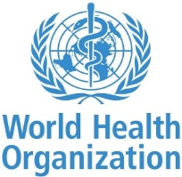

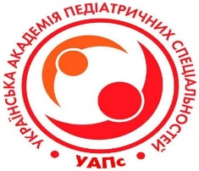


Lviv - 2019

